newsletter
volume 9 issue 4 december 2010

‘Gotong Royong Utrecht’ Foundation

postal address: oudkerkhof 15 bis, 3512 GH Utrecht, the netherlands
email: info@gotong-royong-utrecht.nl
bank account: 84.21.36.932 (FORTIS)
reg.number chamber of commerce H30179877

1. From the board

Warm rain showers and icy winds, early spring and late monsoon, snowfall and ash rains, global warming and a coldness record, contrasts and paradoxes, birth and death, health and sickness, once together now alone, employed and jobless… 2010 was a fierce year for many of you. Where we seek certainty and sustainability, there is only temporality and change and the question rises: how do we learn to enjoy beauty without being disturbed when things turn out differently?

WE WISH YOU A CRYSTAL CLEAR, INSPIRING NEW YEAR!



Change is happening in our lives: next year we will move from Bali to Yogyakarta. The projects on Bali will of course continue, we will regularly spend some time there. A change also took place in the board: René took Inekes place. We thank Ineke for stimulating us all these years with her objectivity, opening our eyes for things that were right under our noses.

Our request for sharing your network with us has not produced any concrete results yet, but two possible successes are on their way: we delivered a presentation to the Kiwanis in Amerongen and are awaiting their decision. And a few freemasons’ lodges in Alkmaar joined in a fundraising activity (thanks in advance Anne, Kees and Jaap)! Thanks also to all sponsors for your generous gifts! We want to mention especially Aad who sent 1500 euros to help the Merapi eruption victims, Ronald (850 euros for both the children’s home and seniors), Hans for a generous gift on behalf of the Veenendaal-Bot Foundation (3000 euros) and Margreet and Paul (2400 euros for the Singaraja seniors).

2. Project information

I. Bali: Widhya Asih III children’s home, Singaraja

Developments in the first semester were positive. The children are a close group, although three new children – all first graders in senior high school – left: one because of home sickness, two because Yohanes’ policy was too strict and structured for them. This is unfortunate, they do not realize they allowed a great opportunity to pass.
Christmas holiday started very early on Bali because the Hindu harvest feast of Galungan and Kuningan took place in December and the Education Service decided to combine both holidays. Therefore the school reports were early too. We had our earliest Christmas celebration ever on December 9! Christmas in the tropics is always strange, but Christmas long before Christmas is even stranger. Nevertheless it was a nice celebration with singing, dancing, a modern Christmas play, and the election of the new Prince and Princess of the Ants (the children’s home council of two children). There were many parents/family members to watch ‘their’ children perform on stage. The home is doing well, it is a special community with Yohanes in the centre. The past months four young students from Singapore stayed here. They gave English lessons daily; we notice the effect in communicating with the children. Yohanes always has plans, some feasible (a new study/relax centre) some not (a swimming pool). There was not enough money for two plans and we did NOT offer to pay for either so a choice had to be made and the plan had to be carried out on the slate. Luckily he chose the study centre. Our (your) money was spent on the school bus: taxes, new tyres and some small repairs.

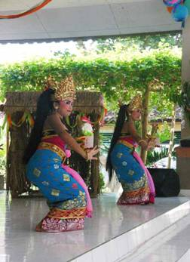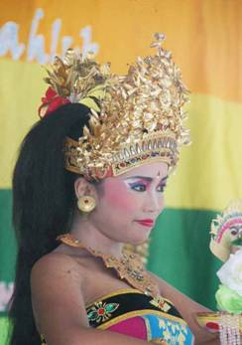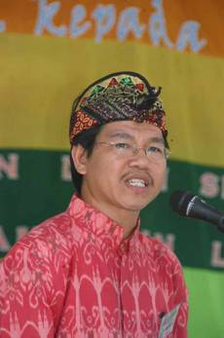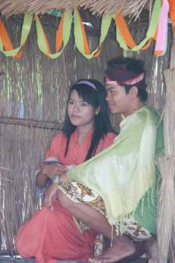
Christmas celebration opening dance She’s got talent bpk Yohanes Joseph, Mary and Child

II Bali: Scholarships

The past three months were relatively quiet, as a result of the good settlements we have with the various schools. A few things had to be done: school books, sports clothing, remedial teaching. But there were no problems. Yudi, the staff member of the children’s home who took a clear position towards the schools, deserves a compliment. He has grown and we were able to step back; our coaching shows effect.

III Bali: Seniors and medical support

Because we have been working with the same group of seniors for years now, we see how time affects them and where problems arise. It is remarkable how quickly they turn from optimistic and mobile elderly into dependent and immobile ‘oldies’. Women, who are the backbone of the grey economy, family and spiritual life on Bali have a harsh life and sooner or later all develop the same complaints to neck/shoulder, hips and mainly knees. They are very glad to be able to talk about it to a doctor or nurse and to receive medication. And we are very glad we are able to offer this to them. The challenge for us is to guarantee continuity: if we are not present, others have to take over. Our friend Ratna seems to be the right person, hopefully the others grant her this position. Anyway, as long as medical assistance is available and the shop that provides the food parcels cooperates, the project is safe.

IV Java: Yogyakarta, Mount Merapi

A big disaster threatened Yogyakarta as the volcano Mount Merapi erupted late October. The threat was huge and the pictures of panic and suffering made a big impression. 350 people died on the slopes, mostly because of poisoned gases and burning winds. Now the mountain is quiet again. The danger is still there though, both in hot lava as in what is called ‘cold lava’: the ash on the slopes mixes with rain and is now coming down in thick sticky layers through the rivers to the city of Yogyakarta. As a result the river-bed of the Code river has risen a few metres, so the river is more shallow and there is a risk of flooding. People are working very hard now to dredge the river.
All Sejahtera Mulia volunteers worked hard in these weeks of emergency and threat to help the refugees, especially with cooking and distributing food and washing clothes. People from the ruined villages will be assigned other places to live. We closely watch this process because we may be able to give support.

V Java: Yogyakarta; Seniors and medical support

The six groups (a total of 350 participants) of seniors in the city receive supplementary food each month (sembako: a parcel containing the nine essential products), twenty of them receive it each week. The process is going well. In December there was another ‘outing’: some 150 seniors were taken to the Kraton (the sultan’s palace) by bus. For some this is sacred ground. Although we were not invited for tea, the day was filled with the respect these people have for their royal house (Hamengkobuono X). Afterwards we went to the Kraton’s carriage museum. And of course we ate and drank together.

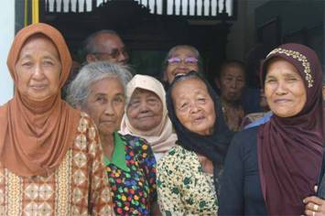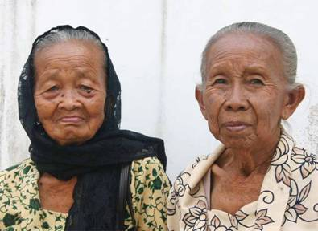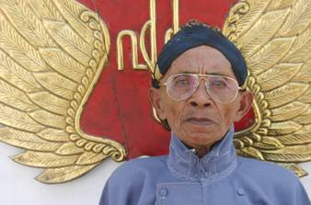

VI Java: students

Eka started the first year of nursing school in the Bethesda hospital (thanks to her Dutch sponsor). Derli is in her second year in this hospital, but in December she was taken in as a patient because of dehydration and nausea: dengue fever. She quickly recovered and after five days and after we paid the bill she returned to campus. Trifena started her theology studies and is amazed by classes such as philosophy that teach you that you are allowed to think independently and out of the box. Hebrew is also a nice challenge. Agung finished his nursing assistant training and got a job in the Nur Hidayah hospital where he was trained.

VII Java: Yogyakarta, Scholarships

Not only on Bali but also in Yogyakarta this program is going well and the period of September until December is relatively quiet. The rush will start again in January with the second semester: shoes, uniforms, books, back packs, school equipment; making an inventory of wishes, ordering, buying, distribution. All this will take several weeks.

VIII Java: MCKs (public wash/bathrooms)

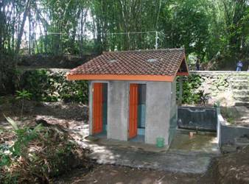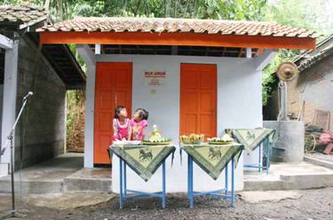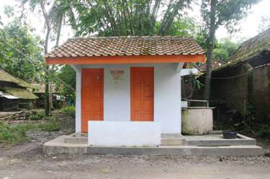
MCK Butuhan MCK Jaten 2 (GPD) MCK Bu Trees (Jaten 1)

In October and December another two MCKs were finished: in Jaten (the second one, thanks to GPD) and a very special one in the adjacent village of Butuhan where we used a natural well by making a reservoir for its water. We left the Bantul region (south of Yogyakarta) and are now exploring Sleman. Mid December we visited some new locations in this region of impoverished small farmers and we are considering building there provided that issues of the suitability of the location and the ownership of the land are solved.

IX Java: Hospital

The Mother and Child project (preventing death at birth) in the Nur Hidayah hospital in Bantul had a delayed start due to government permission, but now fortunately it is successful!

3. Social media (You tube – LinkedIn - Facebook)
Those of you with LinkedIn accounts can add us to their network: we opened a LinkedIn group under the name of ‘Stichting Gotong Royong Utrecht’. We are also considering opening a Facebook account.
Project videos can be found at our You tube page http://www.youtube.com/user/GotongRoyongUtrecht:
- Widhya Asih children’s home; with thanks to Anne from Alkmaar!
- the nursery in Yogyakarta
- Ibu Suresemi (a Parkinson patient receiving our support)
The Jakarta Post article can still be found at our website: http://gotong-royong-utrecht.nl/userimages/jakarta_post_oct12_2009.pdf

4. Sponsor visits !!!

It was busy at the children’s home: several people unknown to us came to visit. They tracked down the home via the Internet and went to it directly, therefore we were unable to meet them. Many of them stayed overnight. Our sponsor Arris visited us in Java, he was inspired by the projects (to be continued).

5. Sponsor possibilities

If you decide to support the initiatives of Gotong Royong financially, first think if you want to help any specific project or if you want to leave the spending to us.

Possibilities:
- the scholarship programme: one scholarship is € 60 (primary school) € 95 (junior high school) or € 125 (senior high school) a year and can start any time during the year,
- sponsoring a child of the children’s home for € 12 a month (€ 36 a quarter or € 144 a year) for complete sustenance,
- the support of a senior (60 plus) for € 10 a month (especially for vitamins, minerals and medical care). This is € 30 a quarter or € 120 a year,
- the support of a child in the Roemah Kita nursery for € 10 a month.
- the support of mentally ill patients by paying their monthly medication: € 14 a month

Of course you can also send us a free gift and leave the spending to us.

6. Gifts

Gifts are more than welcome at our bank account in Holland (Fortis): 84.21.36.932 (for the attention of Stichting Gotong Royong - Utrecht). For people who want to donate and who are living outside Holland, please contact us by e-mail so we can find a proper method of transaction for your donation.

7. Tell a friend

Please would you do us a favour and send this newsletter to your family, friends and colleagues or draw their attention to our website: www.gotong-royong-utrecht.nl where this newsletter is published as well (in English and in Dutch)!

8. Email & website

If you want to let us know something, if you have feedback, do you want to ask anything? Send us an email:
info@gotong-royong-utrecht.nl

And have a look at our website, with many photos of our projects:
www.gotong-royong-utrecht.nl

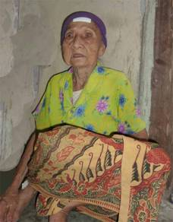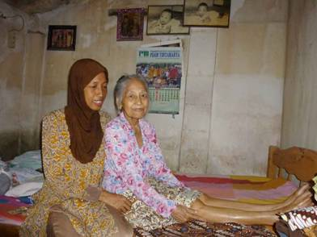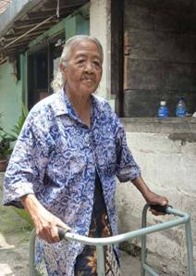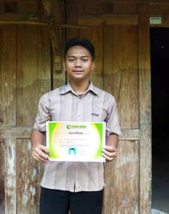
a little while ago we started giving help in the form of supplementary nutrition Agung and his diploma
to these three elderly ladies each week

