newsletter
volume 16 issue 3 september 2017


‘Gotong Royong Utrecht’ Foundation
postal address: oudkerkhof 15 bis, 3512 GH Utrecht, the netherlands
email: info@gotong-royong-utrecht.nl
bank account: NL74ABNA084.21.36.932
reg.number chamber of commerce H30179877

- From the board

For the first time since Wil’s passing away we visited Indonesia in August/September. The March visit was cancelled because Cees was needed in the Netherlands to support Wil. Thanks to Whatsapp, which is widely adopted in Indonesia because many people now have access to Wi-Fi hotspots, we kept in close contact with the project representatives in Bali and with the board members and volunteers of Sejahtera Mulia, our sister organization on Java under the inspiring leadership of Ibu Murdjati Gardjito. Upon our return we found the work had been done as desired and there had been no abnormalities. Of course this is not surprising, but it was a pleasant confirmation. It was good to be among the people of the projects again. Once again we were encouraged to focus on contributing to the development of young people and the well-being of seniors.
We thank all sponsors who support our projects monthly, quarterly or annually. Extra thanks goes to Boris and Aad. They are representatives of two funds that wish to remain anonymous but are important supporters of our scholarship and senior citizens’ projects. Special thanks also to mr Pok and his family who are very generous, and to Noortje, Regina, Maurice and Truus.

2. Couleur locale Indonesia

Currently there is the threatening situation of the volcano Gunung Agung on Bali. There is an increased risk an eruption will occur. Several tens of thousands of people have been evacuated from the slopes. The children living in the children's home we support in Amlapura have also been evacuated. On September 26 fake messages circulated on social media with images suggesting the eruption is already taking place. Let's hope such a thing will not happen.

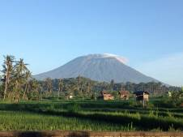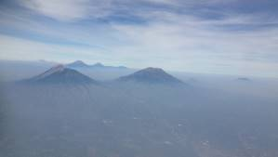
Bali: From a room with a dangerous view Ring of fire, 8 of 130 active volcanos in Indonesia

There is Indonesia from newspapers and magazines and there is Indonesia live: witnessed with your own eyes, ears and feelings. We try to check what we read; we look and inquire. Of course people are talking about topics like "the growing number of Islam fanatics and their influence" and "corruption in many places with the most blatant examples in the Office of Justice and in Parliament." You often hear people say there are more Islamic headscarves than before. This is right, very nice ones too, quite stylish. But is it because of social pressure or is it a sign of religious identity? We cannot tell, but the people we meet are still very friendly, smiling, curious and willing to connect with us.
Whatsapp is also important for poor people, for example for ordering an affordable moped taxi. For this there is a local app (Go-jek) which is very effective and fast and works better than Uber. Modern times are everywhere in this country and it is difficult to imagine sharia will ever fit in. And there is a counter-movement: you now see banners promoting the Panca Sila again. This is the original philosophy developed by Hatta and Soekarno to promote the social and national unification of the country.

3. Project information

I Yogyakarta-Java / Singaraja-Bali: Scholarships

Together with Amaliah, our scholarship coordinator in Yogyakarta and the surrounding areas (including Gunung Kidul), we visited a number of schools to meet children and their parents who receive our scholarships. We were challenged to connect with the children despite the formal attitude they are supposed to take at school during official moments. Of course, we gracefully accepted the thanks we received on behalf of all sponsors. And we were impressed by some mothers who became emotional when they expressed their gratitude and the importance of the scholarships. This is not why we do this work, but still it is very nice to see and hear how valuable our (your!) support is.

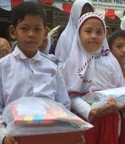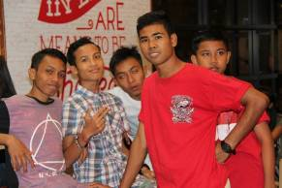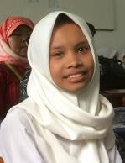

On Bali we support ten students directly (all from Widhya Asih children's home in Singaraja) and we indirectly support all the children in this home and in the home in Amlapura. We are considering converting the indirect support we named the 'food 4 funds programme' into direct school support because this may be more effective.
Once again one of our students has graduated. Kadek Novia got her degree at the Undiksa University, faculty of pedagogy, as an executive teacher. She received the highest possible score for her thesis. She graduated in mid-August and started a job at a school (the CIS, an international school) in Dalung near Denpasar in mid-September. We are very proud of her!

In Yogyakarta we spoke with Sumi who graduated from the Art Academy (dance faculty) last year. She withstood her family's desire to return to Bali and found a job as a dance teacher at the only art school at MSK level (vocational education) in the city. Derli, who graduated in nursing science, is currently working at a clinic in Denpasar at the dental surgery department to broaden her experience.

Surprisingly nice news is that a Gotong Royong alumni club has been founded with the aim of creating a scholarship fund by means of contributions of its members. Sumi is one of the initiators together with Rediasih.

II Yogyakarta: Special Support

Ridwan is a student at the vocational school in Klaten (east of Yogyakarta), he is studying Computer Engineering and is in the second grade now. Although he is a haemophilia patient (which demands permanent attention, care, medicine and caution) he is motivated to go to school. Transport is a big challenge and because there is no public transport near his home, he uses the family moped despite the traffic danger. Ruud of the Van Creveld Clinic of the Utrecht University Hospital asked us to help him.
Maulana is an SMP student (Junior High School) and he is also in the second grade. He lives with his mother and three brothers in a small house along the edge of an irrigation canal in the city. Officially they are not allowed to live there (the land is city property), but it is tolerated, as it is in many places. The father of the family works and lives in Jakarta and comes home once in a while. How much money he brings is a secret: possibly nothing, possibly something. But it is never enough for a decent living. Regina and her daughter Kesuma from the Netherlands have made acquaintance with him and have taken his fate to heart. Recently Kesuma carried out a sponsorship campaign at her school and raised 152 euros! There is now a request to refurbish the cottage a little and to construct a ceiling on top of which a mattress can be laid so two brothers can sleep 'upstairs'.

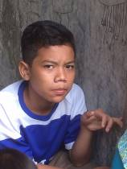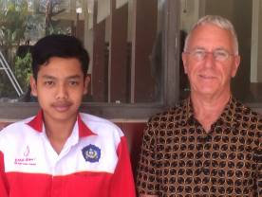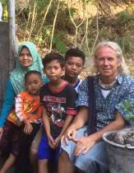
Maulana Ridwan and René Cees Maulana’s family

III Bali: Widhya Asih Singaraja and Amlapura children’s homes

It was a joy to be back at Bali's children's homes again. First we visited the children of Amlapura. This home, where Yudi is the manager, now houses only 16 children. Because of an upcoming renovation which will cause a lot of nuisance, no new children have been admitted since 9 children passed their senior high school exams and left the house. The good atmosphere in the house has not been affected by the smaller population. At the end of our visit we treated them to their first dinner at the new Kentucky Fried Chicken restaurant in Karangasem, which of course was a real treat.
Subsequently, we visited the children's home in Singaraja. It was like coming home. Lots of fun, lots of gratitude and many requests for support ☺. The school bus, which we bought as a good second hand bus in 2008 with support of the Louisa Foundation, is in fact due to be replaced. Above all, it needs new chairs, but it would be better if we could finance an entirely new bus within a maximum of two years. Spread the word! In the meantime, to make some money or to save some, the children produce modern and colourful batiks and work in the garden.

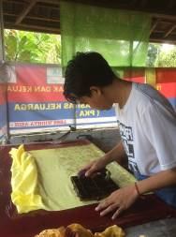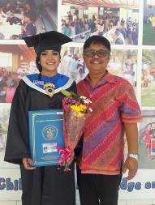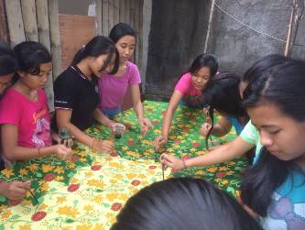
The master stamper Novia and mr Franky The girls of the Batik club

IV Yogyakarta: Seniors’ support

We paid much attention to the seniors’ groups. We made home visits to 13 new candidates for the programme to get an idea of their circumstances. There are participants in the programme who are gravely ill or visually impaired and therefore rarely or never come to the meetings. We visited fifteen of them for the sake of vitamin A (= attention). These were impressive encounters in sometimes compelling circumstances. We attended three monthly meetings and as a special treat we went on an outing with 150 seniors in 5 buses to a leafy place with a large pond. There were gymnastics led by a formidable lady and everyone took part. After this there was singing, dancing and eating. We met with lots of fun and gratitude.

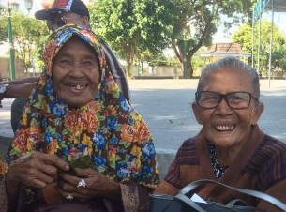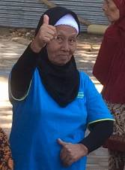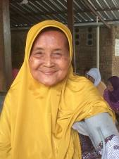

4. Sponsoring possibilities

- the scholarship programme: one scholarship is € 70 (primary school), € 120 (junior high school) or
€ 185 (senior high school) a year and can start any time during the year,
- sponsoring a child of the children’s home for € 12 a month (€ 36 a quarter or € 144 a year) for complete sustenance,
- the support of a senior (60 plus) for € 10 a month (especially for vitamins, minerals and medical care). This is € 30 a quarter or € 120 a year.
Of course you can also send us a free gift and leave the spending to us.

Important news about the scholarships
Due to rising educational costs, children's education is pressing harder on the parents' family budgets. We have never provided scholarships that covered all costs because we believe the parents are also responsible. But we will compensate the rising costs for the parents, and therefore we will increase the scholarships starting from the first semester of the 2017-2018 school year. This has consequences for the sponsorship amounts:
- Primary school (SD): will be 70 euros (previously 60 euros) per scholarship.
- Junior Highschool (SMP): will be 120 euros (previously 100 euros).
- Senior Highschool (SMA) or Vocational Education (SMK): will be 185 euros (previously 165 euros).

5. Gifts

Gifts are more than welcome at our bank account in Holland: NL74ABNA084.21.36.932 (for the attention of Stichting Gotong Royong - Utrecht). For people who want to donate and who are living outside Holland, please contact us by email so that we can find a proper method of transaction for your donation.

