newsletter
volume 15 issue 3 5 october 2016


‘Gotong Royong Utrecht’ Foundation
postal address: oudkerkhof 15 bis, 3512 GH Utrecht, the netherlands
email: info@gotong-royong-utrecht.nl
bank account: NL74ABNA084.21.36.932
reg.number chamber of commerce H30179877

- From the board

In the Netherlands, after a mediocre summer which ended with a stunning finale at the end of September, we are now in cool weather with bright autumn sun and chilly mornings.
It is at this time of changing seasons that board member René returned from his trip to Java, where the weather was also unprecedented: very hot weather with high humidity and lots of rain while it should have been the dry monsoon season. René visited practically all running and recently completed projects. Because we wanted to record his report in this newsletter, this edition is somewhat later than usual.

Good news from two institutional sponsors who have supported us for many years now. Both are foundations which manage money from inheritances. They once again pledged their support for the coming year, which gives us a good starting position, in addition with private donations, to realize our projects. We thank the board members of these foundations. In addition, many warm thanks go to all loyal private sponsors who regularly contribute and have already allowed us to do our work for 15 years now. Special thanks to Frank, who asked his family and friends not to give him presents for his 50th birthday, but to make a donation to Gotong Royong instead. Super!!

Unfortunately there is also sad news. Ibu Murdijati Gardjito, the president of our local partner foundation, although having had surgery on her eyes several times in recent years, has turned blind. It does not prevent her from continuing mentoring several PhD students and writing books with the help of a secretary who guides her 8 hours a day. In her work for the foundation she is assisted by several very experienced volunteers with whom we have been working for many years and who know the ropes.

2. Couleur locale Netherlands-Indonesia

In Indonesia the economy is doing reasonably well, as measured by the increase in the sale of consumer goods and the number of personal loans. The Indonesian treasury profits from the result of the Tax Amnesty Law (a general amnesty for tax evaders who move their savings abroad back to Indonesia).



There is also good news on tourism: 13% more foreign tourists visited Indonesia in August 2016 compared to last year (in particular Australian, French, British, German and Saudi). For the rest Indonesia is not very much in the picture; only historical wrongdoings by the former colonial powers get some press coverage. It is fairly quiet on the surface, but underneath the repression of minorities is significant. The color pink and the rainbow flag in Indonesia are like a red rag to a bull. The LGBT people are having a hard time; they are openly marginalized by politicians in the media. The transvestites at the traffic lights in Yogyakarta, always up for a song, a joke or a smile in the hope of a tip, do not feel safe any more and are disappearing from the scene. Yes, it is going well in Indonesia but beware. It is not for nothing wayang is from Indonesia: things are not always what they seem.

In the Netherlands, the ‘summer of sports’ is finished and we are going back to our daily business. The Western world is preparing for the titanic battle in the US presidential elections. In the Netherlands, people talk about the disgustingly hard campaigns and the nationalistic feelings. This may fill us with wonder, but at the same time the same thing is happening in our own country basically: coarsening, cynicism, lack of nuance, polarization, and blaming others. This atmosphere might affect how our kind of work is being viewed. With our projects we hope to prove that together we can make a difference and thus provide a positive opposing force.

3. Project information

I Yogyakarta-Java / Singaraja-Bali: Scholarships

The first quarter of the 2015-2016 school year finished with tests and exams at all levels. Amaliah, the coordinator of the scholarship programme in Java, provided all children with the necessary items (clothing, footwear, books, et cetera). René and Amaliah visited Maulana Adi and his family. Adi is a special sponsor child who we give care and attention at the request of the Dutch Regina and her daughter Kesuma. He is doing well.

There is good news on Lilu Hutomo from Gunung Kidul (a region in the hills above Yogyakarta). For many years he received a scholarship and in June he successfully graduated from senior high school. After an exciting procedure he was selected for a job for several years in the mining industry in Japan. It is a very popular option because, although he is a cheap employee by Japanese standards, by Indonesian standards he is going to earn a lot of money. The international experience is also considered valuable, but above all it is an excellent opportunity for saving money. He wants to return to Indonesia to invest money in a private restaurant. It is quite a big thing for a kid to leave his Javanese house and family to try his luck in another country. Fortunately for him they also eat a lot of rice in Japan, as for an Indonesian not having eaten rice is the same if not having eaten at all.

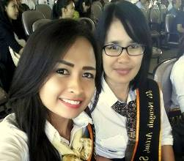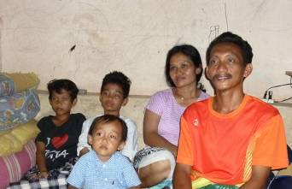
Sudi Master S2 Maulana (second from the left) and his family.

Earlier this year we wrote about our wish to offer scholarships to Ari Muliani and Sujana Asri, two young girls in Singaraja (northern Bali), for university studies. We appealed for funding and although both studies have not completely been financed yet (one has in fact), we decided to give them both the chance to start and we ensured them we will pay their complete studies. Both girls continue to live in the Widya Asih children’s home and in return will act as tutors for the children who are in secondary school.

Luh Sudiyanti (Sudi) not only passed her S2 Master’s exam with honours, she also did well at the International Standard for English test (TOEFL). She is thrilled and we are curious to see what will happen next: foreign countries lure. Her Master’s degree concludes a 9 years’ period of education, thanks to the support of our sponsors Edwin and Lisette (S1) and Frank (S2)!

II. Yogyakarta-Java : community-development

In September René attended the transfer of the completed paved paths and street lighting in Bulus Kulon in Bantul, south of the city of Yogyakarta. We funded the materials to replace the former paths of tamped soil by tiled streets, so that less dust will stir up in the dry season and fewer mud baths will appear in the rainy season. As agreed, the residents built the paths themselves. We also negotiated that they themselves would provide the electricity for the street lighting with a cord from every house to a lamp, so that no problems would arise with monthly payments for a joint account. And so it happened. If you now look at the earth from space at night, you will not only see the lights of the Belgian motorways but also Bulus Kulon: light in the darkness of Javanese sawahs. The evening traffic on the roads in the village is expected to increase significantly now the trails are lit.
The transfer was an official meeting and René obviously could not escape giving a speech on behalf of all of us. Whether his witty remark that "Gotong Royong is expecting a request for traffic lights at the crossroads of paths" was received as a joke, could not be established according to René. As he said: we will wait and see.

III. Bali : Widhya Asih Singaraja and Widhya Asih Amlapura children’s homes

Fortunately there is only positive news on the children's homes. The new kids who arrived in July, do not have to fight to win a place, but are welcomed and included in the group. The other children make room to give them space. The staff members of both houses are all very dedicated young people and they have a very good relationship with the children. Of course there are occasional trifles and finances are short, but nothing is insoluble or of such 'gravity' that emergency measures are necessary. In recent months we covered for medical expenses, mainly hospital admissions for children with dengue or typhoid (caught when visiting family). We also bought Ayu Ludriati her first pair of glasses, which in itself is not special were it not that she started at +6 right away.

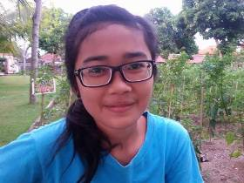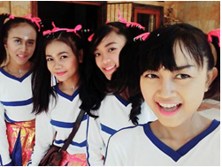
Ayu with glasses Novia (second from right) with fellow students

The eight students are doing well. Most of them, including Novia, are staying at the children’s home. One is living at home again (next to his study he also has to take care of his mother) and one is living in lodgings in Denpasar.

IV Yogyakarta-Java-Bali : Seniors and Medical Support

In September we received a list containing the names of 18 candidates from various areas where we support seniors with food, medical check-ups and medications. René visited all 18 candidates in their respective homes / shelters / slums and together with the two senior coordinators Bu Daryati and Bu Santi assessed the extent to which applications for support were appropriate. In the vast majority of cases seeing the conditions was enough to make a judgment. On some occasions a chat provided the decisive additional information. In a few cases there was a dilemma. For example an old lady with three unmarried sons (33, 35 and 37 years old) all three of whom were unemployed. An obvious response is: "Say, go find work and take care of your mom, why should we help?" Yet sometimes in these situations there are underlying problems which are not easily surfaced. The woman was eventually accepted because we gave priority to her well-being, not so much because of the package of additional nutrition, but mainly because of the monthly medical checkup and the ability to get medication.

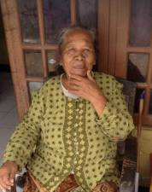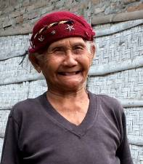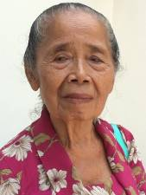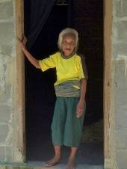

At the end of September there was the previously announced outing for all seniors whom we support. They visited Tamansari (the Water Palace), the Kraton and the Carriages Museum. A full programme with a lot of walking, which for some was a major challenge. But they had great fun and the lunch which was eagerly awaited certainly contributed to the success. For Bu Rus the outing was not strenuous because she was picked up by René and pleasantly surprised she took part in her wheelchair.

4. You tube Gotong Royong Utrecht channel

On our You tube channel http://www.youtube.com/user/GotongRoyongUtrecht you can see several videos:
- Widhya Asih children’s home; thanks to Anne from Alkmaar
- An impression of the location and the operation of a new MCK
- NEW: Sumi’s dance performance
- NEW: an impression of a gamelan lesson at the children’s home and a general overview of the premises

5. Sponsoring possibilities

- the scholarship programme: one scholarship is € 60 (primary school), € 100 (junior high school) or
€ 165 (senior high school) a year and can start any time during the year,
- sponsoring a child of the children’s home for € 12 a month (€ 36 a quarter or € 144 a year) for complete sustenance,
- the support of a senior (60 plus) for € 10 a month (especially for vitamins, minerals and medical care). This is € 30 a quarter or € 120 a year.
Of course you can also send us a free gift and leave the spending to us.

6. Gifts

Gifts are more than welcome at our bank account in Holland: NL74ABNA084.21.36.932 (for the attention of Stichting Gotong Royong - Utrecht). For people who want to donate and who are living outside Holland, please contact us by email so we can find a proper method of transaction for your donation

