newsletter
volume 15 issue 1 31 march 2016


‘Gotong Royong Utrecht’ Foundation
postal address: oudkerkhof 15 bis, 3512 GH Utrecht, the netherlands
email: info@gotong-royong-utrecht.nl
bank account: NL74ABNA084.21.36.932
reg.number chamber of commerce H30179877

- From the board

2016 has started: we have concluded the first quarter and are looking forward to the remaining three quarters of this year with confidence. The mailing at the beginning of the year regarding our scholarship programme was successful: many received it as a welcome reminder to make their contribution. Many thanks on behalf of all the children who benefit!
At the risk of seeming complacent, we can state all projects are successful; we are enthusiastic about both the process and the results of each activity. We thank everyone for the financial and moral support we have received. An additional round of applause for Ton & Saskia, Ria, Loes, Charles & Mariette.

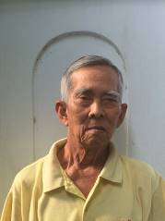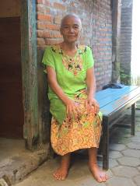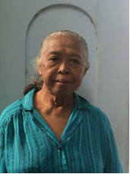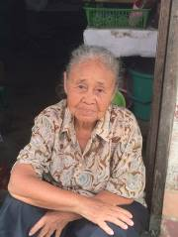
four new ‘members’ of the seniors’ programme

2. Couleur locale Netherlands-Indonesia

The couleur locale in the Netherlands is apparently being determined by increasing polarization. The colours of black and white prevail and shades of grey do not seem to be appreciated any more. You are either 'for' or 'against' and there is no room for subtlety. Cynicism, sarcasm and verbal aggression rule the debate, even and especially in social media like Twitter. In this climate it is difficult to conduct a dialogue on international solidarity and development cooperation.
As for polarization, the Netherlands and Indonesia do not differ. In Indonesia , too, nuance is sometimes tricky and the debate is dominated by repression or the threat of violence from a very small aggressive group. Just like fanatics from the nationalist NVU or populist PVV dominate the debate in the Netherlands, radical Islamists do so in Indonesia. A recent example concerns the acceptance of LGBTs (Lesbians, Gays, Bisexuals and Transgenders). In Indonesia, especially in the Javanese culture, people do not easily express themselves, not so much from fear but because they do not want to make the other 'lose face'. The side effect of this form of courtesy is that change happens slowly and that the motto ‘don’t ask don’t tell’ prevails. It was therefore very surprising when an campaign group of LGBTs spoke openly at universities recently. The reaction was as could be expected: a fierce campaign from the Islamist movement and the activists withdrawing. Incidentally, the country is still suffering from El Niño. Monsoon winds are staying away, the gulf stream has changed its course, there is less rain and temperatures are (even) higher than usual.

3. Project information

I Yogyakarta-Java : MCKs (public bath/washrooms)

Building MCKs has been our ‘core business’ and flagship project since the beginning of our activities in Indonesia. Because of the introduction of small government grants and growing awareness, nowadays more private toilets are being built by families. As a consequence, one of our important project criteria, i.e. the minimum size of the group of MCK users, is not met more often than before. We intend to build public toilets/washrooms for a neighbourhood or district, not private ones for a single or a few families. Hence we build MCKs less frequently now. We are still receiving applications but they do not all meet the criteria.
This month a neighbourhood where we previously built an MCK applied for a second one. Given the composition of the population, it was a good candidate in principle. However, we found the existing MCK was not being maintained properly. We offered to build a second MCK if the population was prepared to repair the first one, but this offer did not meet with a positive response.
In another neighbourhood (Bulus Kulon in Bantul) we had very good contact with the people. Together we renovated the three MCKs we built years ago and we honoured their request for assistance in the construction of paved trails after they accepted our condition: that they themselves would construct simple street lights (a cord from each house to an outside light bulb under a metal roof). In April we will start the same project in another part of ​​the neighbourhood. The request to build a stone bridge (to replace a bamboo bridge) we have suspended for the moment.

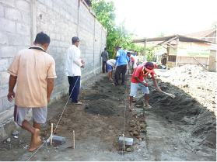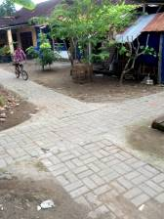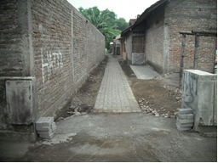
gotong-royong (neighbourship) paved crossroads work in progress

II Yogyakarta-Java / Singaraja-Bali Scholarships

The second semester of the 2015-2016 school year is in full swing; the children who are in their final year (6th grade SD (elementary school), class 9 of the SMP and class 12 of the SMA / SMK) are already fully engaged in preparing for local exams. Nationwide tests will follow in May.
We have already screened a few candidates for the new school year. In Sentolo (where we built an MCK), we spoke with three young people who would like to go to SMP (Junior High School), SMA (Senior High School) and SMK (vocational-technical training). In Bulus Kulon there are two promising children who want to go to vocational school. The government draws a line by not paying for education after the SMP. But in society an SMP degree gets you nowhere. SMA or SMK education is a minimum qualification, but the fees are too high for many poor families. This is where we come in.
On Bali there are three children from the children's home in Singaraja who want to go to college. Two girls wish to attend university (English and Economics) and a third girl (Nyanyi) would like to take a master’s degree in Marketing. It is up to us to find sponsors. Are you willing to support them?

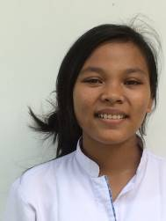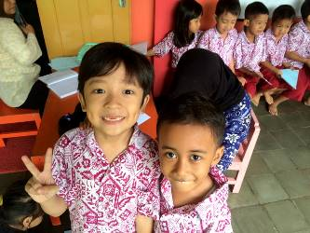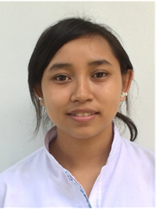
“wants to study Economics” “happy to receive our support” “wants to study English”.

In February, Trifena graduated from Theological College in Yogyakarta. She is now going back to Bali to work as a pastor and religion teacher. Sumi (who graduated from the Art Academy in Yogyakarta, Department of Dance and Choreography in October 2015) is still in Java. She teaches dance in Yogyakarta and is involved in productions at the Academy.

III. Bali : Widhya Asih Singaraja and Widhya Asih Amlapura Children’s homes

In the children's homes in Singaraja and Amlapura we are witnessing the effects of the attention the children are receiving from the staff and from each other: kids are performing better at school, are more relaxed and dare think about their futures.
Dengue fever is still a risk. Last March, there were four children in hospital with severe symptoms (one child even had to go to the ICU). This happened after they had spent a week with their families in the countryside. In cities like Amlapura and Singaraja the local government provides information and sends employees to detect risk areas (mosquito breeding places). Also "foggers" come into the neighbourhood with ‘ghostbuster’-like guns to 'smoke out' the mosquitoes with poisonous steam. In rural areas these measures do not apply and the risk of infection is much higher.
The children's home in Amlapura has received new mattresses for all beds and a covered laundry drying area has been built. We have purchased a new stove and have been given a wish list. The highest priority is ‘krees’ (thin bamboo blinds). The house has also received a 27-years-old fifth-hand car to take the children to school. This means a 70% reduction of transport costs as the children no longer need public transport.

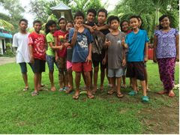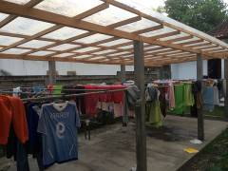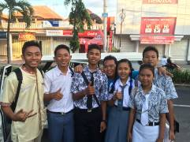
“kids from the block” (Singaraja) laundry drying place Yudi (center) as the driver

IV Yogyakarta-Java-Bali : Seniors and Medical Support

In Yogyakarta one of ‘our’ first seniors has deceased: the blind and bedridden Bu Jati who lived in one of the stables of the Kraton and for whom we organized daily care. She has become over a 100 years old (though possibly this is according to the Javanese calendar, which has fewer days per year than the Gregorian calendar we use).
In the past month, we paid home visits to 14 new candidates for the programme. The visits were all impressive. We selected 10 candidates, based on our assessment that, although personal circumstances (health/house) were very poor, the remaining four still had sufficient family support and resources.
On March 22, another outing was organized for all seniors. With 6 buses we drove to Kemusuk. This is the birthplace of Suharto and there is a new small museum for the military (not the statesman) Suharto. For the seniors, it was wonderful to be out of town in a rural area and to meet in the pendopo (large porch). They sang together, danced and moved their bodies (gymnastics) and of course they ate. It was a feast.

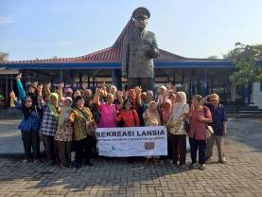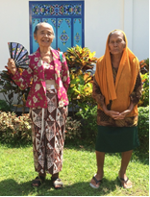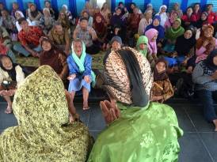
one of the six senior’s groups two participants entertainment by group members

4. You tube Gotong Royong Utrecht channel

On our You tube channel http://www.youtube.com/user/GotongRoyongUtrecht you can see several videos:
- Widhya Asih children’s home; thanks to Anne from Alkmaar
- An impression of the location and the operation of a new MCK
- NEW: Sumi’s dance performance
- NEW: an impression of a gamelan lesson at the children’s home and a general overview of the premises

5. Sponsoring possibilities

- the scholarship programme: one scholarship is € 60 (primary school), € 100 (junior high school) or
€ 165 (senior high school) a year and can start any time during the year,
- sponsoring a child of the children’s home for € 12 a month (€ 36 a quarter or € 144 a year) for complete sustenance,
- the support of a senior (60 plus) for € 10 a month (especially for vitamins, minerals and medical care). This is € 30 a quarter or € 120 a year.
Of course you can also send us a free gift and leave the spending to us.

6. Gifts

Gifts are more than welcome at our bank account in Holland: NL74ABNA084.21.36.932 (for the attention of Stichting Gotong Royong - Utrecht). For people who want to donate and who are living outside Holland, please contact us by email so we can find a proper method of transaction for your donation.

