newsletter
volume 16 issue 2 5 july 2017


‘Gotong Royong Utrecht’ Foundation
postal address: oudkerkhof 15 bis, 3512 GH Utrecht, the netherlands
email: info@gotong-royong-utrecht.nl
bank account: NL74ABNA084.21.36.932
reg.number chamber of commerce H30179877

- From the board

What should have been a festive beginning of our lustrum year was shattered by the passing of our board member and co-founding father Wil Goosen, without whom we would never have achieved all we have accomplished in the past 15 years. For most people his death came unexpected. For family and friends it came faster than expected and hoped. We recollect his pleasure in engaging people to get involved with the foundation; always an ambassador, and a successful one too, until his last months. He was our sparring partner and financial benchmark and for many children in the children's home he was a challenging English teacher. After his death, we received messages from many of them, expressing their gratitude for his support. Many sponsors also sent cards or called us to express their sympathy. We warmly thank them all.


R.I.P.

So, what do you do in such a case of loss? You continue. Merel, René and Cees, the remaining three board members, reallocated the board roles and will carry on, inspired by Wil's drive and focus.

In the meantime, the financial year 2016 has been closed, the financial report has been prepared and the forecast for the coming year has been adjusted. Reservations for ongoing projects have been revised for the coming years and we will meet the ANBI criteria of the Dutch tax authorities again.
2016 was a stable year. We donated more than 51,000 euros to the projects; a little more than the previous year. Revenues fell slightly, but this was mainly because we did not apply for a grant to the organisation which for the past years funded the MCKs: there were no valid project applications for new MCKs. Our overhead costs remained below 5% as usual. All in all it was a successful year.

We thank everyone who supported our projects over the past three months. And we welcome our new sponsors! An extra thank you for (Ma)Ria and Mr Pok (Malaysia) and to Maltie for their big donations. Terima kasih banyak, thank you very much.

2. Couleur locale Indonesia

The projects continued normally in the past months, under the strict management of Ibu Murdijati Gardjito and with the effort of Amaliah who coordinates and administratively supports the execution.
Since mid-May it has been more quiet than usual because of Ramadan (the Islamic one month's fasting). This period was concluded with Idul Fitri on June 25/26, the feast of the breaking of the fast. It is the tradition that after the fasting period you ask all who are near to you (family foremost) and with whom you are socially involved (work, mosque, district) for forgiveness for the things done wrong in the past year. Until mid-July meetings will be held to give you the opportunity to do this, accompanied of course with good food and sweet tea.
Previously, we reported about the governor’s elections in Jakarta. The governor in office had very good chances of being re-elected, but through slanderous campaigns of Islamists (not to be confused with Muslims) and a corrupt and non-independent judicial power, the man’s name was successfully ruined and he was sentenced to prison.

3. Project information

I Yogyakarta-Java / Singaraja-Bali Scholarships

Good news: all children who took their final exams in Yogya passed. Those who graduated from senior high school went to work, we did not receive applications for university studies or higher vocational education. Of those who graduated from primary school or junior high school, there are 18 children who now want to pursue further education: 7 from primary school to junior high school and 11 from junior high school to senior high school. In principle, we will support them. All other children have moved on to the next form. Amaliah has a full schedule visiting all 92 children. First to retrieve and discuss copies of the reports, after that to collect all ‘shopping lists’, purchase the items needed, and distribute them. Fortunately, she still has a couple of weeks left, because even though schools start again on July 17, it is still pelan-pelan (easy does it) in the coming period.

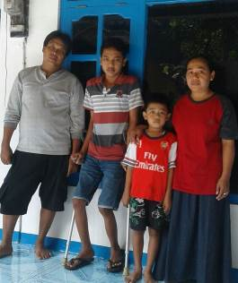
Ridwan with his parents and younger brother

Amaliah has recently made a home visit to Ridwan: a young kid (16 years old) who, apart from haemophilia, also has a good set of brains and a positive attitude and drive. We were brought into contact with him by Ruud of the Dutch UMC Van Creveld Clinic. Ridwan is in the second year of vocational education where he is studying IT. We have investigated whether his living and home situation meet our criteria to support him with a scholarship. The answer was yes.

The children of the two children's homes in Bali (Widhya Asih Singaraja and Widhya Asih Amlapura) are also doing well. From Singaraja we received the request for scholarships for Komang Mas Suniati and Diana Astuti, two girls who passed senior high school and according to the staff of the home are smart and motivated for a university study (both want to study Economics). We have promised to support them with study fees, travel money and pocket money.
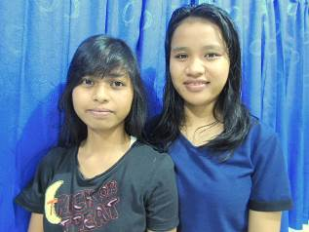
Komang Mas Suniati en Diana Astuti

Important news about the scholarships
Due to rising educational costs, children's education is pressing harder on the parents' family budgets. We have never provided scholarships that covered all costs because we believe the parents are also responsible. But we will compensate the rising costs for the parents, and therefore we will increase the scholarships starting from the first semester of the 2017-2018 school year. This has consequences for the sponsorship amounts:
- Primary school (SD): will be 70 euros (previously 60 euros) per scholarship.
- Junior Highschool (SMP): will be 120 euros (previously 100 euros).
- Senior Highschool (SMA) or Vocational Education (SMK): will be 185 euros (previously 165 euros).

II Bali : Widhya Asih children’s homes in Singaraja and Amlapura

The children did very well last school year. They all passed to the next form and all of the children who took their final exams graduated.
Nyanyi, the bookkeeper of the children's home, who graduated from university last year (Economics and Marketing), has been admitted to a Master's degree programme in Denpasar. Another young woman, Sudi, who preceded her and got her Master’s degree last year, now works in Australia, where she is successful. With her earnings she supports her closest family in Bali (grandma, blind father and younger brother). Last June she returned for a holiday and witnessed the building of the house for her family (pictures below). She also pays the language project in her village with her Australian dollars.

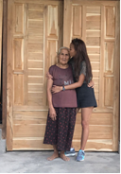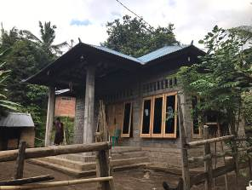
As you may know, the children at the children’s home produce batik which is commissioned or sold through Bali stores. A few months ago we received a request for new batik stamps. They would like to have their own creative motives in stamp form. We financed it and we show you the results below:

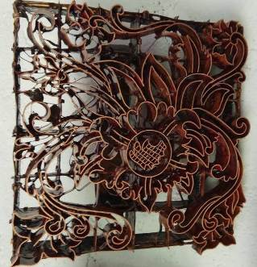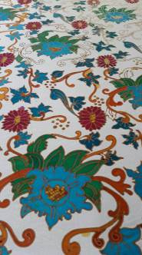
one of the new stamps the prints made with it

III Yogyakarta : Seniors’ support

The seniors’ programme is in full swing: over 200 senior citizens receive support, a small group weekly and a larger group monthly. Extra care and attention in between meetings is organized by the community volunteers. The medical program with monthly check-ups and medication is highly appreciated and effective: especially the part that focuses on high blood pressure and diabetes.

4. You tube Gotong Royong Utrecht channel

On our You tube channel http://www.youtube.com/user/GotongRoyongUtrecht you can see several videos:
- Widhya Asih children’s home; thanks to Anne from Alkmaar
- An impression of the location and the operation of a new MCK
- NEW: Sumi’s dance performance
- NEW: an impression of a gamelan lesson at the children’s home and a general overview of the premises

5. Sponsoring possibilities

- the scholarship programme: one scholarship is € 70 (primary school), € 120 (junior high school) or
€ 185 (senior high school) a year and can start any time during the year,
- sponsoring a child of the children’s home for € 12 a month (€ 36 a quarter or € 144 a year) for complete sustenance,
- the support of a senior (60 plus) for € 10 a month (especially for vitamins, minerals and medical care). This is € 30 a quarter or € 120 a year.
Of course you can also send us a free gift and leave the spending to us.

6. Gifts

Gifts are more than welcome at our bank account in Holland: NL74ABNA084.21.36.932 (for the attention of Stichting Gotong Royong - Utrecht). For people who want to donate and who are living outside Holland, please contact us by email so that we can find a proper method of transaction for your donation.

