newsletter
volume 15 issue 2 5 july 2016


‘Gotong Royong Utrecht’ Foundation
postal address: oudkerkhof 15 bis, 3512 GH Utrecht, the netherlands
email: info@gotong-royong-utrecht.nl
bank account: NL74ABNA084.21.36.932
reg.number chamber of commerce H30179877

- From the board

It looks like the summer break started early this year: it is very quiet, both in the Netherlands and in Indonesia; there is not much that requires extra attention. In Indonesia, the children have their holidays and for the Muslims it was Ramadan. We expect this year’s ongoing projects will be financially covered, so no worries about that. In response to our call last quarter to the readers of this newsletter, about sponsoring three girls who have academic dreams, we already received a donation for the entire study of one of them (thanks to our sponsor from Kuala Lumpur). Because we trust that we will eventually generate enough support, the other two girls may also begin their studies and we guarantee that we will fund their entire study. One of the reasons we are so confident about this, is that another sponsor (Jacques) who supported the entire study of Derli in Yogyakarta (Nursing at university level), after her graduation has extended his support for at least one more year (many thanks!). We will use this support for the other students. However, the call remains: who wants to support a university education for one of our selected potentials? Please let us know if you are interested.
This quarter, we especially like to mention Ria, Pok, Theo, René and Pim and thank them for their continued and more than average donations!!

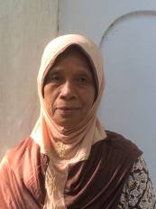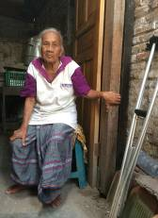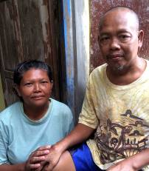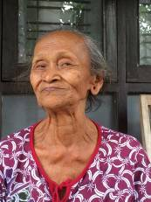
Four participants of the senior’s programme

2. Couleur locale Indonesia

Last month it was Ramadan for Muslims around the world and this is not an easy job. In Indonesia it was extra hard because of the heat (thirst), whereas in the Netherlands the short nights of the summer season required much perseverance (more hours of fasting). In the aftermath of the Sugar Feast (Idul Fitri) in Indonesia people organise meetings to show each other respect (halal bi halal) and ask / give forgiveness for mistakes made. Because of Ramadan and Idul Fitri the activities in the Javanese projects were somewhat reduced in recent months, but that is not a problem.

3. Project information

I. Yogyakarta-Java : community development

Over the last few years we have been successful in building MCKs (public wash / shower / toilet houses, of which we built more than 100). We are now focusing on other activities that add value in small local communities. During the period of reconstruction after the big 2006 earthquake, we gained experience in improving drainage (through canals and gutters) and increasing accessibility to the villages (by means of paving and lighting). Now we use this experience in a few neighbourhoods that are familiar to us because we built MCKs there. We experienced for instance that home-made paving stones in the longer term are not cheaper because the composition of the stones (ratio of sand, water and cement) varies due to "economic use" of the most expensive material: the cement. As a result the bricks wear down faster (they crumble or break) and need to be replaced sooner. Therefore we now provide the bricks the residents can use to pave the streets, under the condition that they themselves take care of the lighting. If necessary we contribute to the costs of the materials. This depends on the situation: sometimes collective money has already been used for other community affairs. Then we assist.
Late June a paving and lighting project was finished in a second village in Bulus Kulon in Bantul.

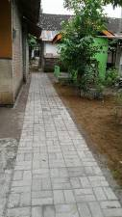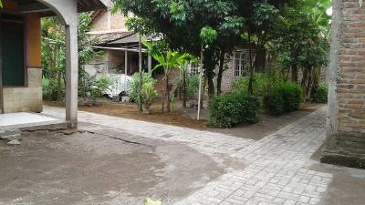
new streetscape

II Yogyakarta-Java / Singaraja-Bali: Scholarships

For some time now we are having closer contact with a Dutch sponsor who has a special relationship with Indonesia and specifically with Yogyakarta. Regina and her daughter Kesuma have a mission that is consistent with ours. In order to avoid the pitfalls in development aid they contacted us and now we 'guide' them at a distance. They wanted to support a child (and his family) in Yogyakarta in order to ensure he gets a good basic education and thus will be able to find his way in life. Our coordinator Amaliah nominated Adi Maulana, whom she knows from our scholarship programme. In March we visited him, his parents and his three brothers. Last May Regina and Kesuma travelled to Yogyakarta to get acquainted with the family and this is probably the beginning of a long mutual contact. At their request we will monitor the process and learn from it.

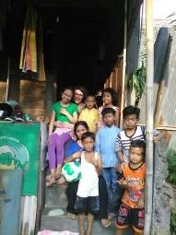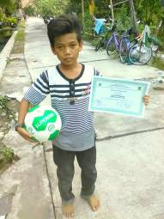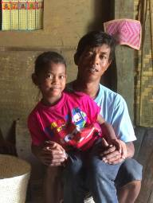
Kesuma, Regina, Maulana and family. Maulana with Dutch footbal Girl from Sentolo with her father

In Bali we officially support only a few (nine) university students who all do very well. Because the children's home (not an orphanage!) Widhya Asih in Singaraja has problems finding a large sponsor, we help them by paying part of the food budget, under the condition that the money thereby saved is spent on school fees. This method is successful: the schools cooperate and it is completely transparent. But in time it will have to stop. Considerable savings were made because the number of children in the home was reduced from more than 100 to less than 70 by natural course.

We also indirectly help Yudi, the head of a small children’s home in Amlapura, with school fees for 'his' children. He started there last year and has been busy clearing and building. He is also looking for foreign sponsors.
And last but not least: at the end of September Luh Sudianto (Sudi) will receive her Master's degree and the title of M. M. (Magister Management). She has a very high average score and could very well graduate more than Cum Laude. At present she is studying for her TOEFL exam (Test for English as a Foreign Language), an internationally recognized certificate. Super!

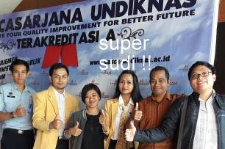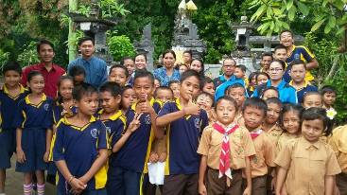
Sudi with her professor and fellow graduates English lessons given by Sudi in her native village

III. Bali : Widhya Asih Singaraja and Widhya Asih Amlapura children’s homes

We have 'old bonds' with these two homes (15 years), but apart from the covert support for education mentioned above, we remain at a distance and only act in emergencies. These often involve medical issues: hospitalization and medications. We also supported when the school bus needed new tires.
During our last visit to Yudi in Amlapura we observed that the heat in the auditorium and the bedrooms is tiring and at times unbearable. Therefore we ordered 'krees (blinds made of bamboo strips) to exclude direct sunlight.

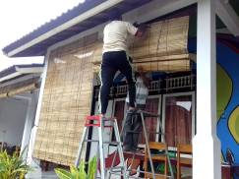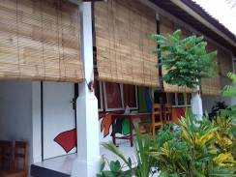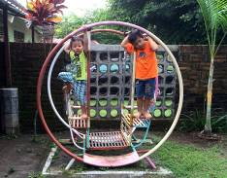
the new blinds in Amlapura children’s home our youngest participants

IV Yogyakarta-Java-Bali : Seniors and Medical Support

We continue our weekly / monthly support to seniors in the form of supplementary food, medical check-ups and medicines. The positive effects of the check-ups and medicines show, especially with those suffering from diabetes and high blood pressure. A lot of high "scores" have fallen and are now under control thanks to the dedication of the volunteers and the medication that was made available.
In May we donated a walker to one of the seniors allowing her to be mobile and stable again. Also the wheelchair of Bu Rus was repaired: the hard-plastic core of the front wheels has been replaced by more solid material. All this was made possible by courtesy of the sponsors who support our senior’s programme. We thank them all.
After the successful outing in March, the wish was expressed to have another outing this year. In September it will take place: a visit to the Kraton, Taman Sari and the Carriages Museum; thanks to René.

4. You tube Gotong Royong Utrecht channel

On our You tube channel http://www.youtube.com/user/GotongRoyongUtrecht you can see several videos:
- Widhya Asih children’s home; thanks to Anne from Alkmaar
- An impression of the location and the operation of a new MCK
- NEW: Sumi’s dance performance
- NEW: an impression of a gamelan lesson at the children’s home and a general overview of the premises

5. Sponsoring possibilities

- the scholarship programme: one scholarship is € 60 (primary school), € 100 (junior high school) or
€ 165 (senior high school) a year and can start any time during the year,
- sponsoring a child of the children’s home for € 12 a month (€ 36 a quarter or € 144 a year) for complete sustenance,
- the support of a senior (60 plus) for € 10 a month (especially for vitamins, minerals and medical care). This is € 30 a quarter or € 120 a year.
Of course you can also send us a free gift and leave the spending to us.

6. Gifts

Gifts are more than welcome at our bank account in Holland: NL74ABNA084.21.36.932 (for the attention of Stichting Gotong Royong - Utrecht). For people who want to donate and who are living outside Holland, please contact us by email so we can find a proper method of transaction for your donation

