newsletter
volume 14 issue 4 30 december 2015


‘Gotong Royong Utrecht’ Foundation
postal address: oudkerkhof 15 bis, 3512 GH Utrecht, the netherlands
email: info@gotong-royong-utrecht.nl
bank account: NL74ABNA084.21.36.932
reg.number chamber of commerce H30179877

- From the board

On behalf of the Gotong Royong Utrecht foundation, Merel, René, Wil and Cees wish you a healthy and peaceful new year with happy moments and surprising encounters which will touch you in the heart.



The last quarter went well. Without anticipating on the outcome of our annual Report, we can inform you that in addition to the stable support by private persons, over the last months we have received several large donations from organizations. Our Malaysian sponsor supported us again, and several funds and foundations were willing to grant us considerable support both for the seniors’ and the scholarship programmes. Special thanks to Aad, Boris, Frank, Mr. Pok, Ronald and Illa.

2. Couleur locale Netherlands-Indonesia

The fact that in December in the Netherlands we are “enjoying” an early spring, with budding daffodils and birds doubting whether or not to start building their nests, of course has nothing to do with global warming. It is just "the weather". The weather is simply unpredictable and adds a touch of surprise and excitement to life. Global warming for most Dutch people is far removed from their personal lives. The dikes are standing firm and a little more warmth is not unpleasant.
In Indonesia, the effects of global warming are already more tangible and problematic. Over there a few degrees’ rise in temperature is a disaster. It was already warm; more warmth brings even more evaporation, more drought and dehydration, a delayed monsoon, declining groundwater and wells running dry. Just think of the implications for irrigation of the fields and agricultural yields. The rising sea level also has direct consequences: there are no dunes or dikes, direct inflow of the water causes erosion and entire islands disappear.

As in Europe, people in Indonesia (especially in Jakarta and Bali) are aware of the terrorist threat and security services are trying to arrest potential offenders before they can strike. In recent weeks,
several attacks were foiled because of the arrest of nine militants. As in Europe, IS-combatants returning to Indonesia and IS sympathizers are closely followed: the government has appointed 88 anti-terror teams to monitor them. The options of revoking passports and citizenship are being investigated.

3. Project information

I Yogyakarta-Java : MCKs (public bath/washrooms)

In the October issue of this newsletter, we announced the building of a new MCK in Sengolo (outside Yogya, past the bridge over the Progo river). This MCK is now finished and has been handed over to the population (see photos). Last month, we conducted a survey in the vicinity of this MCK and we found there were several other places in need of an MCK. These are now being investigated, verified and discussed with the local population.

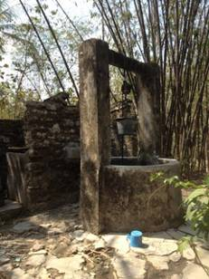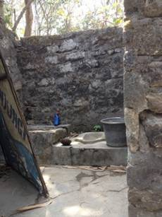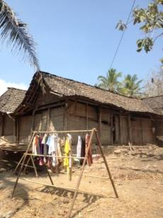
before before, detail surroundings
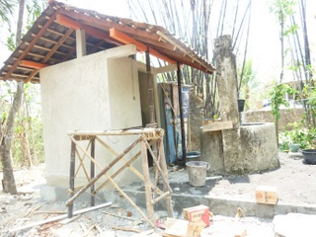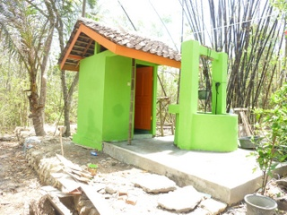
work in progress the new MCK

II Yogyakarta-Java / Singaraja-Bali Scholarships

The children in our scholarship programme are doing fine, we received good reports. In Yogyakarta, we will grant scholarships to four new children by January 2016. Their situation required immediate action, waiting for the new school year was no option and we were happy to have enough financial resources to admit them halfway.
Derli, who studied Nursing at University in Yogyakarta, graduated in November and has returned to her homeland in Bali where she is applying for jobs at various hospitals in Denpasar. She wisely declined the offer to work in Norway (a Norwegian recruitment agency was active in her faculty) after hearing stories about the cold, the poor daylight in winter and the food. Trifena (Theology) is working on her thesis and will graduate in February. Sumi (Marketing master’s course in Denpasar) ended her second semester with very good results. The others (Pande, Nyanyi, Redi, Novia, Ayu and Lina) are still waiting for the results of their semester exams. If you are interested in (co-)funding a university student, please contact us! Already there are new candidates for the 2016-2017 school year, including a request for a master’s study.

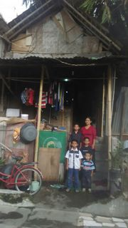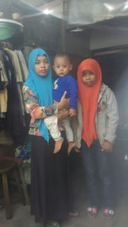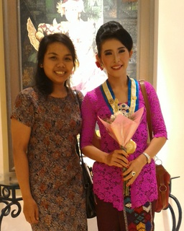
New scholarship participant New scholarship participant Trifena and Derli
(left of mother) (on the right)

III Bali: Widhya Asih III and Widhya Asih VII children’s homes

Things are excellent in both children’s homes, although a few children were ill with dengue fever and typhoid. They stayed in hospital for a few days and happily returned fully cured. The costs were paid by us. The only thing the staff still has not yet succeeded in is finding a sponsor for the costs of education. Through our "Food-4-Funds" initiative we are now temporarily sponsoring educational costs indirectly: because we are paying certain food expenses, they are able to save 300 euros per month from their food budget to pay the semi-annual school fees.
In November we purchased plates, mugs, bowls and cutlery for WA VII in Amlapura, Karangasem (East Bali). And in December we provided thirty durable wooden chairs (teak) for the common room where the children eat and study, to replace the broken plastic chairs which were there before.

IV Yogyakarta-Java-Bali : Seniors and medical support

The situation is one of mixed feelings: we are very enthusiastic about the way the seniors’ programme is going, but we are sorry to say that in the past six months 20 participants have passed away. This is sad both for the volunteers and for us. All of a sudden, people for whom you have organized care and attention for years, do not appear at a meeting. On inquiry, it turns out they have departed this life. In March, we will conduct home visits to select the candidates who may join instead of those who have deceased.
In the Panembahan district (south of the Kraton) we started a small new group after visiting and screening all candidates at their homes. We are very pleased with the way the senior’s programme (six groups now) is run by the two coordinators led by Ibu Murdijati. The number of volunteers per district has been expanded (four per group now), guaranteeing continuity in care and attention.

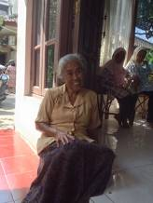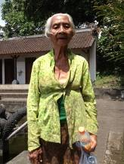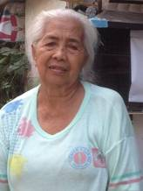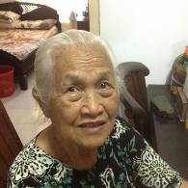

4. You tube Gotong Royong Utrecht channel

On our You tube channel http://www.youtube.com/user/GotongRoyongUtrecht you can see several videos:
- Widhya Asih children’s home; thanks to Anne from Alkmaar
- An impression of the location and the operation of a new MCK
- NEW: Sumi’s dance performance
- NEW: an impression of a gamelan lesson at the children’s home and a general overview of the premises

5. Sponsoring possibilities

- the scholarship programme: one scholarship is € 60 (primary school), € 100 (junior high school) or
€ 165 (senior high school) a year and can start any time during the year,
- sponsoring a child of the children’s home for € 12 a month (€ 36 a quarter or € 144 a year) for complete sustenance,
- the support of a senior (60 plus) for € 10 a month (especially for vitamins, minerals and medical care). This is € 30 a quarter or € 120 a year.
Of course you can also send us a free gift and leave the spending to us.

6. Gifts

Gifts are more than welcome at our bank account in Holland: NL74ABNA084.21.36.932 (for the attention of Stichting Gotong Royong - Utrecht). For people who want to donate and who are living outside Holland, please contact us by email so we can find a proper method of transaction for your donation.

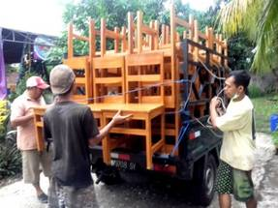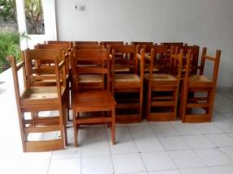
Delivery of chairs to WA VII

