newsletter
volume 16 issue 1 april 2017


‘Gotong Royong Utrecht’ Foundation
postal address: oudkerkhof 15 bis, 3512 GH Utrecht, the netherlands
email: info@gotong-royong-utrecht.nl
bank account: NL74ABNA084.21.36.932
reg.number chamber of commerce H30179877

- From the board


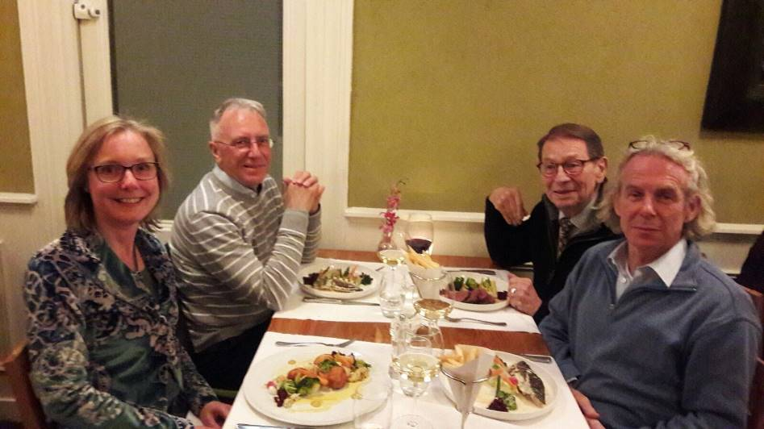

Years of
Gotong Royong

The board enjoying dinner while looking back and looking forward

Our fifteenth anniversary. One may of course ask: is this something to celebrate? A good question. What does this anniversary mean? Perhaps that we have the ability to persevere. Or that we have been successful in collecting the resources needed to carry out the activities we considered necessary. But isn’t it a shame that we are still needed? Or in any case, that this idea is still confirmed by the signals we receive?

Of course, we are very happy that there have been so many sponsors all these years for whom we can be intermediaries; and glad that we have made the lives of a large number of people a bit more bearable and have provided them with better prospects. But whether this is our merit is questionable. Sometimes it feels like we need to do little more than just be alert and grasp the opportunity. We have had a lot of luck and grace and have found support in the people who surround us and who "happened" to cross our path, both in Indonesia and elsewhere. Mrs Gardjito Murdijati, Amaliah and Mrs Suhendro Rediyowati are fantastic people: critical, pragmatic, loyal and very involved. Without them and all the other dedicated volunteers of the Sejahtera Mulia group there would be no Gotong Royong Utrecht Foundation.

We are aware that our work is merely a drop in the ocean. It might even not always be sustainable or aimed at providing structural solutions. But one thing is certain: the drops that keep falling will make enough waves to spread the message that there are people who are less fortunate in life. Who cannot ‘Skype’ with the grandchildren or check their facebook pages. Who cannot take a vacation or time off to ‘chill’. We call upon you to spread our drops to the people around you and make them aware that with small contributions they can do a lot for others – and thereby also for themselves. Because as long as our help is needed, we will gladly continue for another 15 years!

We thank all the sponsors who donated generously in the past three months. An EXTRA thank you for Leo, Antoinette, Ine & Piet, Ltd Pok (Malaysia) and a sponsor who celebrated his 80th birthday with a very large donation. Terima kasih banyak, thank you very much.

2. ‘Couleur locale’ Indonesia

There is not much news, except for the man in Sulawesi who was swallowed by a big python (including his shorts and boots). Neither of them survived the adventure. Furthermore, the heavy rain causes problems. Both in Bali (at least in Denpasar) and in central Java, farmers suffer. Now farmers around the world always have a frustrated relationship with nature and certainly with the weather: it's too dry, too wet, too hot, too cold, there is too much wind, too little wind. But this year, conditions are definitely very bad.

The first round of the elections for the function of Governor of Jakarta was won by Ahok. He is the man who was accused of blasphemy by the Islamists (see our previous newsletter). He received 43% of the votes. There is a second round in April between Ahok and the candidate who finished second. But first Mr. Ahok (who is the current Governor) will have to undergo the court trial. Sometimes life is a wajang puppet play.

3. Project information

I Yogyakarta-Java / Singaraja-Bali Scholarships

Amaliah visited all 92 children in Yogyakarta again at their schools and in their neighborhoods to ensure they all received what they need for school fees, school supplies and clothes.

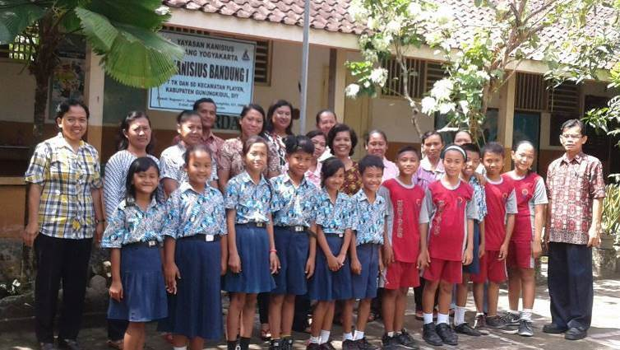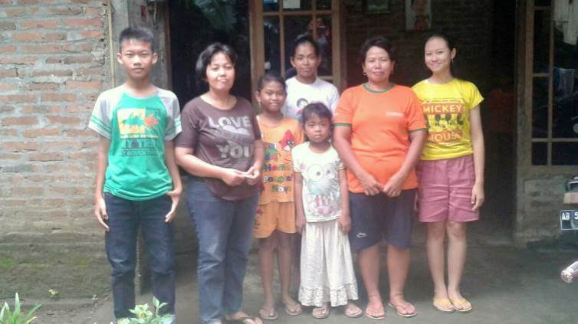
Team & children of SD Kanisius in Gunung Kidul 4 children and their mothers in Karung Semut near Bantul
Next month, all children who are in their final year (primary school, junior high school and senior high school) will do their final exams. The exam fees must be paid and these are getting higher. We are therefore considering raising our support because our current scholarships are no longer adequate. Initially, the scholarships were not meant to cover all costs, because we believed parents also have a responsibility. But according to our local volunteers and the coordinator, the costs parents have to pay are significantly higher than a few years ago, despite state support to primary and lower secondary school. And because we have not raised the scholarships for the past couple of years, an increase is inevitable now, possibly by July 2017. This will significantly increase the required budget. We will take the challenge, hopefully with your support.In the previous newsletter we wrote about Ridwan, a haemophilia patient from Klaten near Yogyakarta. Because we had to cancel our trip to Indonesia in February, we were unable to visit him to see whether his circumstances meet our criteria for a scholarship. Instead, Amaliah will visit him shortly.

II Bali : Widhya Asih Singaraja and Amlapura children’s homes

In the children's home in Amlapura, a Dutch volunteer (Nienke) taught English lessons to the children in recent months, especially those who have to take their final exams. Many thanks for her commitment.

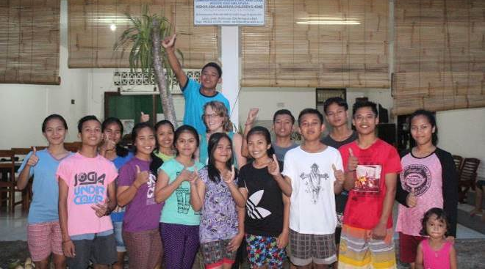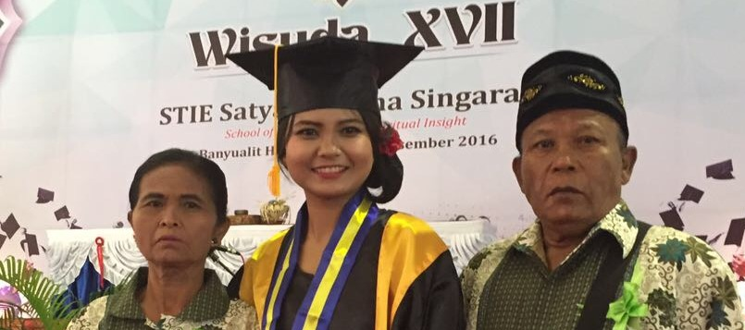
Nienke and her pupils Nyanyi and her parents

From the children's home in Singaraja (Widhya Asih 3) we also receive good news, apart from the structural shortage of money, that is.
The home might lose its valuable staff member Nyanyi. Officially, she is the bookkeeper but actually she runs the home together with Frankie, the official head. If she is admitted to the Master's programme in Marketing at Denpasar (Southern Bali), she will have to move there. We promised to seek sponsors for her study costs and in Frank we have already found the financier for the first year. The Widhya Asih organization will help her pay for the costs of housing and living in Denpasar.

From the group of 11 children who will take their final exams at Senior High School this year and who want to continue their studies, the staff selected two girls as candidates for sponsorship. Komang Mas we have known for over ten years. At primary school she was the best of class. She is a go-getter. She is from a family of five children, who have received care from us for years. They lived in a cabin in the midst of the ruins of the old Dutch cinema in Singaraja. When her elder sister (who passed senior high school) and her father (a garbage collector) passed away, we did our best to provide a place in the children’s home for some of the other children because the mother was not strong enough to care for them. In the end it was only Komang Mas who took the step, now six years ago. Her younger brother was already "fought free", her eldest brother disappeared without a trace and her youngest sister was still too young to be without a mother. Komang Mas enjoys life at the children's home. She has performed well over the years and she now wants to study Accountancy. In the children's home she takes a leading role in the production of batik.
Diana Astuti is from an economically weak gardener’s family. She has lived in the children's home since she was ten years old. She wants to study Economics and in the future she hopes to be working for a bank.
Two gifted girls who deserve to study!

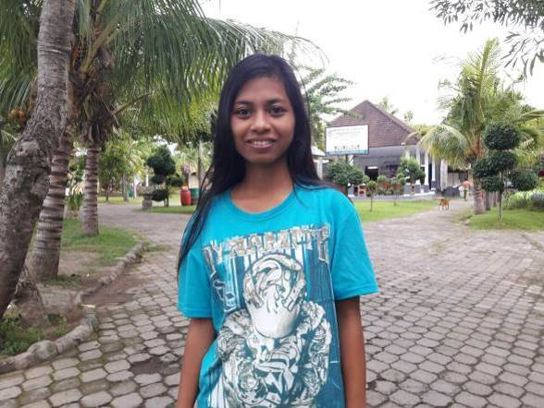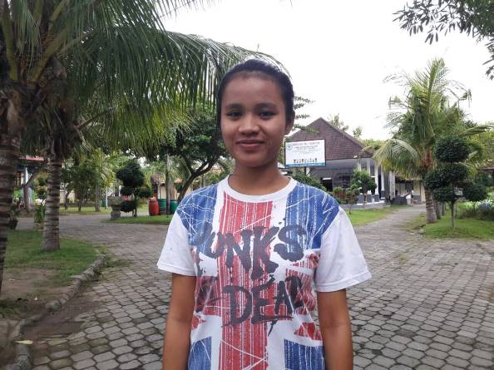
Komang Mas Diana Astuti

III Yogya : Senior’s support

The seniors’ support programme is in full swing. Over 200 senior citizens receive support, a small group weekly and a larger group monthly. Extra care and attention between meetings is organized by the local volunteers. The medical programme with monthly check-ups and medication is highly appreciated and effective: specifically the care which focuses on high blood pressure and diabetes.

4. Sponsor news

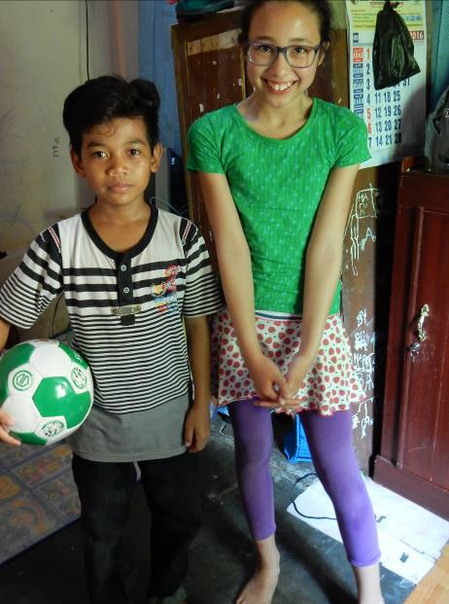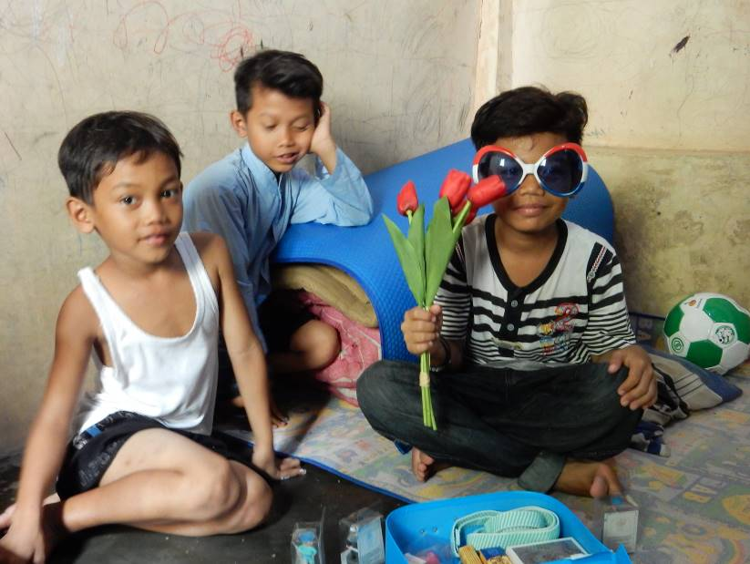

The picture on the left features Maulana and Kesuma (right). Kesuma visited Maulana with her mother. Back in the Netherlands, she wrote a paper about Indonesia in general, about Yogyakarta in particular and of course also specifically about Maulana, his family, their circumstances and their encounter. This was a true act of promotion for our joint efforts. Many thanks to Kesuma.

5. You tube Gotong Royong Utrecht channel

On our You tube channel http://www.youtube.com/user/GotongRoyongUtrecht you can see several videos:
- Widhya Asih children’s home; thanks to Anne from Alkmaar
- An impression of the location and the operation of a new MCK
- NEW: Sumi’s dance performance
- NEW: an impression of a gamelan lesson at the children’s home and a general overview of the premises

6. Sponsoring possibilities

- the scholarship programme: one scholarship is € 60 (primary school), € 100 (junior high school) or
€ 165 (senior high school) a year and can start any time during the year,
- sponsoring a child of the children’s home for € 12 a month (€ 36 a quarter or € 144 a year) for complete sustenance,
- the support of a senior (60 plus) for € 10 a month (especially for vitamins, minerals and medical care). This is € 30 a quarter or € 120 a year.
Of course you can also send us a free gift and leave the spending to us.

7. Gifts

Gifts are more than welcome at our bank account in Holland: NL74ABNA084.21.36.932 (for the attention of Stichting Gotong Royong - Utrecht). For people who want to donate and who are living outside Holland, please contact us by email so that we can find a proper method of transaction for your donation

