newsletter
volume 13 issue 3 10 october 2014


‘Gotong Royong Utrecht’ Foundation
postal address: oudkerkhof 15 bis, 3512 GH Utrecht, the netherlands
email: info@gotong-royong-utrecht.nl
bank account: NL74ABNA084.21.36.932
reg.number chamber of commerce H30179877

- From the board

Welcome back! For most of us it is ‘business as usual’ after a nice long summer and hopefully happy holidays. The children went back to school or stretched their wings to their university cities, work started and at home the usual routines were taken up again. We wish you good luck in focussing on the things that require your attention.
Focus is also the key word for the Gotong Royong foundation: focussing on running projects, monitoring developments and investigating possible projects in a critical way. Fortunately we are not alone; our local volunteers and sponsors keep us on the ball by listening, asking questions and providing feedback.
All students we support are doing well and the two candidates for follow-up studies (Pande and Lina) started their studies! The seniors’ projects meet our expectations (not in the least thanks to Bu Santi and Bu Daryati helping us in Yogyakarta). The MCK project demands our attention because of social developments that need to be taken into account. More on that later in this newsletter (III.1 MCKs).
Finally we would like to mention our large and small sponsors here. Thank you very much for your
involvement and support. Special thanks to Noortje, Ed and Lisette

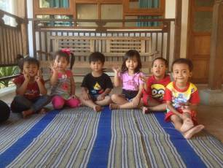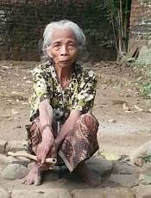
The youngest pupils at Rumah Kita nursery A member of our seniors’ group

2. Couleur locale Indonesia

The elections are over. The battle was tough and expensive. There was much slander and a lot of money was used to buy votes. Even at the polling stations there were people present to hand out envelopes. Ultimately it turned out to be a big victory for the 'modernist' Jokowi. He demonstrated the old forces (the Suharto clan) can be beaten. Of course, the victory was challenged by the opponent, the former officer Prabowo: he blamed the winner for engaging money-politics. This is funny, considering it was his party which handed out money to vote for him.
The KPK (anti-corruption brigade) caught some big fish in the group surrounding the former president SBY ánd had them sentenced.
Of course, global developments regarding IS-terror call forth many reactions here in predominantly Muslim Indonesia. While in the Netherlands Muslim groups do not clearly express themselves on the issue, there is evident opposition in Indonesia (also in the mosques) with regard to everything that has to do with IS.

3. Project information

I Yogyakarta-Java : MCKs (public bath/washrooms)

Although we have the financial means (including gifts from Impulsis and a Rotterdam healthcare fund), not many MCKs were built this year. The reason is twofold. The first reason was the elections for the representatives of the people, and after these the presidential elections. For six months this had an impact on finding suitable, reliable locations. We did not want to be used for the political ambitions of local people, so we did not give them the opportunity. The construction of an MCK could be used by them: "I arranged this for you (or I will arrange one for you), now you are morally obliged to support my party in the elections." Attempts were there, we smelled the scent of bribery, and we pulled back in time.
This election effect is over now. But there is a second reason, which may have more effect in the longer term. In 2014 a regional subsidy was launched for building private toilets. Individuals could qualify to receive 4 million rupiahs (260 euros) to build a toilet. This subsidy was used extensively. It remains to be seen whether this was not used for the elections and whether these funds will continue to be available in the coming months. In any case there is noticeably less need for public toilet/wash-houses: requests are few, people are waiting and hoping they will be given the chance to build a private toilet.

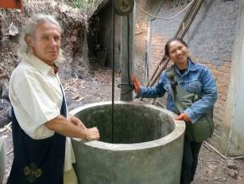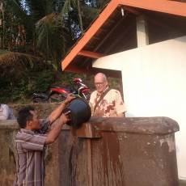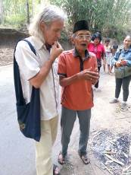
On a tour of inspection with Amaliah Aad learns how to operate an MCK Consultation with the local elder

A few weeks ago (mid-September 2014), we did start the construction of an MCK in Nogosari RT6 and we approved previous applications for major maintenance. For instance at two MCKs in Butuhan: the wells were dry because of the lowering groundwater. We will make the wells 5 to 8 metres deeper.

II Yogyakarta-Java / Singaraja-Bali Scholarships

It's almost like breathing in and out: semester started, semester completed, school year started, school year finished. We are very pleased we raised enough money (private sponsors and a foundation) to allow Pande and Lina, children of the orphanage in Singaraja in Bali, to start their university studies in Economics and Dietetics. Imagine you get the opportunity to study, coming from a social background where such a thing seemed impossible. To be clear: we have NOT found sponsors to support their entire studies, but we are confident we can raise enough scholarship funds over the next few years to pay for their studies. Please do not hesitate if you wish to contribute!

-+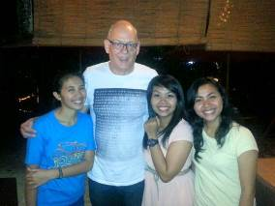 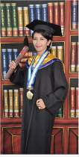 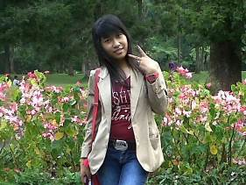
Aad, Derli, Trifena and Sumi Derli Student Ayu
We finished and ended the scholarship programme for primary school and secondary school in Bali. We continue to support the university students: Sudi (Economics, about to graduate), Nyanyi (Economics, 3rd year), Novia (Economics 2nd year) and Ayu (Nursery Education 2nd year).
Derli (Nursing, University of Yogyakarta) gloriously passed the academic part of her study. She belonged to the top three of her year; she was hoping to graduate with credit (3.75), but she just did not make it (3.72 out of a maximum of 4.0). She will now start a practical year and after this she will be fully qualified.
Eka (Nursing, bachelor) who graduated in Yogya last year, now works in Denpasar Bali in the renowned Bali Medical hospital. The study of Suarcaya (cooling techniques in Denpasar) was delayed by a year because of 'family circumstances' and therefore he has not yet graduated. Trifena (4th year Theology) just completed six months of practice in Bali and went back to college in Yogyakarta. And finally, Sumi (4th year Arts Academy, Dance Department, choreography) successfully completed her first assignment: creating a dance and organizing a performance. Reactions were enthusiastic.
Do you feel as happy as we do when you read all this?

III Yogyakarta-Java-Bali : Seniors and Medical Support

According to Ibu Murdijati, chairwoman of our local partner foundation Sejahtera Mulia, the new volunteers and the revised policy regarding the basic medical care we provide, are having a positive impact on the groups. There is more cohesion. The revised policy (specifically for high blood pressure and diabetes) does have an impact on the medical budget needed, but we rely on our sponsors. This part of the project is of vital importance and has positive effects which can be measured straightaway.

IV. Bali : Widhya Asih III children’s home, Singaraja

There is not much news this time, except for the fact that all goes well at the children’s home. They succeed in managing the operating costs and alternative sponsors were found for the scholarships we provided in the past. We continue to sponsor the studies of eight students, the living expenses of six younger children and all medical expenses (other than the GP) for all children. And we continue to facilitate the indoor football. Otherwise there are no long-term 'liabilities', although we keep a watchful eye and are prepared to help in case of emergencies. We still feel an emotional bond.

4. Sponsor visits

Loes from Holland, who worked at the children's home for nearly two months, returned home. She did a good job, enjoyed it very much and made a lot of friends. Her presence was much appreciated and her enthusiasm was contagious.
At the end of September Aad arrived in Yogyakarta; he is the chairman of a fund which is important to us. He joined us to visit completed projects and witnessed what we had achieved during the many years of their sponsorship. To say he was impressed is an understatement.

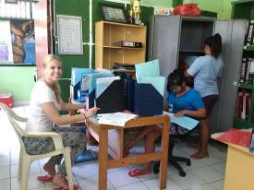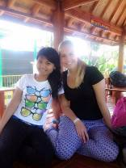

Loes in the children’s home office Loes and member of staff Nyanyi

5. You tube: Gotong Royong Utrecht channel

http://www.youtube.com/user/GotongRoyongUtrecht
- Widhya Asih children’s home; thanks to Anne from Alkmaar!
- new walker for Ibu Tegalmulyo
- NEW: an impression of the location and the operation of a new MCK: http://www.youtube.com/watch?v=pY8CY9Yr5pc

6. Sponsoring possibilities

- the scholarship programme: one scholarship is € 60 (primary school), € 100 (junior high school) or
€ 165 (senior high school) a year and can start any time during the year,
- sponsoring a child of the children’s home for € 12 a month (€ 36 a quarter or € 144 a year) for complete sustenance,
- the support of a senior (60 plus) for € 10 a month (especially for vitamins, minerals and medical care). This is € 30 a quarter or € 120 a year.
Of course you can also send us a free gift and leave the spending to us.

7. Gifts

Gifts are more than welcome at our bank account in Holland: NL74ABNA084.21.36.932 (for the attention of Stichting Gotong Royong - Utrecht). For people who want to donate and who are living outside Holland, please contact us by email so we can find a proper method of transaction for your donation.

8. Email & website

If you want to let us know something, if you have feedback, if you want to ask something, please send us an email: info@gotong-royong-utrecht.nl

