newsletter
volume 14 issue 3 30 september 2015


‘Gotong Royong Utrecht’ Foundation
postal address: oudkerkhof 15 bis, 3512 GH Utrecht, the netherlands
email: info@gotong-royong-utrecht.nl
bank account: NL74ABNA084.21.36.932
reg.number chamber of commerce H30179877

- From the board

Autumn 2015: while writing these words, the leaves start turning colour. They are not falling yet, but it will not be long. Already the sun no longer rises high enough to shine over the top of the Dom tower. Autumn is inevitably here. Meanwhile on Java the sun is high in the sky and dry and dusty Yogyakarta almost reaches boiling point.
Recently, we have visited all projects again and evaluated them together with the local staff. Our meetings were shaded by the sudden blindness of our president in Yogyakarta: Ibu Murdijati. As soon as a donor has been found she will have corneal surgery. There is a chance sight will return in one eye. Let us all light an extra candle for her!
The renovation of the MCKs (public bath/washrooms) has been completed and the results look just fine: the freshly painted green and orange MCKs catch the eye and everything is working properly again.
We visited a lot of seniors and were reconfirmed that in addition to children (scholarships) this group should be a priority for our foundation.
Financially things are reasonable. We have some reserves and we are happy to have a group of loyal dedicated sponsors: individuals as well as foundations. Last month, a meeting with a representative of one of the foundations again resulted in a substantial contribution to the scholarship programme and the seniors’ support. Many thanks to Boris.

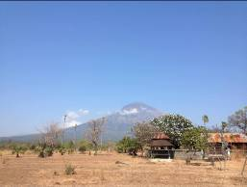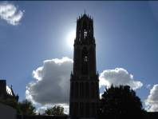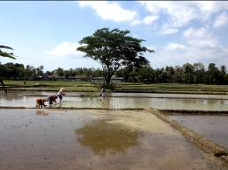

2. Couleur locale Indonesia

A lot is happening in Indonesia. Jokowi (the President) has launched three programmes, all in the fields in which we provide support: living/housing conditions (including the elderly), scholarships (high school and up) and health care (access to medical care). We keep an eye on these developments to see if and when these programmes will descend to the level at which we operate. For now it seems that those who sit closest to the lowest level of local government, benefit from the programmes. They are not the ‘target groups’ of our activities.
The rigid law on alcohol (which appears to have a negative effect on Western tourism, but was instituted to reduce the availability of alcohol for local people) will be weakened.
The Members of Parliament, together with the judiciary and the executive powers (police, military) are working hard to obstruct the national Anti-Corruption Brigade. Unsurprisingly the opponents of this autonomous Brigade are often its target. You can be cynical about it, but in the land of the Wayang Topeng (mask-wayang), this is also regarded as entertaining.

3. Project information

I. Yogyakarta-Java: MCKs (public bath/washrooms)

In September all 11 renovated MCKs were finished and we visited them to see the results. Everything is working properly again: doors have been repaired, cornices restored, septic tanks cleaned, roof tiles replaced. We visited one location for a new MCK in Sengolo. Given the limited size of the group of residents we decided to build an MCK here with a single toilet/bathroom. We will renovate an old well; it is the only one in the area where there is water throughout the year. Amaliah, our MCK coordinator, reported that the number of locations that meet our criteria is becoming smaller. This is due to subsidies that are now available for building private toilets. Amaliah does not have to ‘sell’ new MCKs: after all we work demand-driven, we’re not pushy.

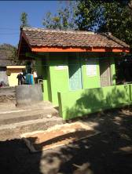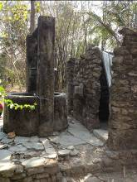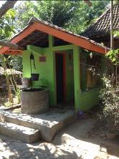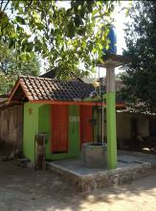
MCK Wukirsari RT 5 Old well in Sengolo MCK Bulus Kulong RT 2 MCK Karang Kulong RT 8

II Yogyakarta-Java / Singaraja-Bali: Scholarships

The 2015-2016 school year has started. In Yogyakarta 79 children (mostly junior and senior high school level) receive a scholarship, and so do a dozen university students on Bali. We also help the two children’s homes in Bali (WA3 and WA7) by contributing to the general education expenses. While the number of children receiving support has decreased, the amount we spend on scholarships has increased; because of the rising educational costs we chose to give more support to fewer children.

In September Sumi graduated (Art School Dance Choreography). After the official ceremony, upon leaving the auditorium, there was an exuberant happening that in Indonesia can only take place in the artist community. The younger students welcomed the fresh graduates with carnival outfits, stimulating music, chants, flowers and many hugs. It was heartening to witness the formerly modest Balinese Sumi who is now completely integrated into the Javanese art scene. Sumi's scholarship started five years ago, as a result of our first and only crowdfunding action on Facebook. Thanks to Boris and especially Wouter, who promised to double the revenue, we collected the funds needed. Thanks again everyone!
The next student who will graduate is Derli (nursing, university level). This will be in November. Trifena then will be the last of four Balinese girls who went to study in Yogyakarta, who is still residing there. She hopes to graduate in the first quarter of 2016. Derli and Trifena will definitely return to Bali. For Sumi this is still a challenge: she feels her family would like to see her home again, but she wants to stay in Yogyakarta.
On Bali, Kadek Rediasih started studying Economics and Pande (also a student of Economics) has left the children’s home to continue his studies as a working student living at home.

If you are interested in (co-)funding the studies of one of our students, please let us know.

III Yogyakarta-Java-Bali: Seniors and medical support

For the seniors of Yogyakarta we have organized their annual outing in mid-September. With five buses with seniors from five districts we went to the Mount Merapi Museum on the slope of the volcano. They made a tour, saw a film about the destructive power of the volcano and on the terrace they sang, danced and laughed a lot during the performance of an outstanding traditional Javanese comedian.

Recently we have visited a large number of candidates for the senior support programme at their homes. Often these were impressive visits to poor little houses and cottages where we were received by dignified, resilient and hospitable people. We will start a new (small) seniors’ group in the Kraton area.

There is good news about the bedridden Ibu 'Rus' who lives in the depths of an illegal but condoned slum. Her dwelling has become a real room: the walls and ceiling are panelled and painted and on her bed she now runs a small shop. It is self-service, in the hope that one pays for what one takes. The money for the renovation came from one of her daughter’s friends, who was concerned about the woman's fate. One half is a grant and the other half must be repaid in instalments. Chances are this will not happen, unless the daughter vouches for her. Profit from the warung is in fact a matter of small change.

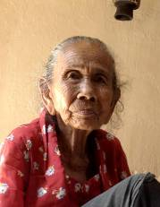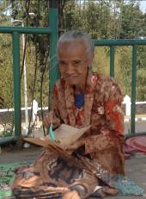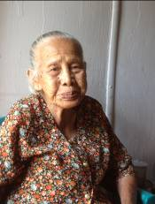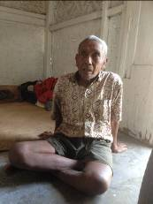
Four seniors who have most recently joined the programme

IV. Bali: Widhya Asih III and Widhya Asih VII children’s homes

Widhya Asih headquarters has noticed that global NGOs are no longer interested in children’s homes and certainly not in orphanages (often filled with non-orphans). The policy-makers of the international NGOs nowadays prefer supporting children within their families. In itself this is a commendable point of view, but it should be clear that 'home' or 'the family' in impoverished areas is often not particularly ideal. We see many children growing up in Widya Asih III and VII who after staying with their families (often as short as possible) are glad to be back in the home. However, because of the shifting focus in international grants, a programme is now being set up to support children who are living at home, with regular staff visits and tailor-made support.

We have recently visited the Widhya Asih VII Children’s home in Amlapura Karangasem (East Bali) where Yudi now is the ‘house father’ for 20 children aged 12 to 18 years. In terms of traffic and crowds the region resembles the Bali of twenty years ago: wonderfully laid-back and quiet, but indeed less prosperous than the rest of Bali with its mass tourism. We were impressed by the way Yudi is managing the place. The facilities and furnishing of the house are very limited and we are considering to contribute to its improvement. He and the kids deserve it.

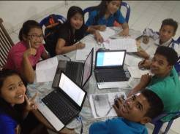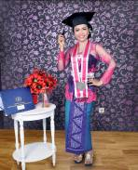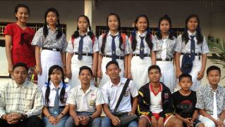
Studying together on 3 laptops Sumi gratuated Junior and senior high school students

4. You tube Gotong Royong Utrecht channel

On our You tube channel http://www.youtube.com/user/GotongRoyongUtrecht you can see several videos:
- Widhya Asih children’s home; thanks to Anne from Alkmaar
- An impression of the location and the operation of a new MCK
- NEW: Sumi’s dance performance
- NEW: an impression of a gamelan lesson at the children’s home and a general overview of the premises

5. Sponsoring possibilities

- the scholarship programme: one scholarship is € 60 (primary school), € 100 (junior high school) or
€ 165 (senior high school) a year and can start any time during the year,
- sponsoring a child of the children’s home for € 12 a month (€ 36 a quarter or € 144 a year) for complete sustenance,
- the support of a senior (60 plus) for € 10 a month (especially for vitamins, minerals and medical care). This is € 30 a quarter or € 120 a year.
Of course you can also send us a free gift and leave the spending to us.

6. Gifts

Gifts are more than welcome at our bank account in Holland: NL74ABNA084.21.36.932 (for the attention of Stichting Gotong Royong - Utrecht). For people who want to donate and who are living outside Holland, please contact us by email so we can find a proper method of transaction for your donation.

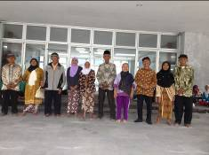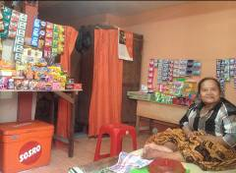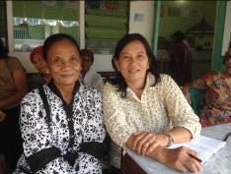
Participants of the seniors’ outing - Shop and room of Bu Rus - Bu Santi and Bu Daryati (coordinators)

