newsletter
volume 12 issue 3 29 september 2013


‘Gotong Royong Utrecht’ Foundation
postal address: oudkerkhof 15 bis, 3512 GH Utrecht, the netherlands
email: info@gotong-royong-utrecht.nl
bank account: 84.21.36.932 (ABNAMRO)
reg.number chamber of commerce H30179877

- From the board

A challenging autumn lies ahead of us with important goals, the most important of which is to ensure the high quality of our work while reducing our presence on site. We have invested a lot, and will keep doing so, in the relationship with our local partner foundation Yayasan Sejahtera Mulia. We have been working with them for twelve years now, doing projects together. They are a group of dedicated volunteers led by Ibu Murdijati Gardjito, who is the driving force, and Amaliah, our tower of strength. With regret we gave up our local office (the rent was too high) and moved into the house of Ibu Gardjito, where we already ran an office in the years 2001 to 2009.

Another important goal is of a financial nature. Fundraising (private sponsors) has been a bit so-so. So we will have to call a bit louder, and we ask you to do the same. Fortunately, we again received funding for building MCKs (public bath-washrooms) from Impulsis (a Dutch charity organization in cooperation with the municipality of Utrecht) and another very committed fund that wishes to remain anonymous. For the scholarships we expect no severe weather as our major sponsor (a fund) assured us we can count on their support. The senior citizen’s project continues to be a financial problem. It is difficult to get the bigger sponsors interested in this project, although the effectiveness of the project is beyond all doubt.
Yet it is easier to raise money for children than for seniors. We continue to put our efforts into the senior programme, sometimes successfully as there were two larger gifts for seniors recently. One of the Vivi Foundation and the other made by Edwin and Lisette. Many thanks to them!



2. Couleur locale

A few things catch the eye: the huge price increases for food and building materials (which also affects our budgets) supposedly caused by the price increases of petrol. It is downright shocking to see how this is abused as an excuse to raise prices. The have-nots suffer, they have no choice. Apparently the economy is doing reasonably well, but inflation rose to 9.2%.
In Bali economic growth has taken place over the past ten years, although making fast money sometimes goes at the expense of culture and the environment. In any case, the percentage of the population living below the poverty line declined from over 10% (2004) to 3.9% and will, if the Governor is right, be less than 1% in about five years. To us it is clear there is less work for us to do on Bali.

3. Project information

I. Yogyakarta-Java : MCKs (public bath-washrooms)

Our success story! Just before and shortly after Ramadan four MCKs were completed. Two in Kedungprahu (early July) and two in Karangasem (end of August). During the completion of the MCKs in Karangasem we also visited two new locations in other neighbourhoods in Karangasem. The locations were suitable and building started late September. We rejected a location in Seropan and at this moment we are talking with representatives of the population in two or possibly three other locations. We have already seen the (remote) sites. The need is usually unmistakable, but we also look at social support and the willingness to participate in the building and in the maintenance of the MCK after it is finished.
One of the MCKs to be built in this region was donated by the parents of Lisette, who raised money from their family and friends at the occasion of their 40th wedding anniversary. They were so successful that in addition to the MCK a substantial amount was donated to the seniors’ project. FANTASTIC, THANKS!

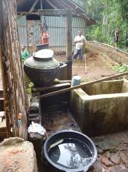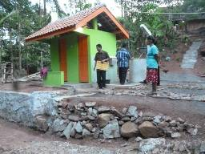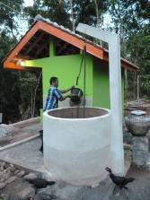
Karangasem, previous situation Karangasem: new MCK

II Yogyakarta-Java / Singaraja-Bali Scholarschips

The students are doing well, we regularly see very good results, especially those of Derli and Sumi in Yogya and Sudi and Nyanyi in Bali. Next month Eka (nursing), Ariasa (civil engineering) and Dwi Muliani (Indonesian language teacher) will finish their studies. While Novia and Ayu Mang have just started their new courses at universities in Singaraja.
In Yogyakarta Amaliah practically on her own managed the scholarship programme for the entire group of 91 students in elementary school and high school. Tuition fees were paid and she provided them with shoes, clothing, books, etc. The scholarship ‘prices’ we charge our sponsors are no longer enough because of inflation and increased school tuition fees. Starting January 2014 we will raise our contribution to help the families cope with the increased cost of living.
In the children’s home in Bali we keep supporting another ten children until they finish their vocational training (SMK PGRI). Two grandchildren of Pak Putra Made from Delod Peken also receive scholarships, for SMP (junior) and SMK (vocational training).
To underline the meaningfulness of the programme:Last year we supported two students from Bondalem. Gede Wira has now been selected after various interviews and tests for a job as a cook on a cruise ship in the Caraibbean sea, and Komang Metu starts an internship on a cruise ship in Malaysia.

III Yogyakarta-Java : Senior citizens and Medical support

In the previous quarter blood pressure and blood glucose of all seniors were measured. Those who scored within the parameters set, received medication for the entire month. Already remarkable results have been achieved in bringing down their levels​​. This group is checked every month now, the rest of the seniors gets its sugar level check-up every three months. Blood pressure will be measured every month.
It was to be expected: after the price increases of recent months the food packages (the sembakos) were 'eroded': less rice, fewer eggs, etc. Prices had already increased in the first months of the year, but with the petrol price as an excuse, food prices have increased excessively (ranging from 15% to 30%). We are obliged to help and raised our contribution with 50 cents per package, which gives much relief. It costs us 130 euros a month more. Who will help us out?

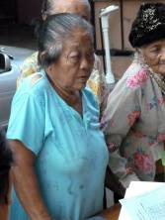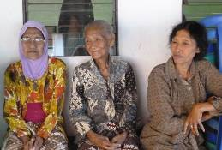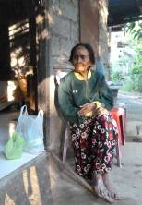
Seniors waiting for medical check-up and food packages. Bu Abasan on Bali

IV Yogyakarta-Java : Roemah Kita nursery

In the last newsletter we reported about the construction of the new classroom. It was financed largely by the Yogya society (which was our condition). The missing amount (1100 euros) was donated by the Masonic Louisa Foundation. The construction is finished and the room is in use now. It was surprising to see how it worked out, the area was small but the room really looks spacious.

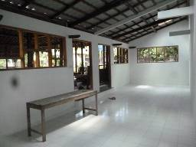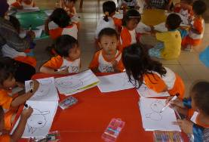

V Bali : Widhya Asih III Children’s home, Singaraja

You must have noticed over the past year that our relationship with the children’s home in Singaraja has changed. After we announced (three years ago) that we were going to focus on scholarships for STUDENTS (children of the orphanage), they started looking for other sponsors to support operations and renovations. The fact that the bathrooms and toilets for boys and girls have now been rebuilt, proves they were successful.
Sulastra, the gardener, cheerfully continues to put his knowledge of growing vegetables into practice. Frankie, the Head of the home, is very active in many areas and coaches the staff. He appointed Yudi as his new assistant (to train him to become Head himself in the future) and Nyanyi (who is studying Economics) is the new accountant. There are more and more international contacts and regularly groups of young people (students) stay at the home for a short time. Recently from Germany and Singapore.
At the end of August Jannie’s gift worth 100 pounds of sugar, 80 boxes of milk powder and many cans of cooking oil, was handed over. Once again many thanks for this kind gesture.

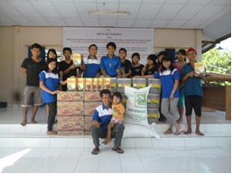 Jannie’s gift

4. Sponsor visits
In the summer we had visitors twice: Frank and Loes (in Yogya and in the children’s home in Bali) and Lieke and Hanneke (in the children’s home in Bali). There is no denying that the visits made a long-lasting impression.

5. YouTube: Gotong Royong Utrecht channel

http://www.youtube.com/user/GotongRoyongUtrecht
- Widhya Asih children’s home; thanks to Anne from Alkmaar!
- new walker for Ibu Tegalmulyo: http://youtu.be/87X6JaeOqBg

6. Sponsoring possibilities

- the scholarship programme: one scholarship is € 60 (primary school), € 95 (junior high school) or
€ 125 (senior high school) a year and can start any time during the year,
- sponsoring a child of the children’s home for € 12 a month (€ 36 a quarter or € 144 a year) for complete sustenance,
- the support of a senior (60 plus) for € 10 a month (especially for vitamins, minerals and medical care). This is € 30 a quarter or € 120 a year.
Of course you can also send us a free gift and leave the spending to us.

7. Gifts

Gifts are more than welcome at our bank account in Holland (ABN AMRO): 84.21.36.932 (for the attention of Stichting Gotong Royong - Utrecht). For people who want to donate and who are living outside Holland, please contact us by e-mail so we can find a proper method of transaction for your donation.

8. Email & website

If you want to let us know something, if you have feedback, if you want to ask something, please send us an email: info@gotong-royong-utrecht.nl

And have a look at our website, with many photos of our projects: www.gotong-royong-utrecht.nl

