newsletter
volume 11 issue 3 30 september 2012


‘Gotong Royong Utrecht’ Foundation
postal address: oudkerkhof 15 bis, 3512 GH Utrecht, the netherlands
email: info@gotong-royong-utrecht.nl
bank account: 84.21.36.932 (abn amro)
reg.number chamber of commerce H30179877

- From the board

One thing is certain and that is that everything is uncertain, except change. Meanwhile the motto is: keep hoping for prosperity, then add three ounces of luck, mix it with a litre of confidence, a teaspoon of courage and a pinch of seduction.. and behold: success! Many sponsors again contributed and our worries were taken away: there is enough money to continue the scholarship programme. Many thanks to all private sponsors who generously donated. Also thanks to Boris with his club and Jos, Wendy, Bram and Guus of ‘We Do It’ foundation for their substantial donations!

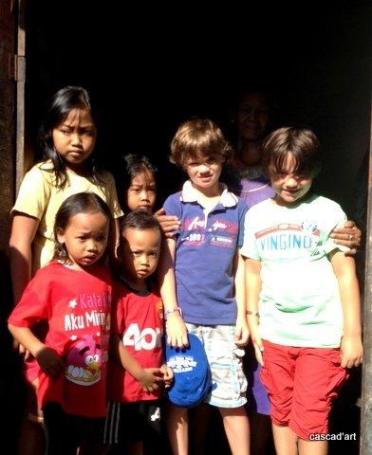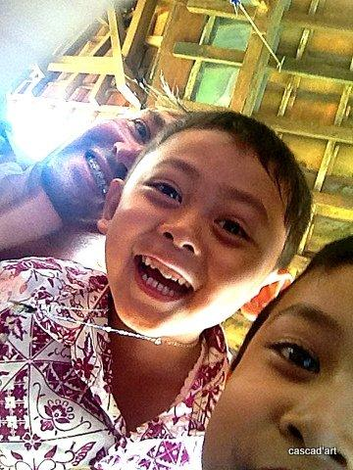
Bram and Guus in Yogyakarta Jos with two jokers

2. Couleur privé et locale

The English saying ‘Home is where the heart is’ and the Indonesian song ‘Disini senang, disana senang, dimana2 hatiku senan’ both express the same. There is also the song "Torn between two lovers" and a saying of Goethe "zwei Seelen in meiner Brust". All refer to the dilemma, or challenge, in dealing with two strong forces that pull on you. In our case: we gave our heart to people in another country on the one hand and on the other hand we experience that staying in our home country has its advantages. We learn to deal with it and for the first time in all those years this summer we stayed for three months in the Netherlands and (surprise) enjoyed it. Now the work and the Dutch autumn, which is gray, damp and cool, drive us back to Java where the heat awaits us and where people are eagerly looking forward to the cool monsoon.

While we were away, local population was involved in the feasts of Ramadan and Idel Fitri (Java) and Galungan and Kuningan (Bali). During the weeks of Ramadan on Java, people are not very productive. In itself this is not surprising: imagine not drinking or eating anything during the day when temperatures rise above 30 degrees Celcius, and keeping that up for a whole month. It drains your energy. Evidently this is not a good time to launch new projects, so we could safely linger in the Netherlands a little longer this year.

Economically Indonesia is still doing a lot better than Europe. After China, India and Brazil it is the country with the largest economic growth. The percentage of super-rich in Indonesia is higher than in other Southeast Asian countries. ‘Less is more’ is not their motto, the contrary is true. Consumer credit pushes sales tremendously, with all the risks included. The growing prosperity is visible in the gadgets possessed by the new middle class that is very keen on status. It is said that this economic development will reduce the religious fanaticism. But that will only be the case if the gap between rich and poor is closed, because slums are the breeding ground for fanaticism.

A striking fact is that the new Regent of Greater Jakarta is an outsider from another region, he is not part of the old boys network of local VIPs and mafia. He won the elections without any religious campaigning, unlike his opponents. In our opinion his victory is a good thing.
Meanwhile we continue to be critical in judging where our support is needed, and make adjustments where necessary.

3. Project information

I. Yogyakarta-Java : MCKs (public bath/washrooms)

In July, an MCK was completed in Banaran Kidul. Board member René was there. He not only listened to all the speeches, but gave one himself. In August during Ramadan not much happened, but in September, after investigating the necessity and discussing their contribution with the residents, we started construction of a new MCK in Ngaglik Sumbersari in Sleman.

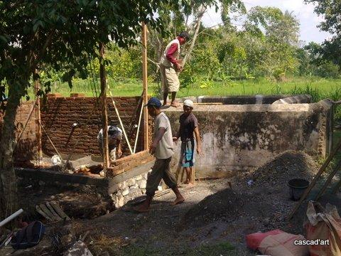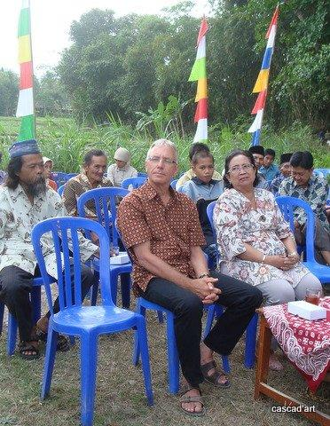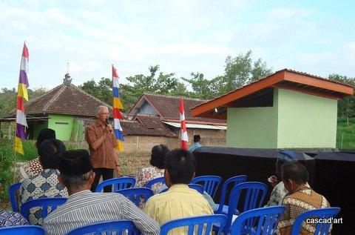

II Yogyakarta-Java: Scholarships

The scholarship fundraising action has been quite successful: every student we were committed to is able to start or proceed his or her education. So we saw a lot of happy faces. In early August Jos, Wendy and their children, interested sponsors, visited. Amaliah and Ibu Gardjito took them to the ramshackle houses of new scholarship recipients. Furthermore Amaliah all by herself visited 100 scholarship children (including 32 new), mostly gathered in small groups in a neighborhood, to hand them the goods we supply (school uniforms, shoes, stationery, etc.). It all went smooth and transparent; all parties (children / parents / schools) know where they stand, because the rules are explained by Amaliah very clear and very precise.

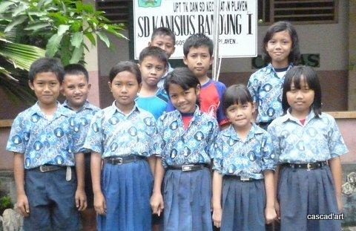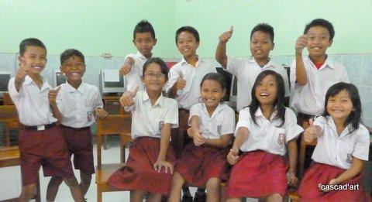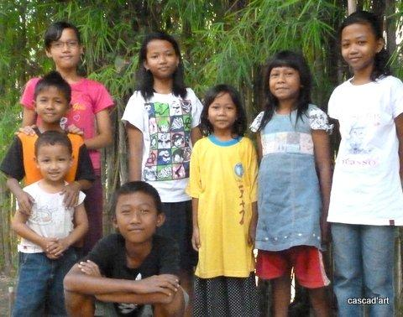

III Yogyakarta-Java: NEW community development project

There is no news, the project still has not started, the ‘incubation period’ was prolonged silently. Whether the project will start at all is yet to be seen. The Javanese powers are not very transparent.

IV Java - Bali: Seniors and Medical Support

The seniors’ project is still going strong despite the struggle for the money and thanks to Boris and We Do It foundation. Their support enables us to organise another seniors’ outing in the coming months. Last year we stopped the outings for budgetary reasons, but thanks to ‘We Do It’ we are again planning one now. This news will certainly be received with great joy.
There was also a nice development in Bali, where we made the food parcels smaller because of budget problems. The local price increases made ​​the parcels ever more expensive so we had to choose to give either smaller or fewer parcels. We chose the first. But then we asked the owner of the shop that handles the parcels if he could sponsor and he answered he was willing to do so and added extra items worth 70 eurocents per parcel (which is a lot of money!). Many thanks to Bpk Guido Hendra of ABD.
In July René delivered the third shipment of medical instruments. Wil was able to get the second hand instruments for free from a Dutch hospital and René carried them to the private hospital we support: Nur Hidayah.

V Bali: Widhya Asih III children’s home, Singaraja

Times are changing, it was the theme of these past months. In August, we were surprised by the news that Pak Yohanes was transferred to Bangli where the congregation appointed him to do pastoral work. He had managed to stretch his appointment in the orphanage from four to ten years and managed to escape the usual rotation within the church organization. But now his luck had changed and he was transferred (September 15). This brought a shock. The kids burst into cry and wail. The staff was upset. For the new Head (Pak Franky) it will be difficult having to compete the memory of Yohanes. We too are curious how he will perform. We know him pretty well and give him the benefit of the doubt. Perhaps some things will change for the better. New rounds, new opportunities.
In the meantime, the new kids that arrived settled down well. We are very pleased with the decision of the staff to give home to Suni, daughter of Bu Seldri. We already paid school fees for Suni while she was living with her family. After both her older sister and her father deceased last year, her mother was unable to properly raise and nurture the remaining three children. Last month Suni fainted at school and was taken into hospital with malnutrition. A telephone call to Yohanes and an interview with the mother was sufficient to admit Suni to the children’s home where she now shares a room with her classmates.
As a legacy Pak Yohanes left Pak Franky a budget deficit that was caused partly by his spending policies, partly because we withdrew as a sponsor of school fees and partly because the parent organisation Widhya Asih still does not contribute, although that is 100% their responsibility. We kept out of the discussion and waited. Finally we decided to pay the school fees for a small group of 23 children, to give a bit of relief.

VI Bali: Scholarships

As mentioned above, 23 children of the second and third year of vocational education (SMK) are assured of a scholarship and therefore they can finish their schooling. In addition, four individual children outside the home receive a scholarship for secondary education (vocational schools and junior high school). Then there are the students who are connected to the children's home: a total of eleven children (university, technical college, nursing school, theology, dance training), with five still living at the orphanage, two live in Denpasar and four in Yogyakarta.

4. Sponsors

Wendy, Jos and their children Bram and Guus visited the nursery and met children who applied for a scholarship. They saw an MCK and visited a group of seniors. They were very impressed and donated generously for seniors and scholarships from their freshly established We Do It foundation. Furthermore, we received large and unexpected gifts from Ton and Saskia, Jaap and René and a number of new sponsors. Terima Kasih sekali.

5. Social networks

Project videos can be found at You tube: http://www.youtube.com/user/GotongRoyongUtrecht:
- Widhya Asih children’s home; with thanks to Anne from Alkmaar!
- Ibu Suresemi (a Parkinson’s patient receiving our support)
- NEW: new walker for Ibu Tegalmulyo: http://youtu.be/87X6JaeOqBg
If you are a Facebook user, please link our website to your Facebook by using the ‘thumbs up’ symbol on our site. Your Facebook friends might be interested in supporting us!

6. Sponsor possibilities

- the scholarship programme: one scholarship is € 60 (primary school), € 95 (junior high school) or
€ 125 (senior high school) a year and can start any time during the year,
- sponsoring a child of the children’s home for € 12 a month (€ 36 a quarter or € 144 a year) for complete sustenance,
- the support of a senior (60 plus) for € 10 a month (especially for vitamins, minerals and medical care). This is € 30 a quarter or € 120 a year.
Of course you can also send us a free gift and leave the spending to us.

7. Gifts

Gifts are more than welcome at our bank account in Holland (ABN AMRO): 84.21.36.932 (for the attention of Stichting Gotong Royong - Utrecht). For people who want to donate and who are living outside Holland, please contact us by e-mail so we can find a proper method of transaction for your donation.

8. Email & website

If you want to let us know something, if you have feedback, if you want to ask something, please send us an email: info@gotong-royong-utrecht.nl
And have a look at our website, with many photos of our projects: www.gotong-royong-utrecht.nl

