newsletter
volume 10 issue 3 30 september 2011

‘Gotong Royong Utrecht’ Foundation
postal address: oudkerkhof 15 bis, 3512 GH Utrecht, the netherlands
email: info@gotong-royong-utrecht.nl
bank account: 84.21.36.932 (FORTIS)
reg.number chamber of commerce H30179877

1. Couleur locale

While in the Netherlands autumn is about to begin, spring is approaching on Java and Bali. Or, to be more accurate: the monsoon season. The past few months have been extremely dry and dusty in Yogyakarta and Singaraja and people are looking forward to the rain.
Ramadan and Idul Fitri took place one month ago, but halal-bihal meetings, to ask forgiveness for mistakes made in the past year, are still taking place.
Meanwhile next year’s presidential elections announce themselves with a lot of plans, promises and hollow words. An entertaining show to witness in this land of the wayang (shadow play). As long as you realize your eyes are deceiving you and what you see on your side of the curtain is not real.

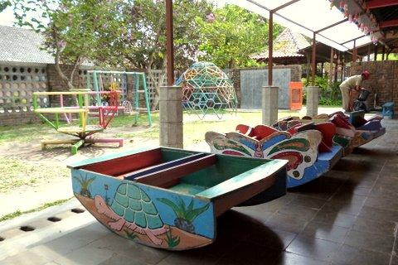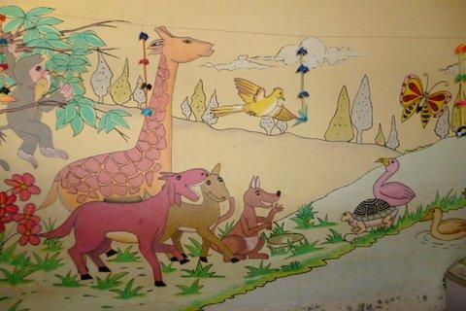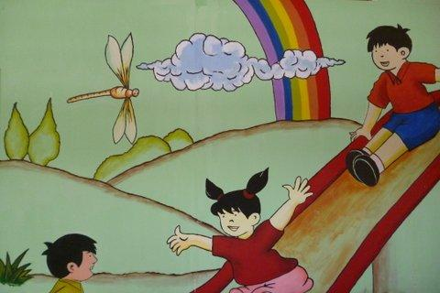

Pictures of the Rumah Kita nursery: freshly painted and a new roof

2. From the board

We received support from various organisations. The Louisa Foundation funded computers in the children’s home and supported the nursery. The Vivi Foundation donated for the senior citizen’s project as well as the children’s home. And a foundation that does not want to be mentioned granted us a lot of support for scholarships and seniors. At this moment we are approaching organisations for co-financing MCKs (public bathrooms). We especially want to extend our gratitude to Boris, Aad, Wim, Gert and Roland who are members of these organisations and enthusiastic promoters of our projects. Thank you for your trust!

For many years we experienced the power of the flywheel that you witness when you involve people in your work: their enthusiasm infects others. This is the origin of our foundation and we feel proud to represent all these people. And we still experience it, from old sponsors as well as new ones. But overall we get the impression that commitment is declining. Response on the e-mail we sent to raise funds for scholarships was low. Donations are still coming in, but remarkably fewer than in previous years. We do not know what causes this and will set up a small survey to get more information, and to investigate whether we should adjust our policy.

3. Project information

I. Bali: Widhya Asih III children’s home, Singaraja

July and August always are busy months: school starts and many things have to be organized. Most exciting in these months is the integration of the newly arrived children. After the summer holidays the children that finished senior high school left, except a few who might go to college and will be staying for one year to work at the home and prove their motivation. Ten new children arrived and are getting acquainted with their new roommates, the new rules and their new schools. This keeps Yohanes and his staff quite busy.

Happy faces looked at us when we broke the news that eight new computers can be bought thanks to the support of the Louisa Foundation (a freemason’s organisation).
Staff member and ex-inhabitant Sumiasih left for Yogyakarta where she started dancing classes, thanks to a successful fundraising campaign earlier this year. We met her in Yogyakarta and she was beaming.
The school bus needs to be repainted, rusty patches appear even on the roof, the price of a sunny climate.

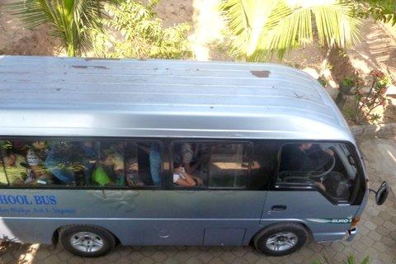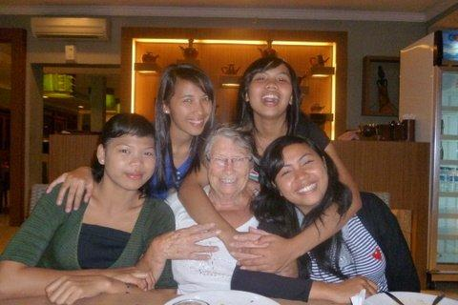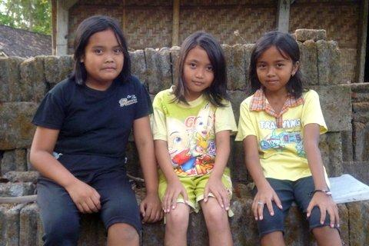

The school bus needs repainting Five merry girls Three shy ladies

II. Bali : Scholarships

The new semester started with more scholarship applications than we can pay for, so checks and choices had to be made. After this the usual job of making the inventory, buying and distributing the uniforms, books etcetera started. It was easy for us this year, because Ratna and Sudi managed the entire project with the aid of staff members. They did a great job and are a real promise for the future.
There are again some special scholarships this year, one for kindergarten and one for vocational school (cookery school). Gede Wira, who wants to study law, decided to go to vocational school for one year so he can start working quickly to earn money to support his parents. He says he will go to law school in the future. In his case not a mere promise, we think he will really make it happen, “he is on a mission”.

III. Bali-Java: Senior citizens and medical support

The past three months we practically met all 420 seniors. In Singaraja (60 participants) Ratna is doing a very good job organizing the project: she buys the medicines, takes care of the invitations, puts together the parcels and makes arrangements with the two nurses. Two seniors in Singaraja receive extra weekly support.
In Yogyakarta (360 participants) our co-ordinator Joko is in charge of the volunteers of all six districts who supervise the meetings. She organizes the food parcels, medical checks and medicines. Here 25 seniors receive extra weekly support.
In Bantul, south of Yogyakarta, we support the Nur Hidayah hospital with their mother and child programme to reduce death at child birth with information during pregnancy, medical checks and – in some cases – payment of Caesarian sections. At this hospital we found a team of a doctor, a nurse and an assistant willing to visit our senior citizen’s groups every two months. We only have to pay for the medicines.

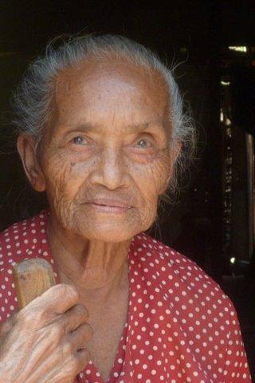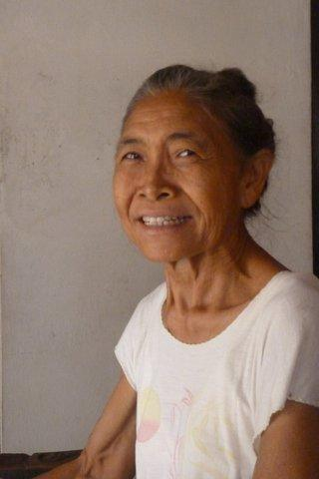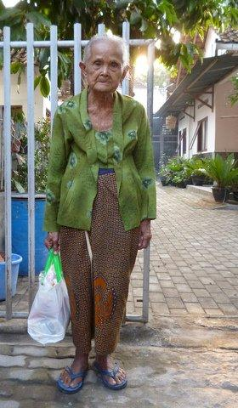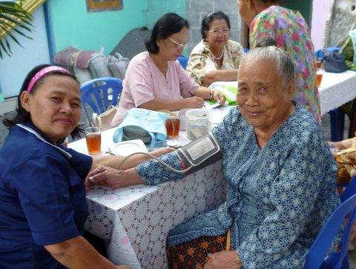

IV. Java: MCKs

During Ramadan it is hard to find voluntary workers (the community’s contribution to the project). This is understandable, it would be bad policy to perform physical work in a tropical climate without drink or food. Nevertheless one MCK was finished (Botokan IX Rt 02). And in Butuhan Rt 03 some additions were made to a recently finished MCK: banisters, a second washing place and a drain.
In the past few weeks we visited several potential new MCK locations and spoke with the local representatives. We will build new MCKs in Botokan Rt 02 and Gunung Mojo. All locations are in the Sleman area.
In the last newsletter we placed a call to fund an MCK “You might want to consider sponsoring an MCK together with your friends or colleagues or ask one for your birthday!” We promply received donations, fantastic!

V. Java: Yogyakarta; Scholarships

The new semester started here also. Staff member Amaliah managed the project. The plan to sponsor more children at vocational school was implemented. Vocational schools (SMKs) do not receive money from the government contrary to primary schools (SD) and high schools (SMP) which are compulsory. Vocational education is more expensive and not compulsory, making it almost inaccessible for children from poor families. We decided to help children that performed well in junior high school to move on to a vocational school. Amaliah supervised this process very well.
As our scholarship budget is the same, we had to make choices: for every vocational student we cancelled four primary school scholarships (new ones that is, the ones who already started of course remain part of the programme). We now have 89 scholarships in Yogyakarta: 42 in primary school, 24 in junior high school and 23 in vocational education or senior high school. Apart from this we granted a scholarship to two teachers of the Rumah Kita preschool. They go to university in the evenings to get the qualifications needed for the accreditation procedure Rumah Kita will be submitted to.

4. News from our sponsors !!!

In September Cathja visited us in Yogyakarta and she left with the mission to find sponsors. She visited many projects and helped Bu Rus, a sick woman in our senior’s support programme.
At the end of July Ria, together with her husband and two sons, stayed in the guest houses at the children’s home.
Two sponsors set up a fundraising event: both Jacqueline and Frank & Linda threw a party and asked their guests for donations instead of gifts, raising a considerable amount. Lots of thanks to them!
Thanks also to Wouter who offered to help our webmaster Merel with the website and the newsletter.

5. Social networks

Project videos can be found at You tube: http://www.youtube.com/user/GotongRoyongUtrecht:
- Widhya Asih children’s home; with thanks to Anne from Alkmaar!
- the nursery in Yogyakarta
- Ibu Suresemi (a Parkinson’s patient receiving our support)
If you are a facebook user, please link our website to your Facebook by using the ‘thumbs up’ symbol on our site. Your Facebook friends might be interested in supporting us!

6. Sponsor possibilities

- the scholarship programme: one scholarship is € 60 (primary school), € 95 (junior high school) or
€ 125 (senior high school) a year and can start any time during the year,
- sponsoring a child of the children’s home for € 12 a month (€ 36 a quarter or € 144 a year) for complete sustenance,
- the support of a senior (60 plus) for € 10 a month (especially for vitamins, minerals and medical care). This is € 30 a quarter or € 120 a year,

Of course you can also send us a free gift and leave the spending to us.

7. Gifts

Gifts are more than welcome at our bank account in Holland (Fortis): 84.21.36.932 (for the attention of Stichting Gotong Royong - Utrecht). For people who want to donate and who are living outside Holland, please contact us by e-mail so we can find a proper method of transaction for your donation.

8. Email & website

If you want to let us know something, if you have feedback, do you want to ask anything? Send us an email: info@gotong-royong-utrecht.nl

And have a look at our website, with many photos of our projects:
www.gotong-royong-utrecht.nl

