newsletter
volume 9 issue 3 25 september 2010

‘Gotong Royong Utrecht’ Foundation

postal address: oudkerkhof 15 bis, 3512 GH Utrecht, the netherlands
email: info@gotong-royong-utrecht.nl
bank account: 84.21.36.932 (FORTIS)
reg.number chamber of commerce H30179877

1. From the board

The World Cup brought a lot of excitement. Global village and tribal war went hand in hand. But now the flags are stowed away and the vuvuzelas (hopefully) thrown away, and life is taking its usual course again. Ramadan is also over and Eid al Fitr was celebrated exuberantly.
Summer left and ‘winter’ never really took place: it rained in July, August and September, which is very unusual. The weather gods appeared to have cancelled the cool August nights without advance notice.
Although we are in the East, our attention is drawn to Western (Dutch) politics nowadays. The success (or lack of it) of development projects is discussed in a blunt way while the people concerned cannot defend themselves. Nuance seems to be lost. The Netherlands are increasingly associated with ‘koran haters’ and ‘muslim bashers’. This will undoubtedly influence international relationships and it can only be hoped it will not pose a threat to overseas compatriots.
Overall, however, we are doing well.

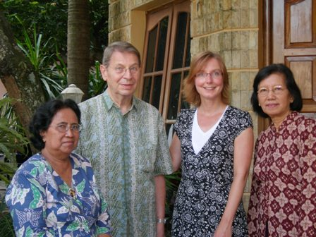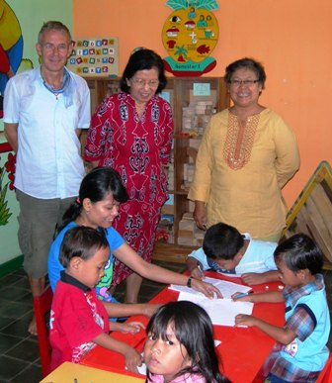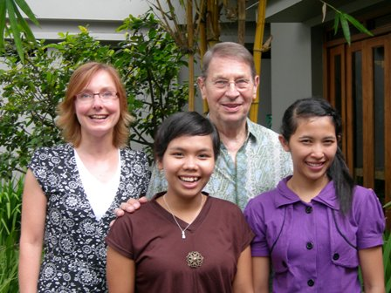
Board members Wil and Merel with Ibu Murdijati Cees, Ibu Suhendro and Bu Rita Merel,Wil, Trifena and Derli ( students)
and Ibu Suhendro
Thanks to all sponsors for your generous gifts! You enable us to continue our work and receive in return words of gratitude, sparkling eyes and the need for more.
Our request for sharing your network contacts with organizations such as Lions and Rotary so far produced three responses. Thank you Arris, Jolanda and Winnifred. We hope more will follow.

2. Project information

I. Bali: Widhya Asih III children’s home, Singaraja

At the children’s home July to September is the period of adjustment: the children who finished senior high school left and new, younger children have arrived. The boys’ and girls’’ rooms have been rearranged and new friends are being made. The children started their new classes, sometimes at new schools. At the start of September all were settling in, not in the least thanks to the hard work of Yohanes and his staff who put a lot of effort in creating a family feeling.
We were lucky that staff member Trifena had not left for her theology studies in Yogya yet. She once again helped Wil with organizing and executing the purchase of uniforms, shoes, backpacks and books for all 105 (!) children in the home. It is nice to witness how she has grown and takes responsibility, saying ‘just leave it to us’. Together with some of the older children she did a great job.
Dengue fever is starting to become a problem on Bali. Frequently children at the home are affected by this disease which is spread by mosquitoes. Usually hospital admittance is necessary to prevent the children from dehydration and injuries (wounds heal badly as a result of this disease).
In August again four students from Singapore arrived to teach English. They will stay for a couple of months and adjust themselves remarkably fast. There were also a lot of guests at the home; clearly Bali received a lot of tourists this season. Most guests were Dutch or Australian and some stayed for a few days and slept in the guesthouses on the premises. The resulting sale of home made batik and rosella tea made a nice extra income.
Good news for Eka, who will start nursing school in the Bethesda hospital in Yogyakarta: she has got a sponsor! It is the Dutch couple who already showed interest in November. Fantastic!

II. Bali: Scholarships

Because Trifena took care of the 105 children of the home (under the supervision of Pak Wil), it was a ‘piece of cake’ for us to take care of the rest. At the primary school (SD) Santo Paulus we have 14 children, at the junior high school (SMP) there are 80 and at the Paket Agung primary school another 32 children. Thanks to our experience over the past eight years, the procedures we developed and the help of Lucienne and Edward, the process went smoothly. Of course there are some special cases: children on different schools, children you meet along the way, situations that cry for help. Sometimes it is only about uniforms, sometimes school fees, and sometimes a complete scholarship. We feel blessed we have the means to respond.

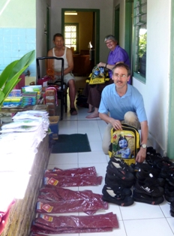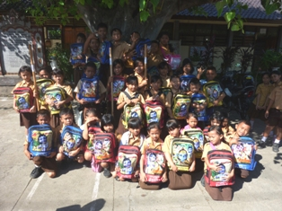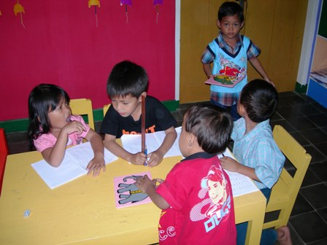
Filling backpacks: Edward, Lucienne and Wil Scholarship group Paket Agung Pre-school in Yogyakarta

III. Bali: Seniors & Medical Support

Life inevitably has its end, also in our seniors’ groups. The past two months three seniors passed away. Also some have been admitted to hospital, their perspectives are not good. For the many who are not insured, the hospital is the place to die. Living opposite the cemetery it is strange to see the smoke of the cremation rising once again, but this time wih the knowledge of who the person was who was carried through the street with a lot of ceremony, music and singing.
Putu Oka (we told you about him in our previous newsletter) ultimately was kept away from hospital. His family had no faith in it. As a result Pak Ola continues his plant-like life. We sometimes find it hard to understand decisions, especially when those involved cannot participate. But then again you don’t always want to know the backgrounds and history.
As they say: life goes on. This certainly applies to our group. Every month 69 seniors receive a food parcel, a medical check-up and medication (some receive this help every week). A small number of seniors who cannot possibly come to the meetings we visit at home for care (“vitamin C”) and medication. The digital blood pressure meter is a magical instrument we always take with us. In July and August nursing-student-to-be Eka assisted and showed that she is fit for the job.
Our support to the 20 patients of Hidup Bahagia (a volunteer organization taking care of psychiatric patients) continues.

IV. Java: Yogyakarta- Community development.

In April we thought we could start building three MCKs because we received funds from private sponsors (Margreet, Paul, Trees and Gerard). But in July we had to cancel the project. Although the location completely meets our requirements, we retreated after experiencing ‘wayang kulit’ (shadow play) by local chiefs and bosses trying to pocket part of the project budget. When it became clear we did not allow this, the project was not needed anymore, or rather ‘unwanted because it was paid by Western money’.

V. Java: Yogyakarta; Seniors and medical support

In July and August we witnessed the meetings of several of the six groups, who are very well coordinated by Bu Joko. We always enjoy these visits and the participants love the presence of the ‘orang Belanda’.

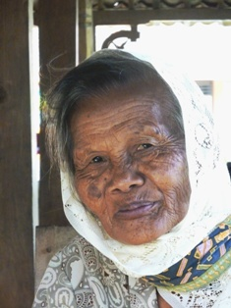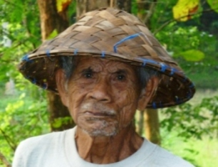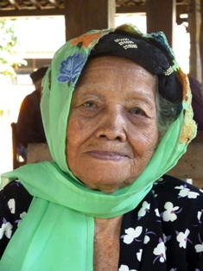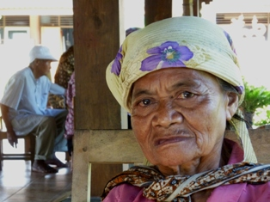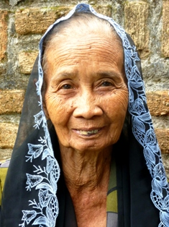

VI. Java: Yogyakarta; Scholarships

In Yogya we also continue our scholarship programme. The design will be changed, because we have learned that vocational education deserves more attention and, thus, more money. This type of education is becoming unaffordable for our target group. Many children are forced to leave school after junior high school, without learning a craft. So the demand for SMK-scholarships is growing. Ibu Murdijati Gardjito, president of our local foundation Sejahtera Mulia supports this demand. This year we will not yet change the programme (the budget is not sufficient), but next year we hopefully will be able to respond.

VII. Java: MCKs (public wash/bathrooms)

Building continued in August and September (despite Ramadan) and two new MCKs were finished. One in Karang Anom and one in Sidoredjo. One more is planned in Sidoredjo, but for this another location has to be found. The necessity of an MCK is clear, but there are issues about the ownership of the land. We can trust Amaliah, our MCK-coordinator, to effectively solve it.

VIII. Java: Community Activity Centre -Roemah Kita- ; nursery (PAUD)

Previously we informed you about the plans to establish a pre-school group (unofficial kindergarten) next to the nursery, for which we received the money we needed. Now we can announce the class started with a newly appointed teacher!
Ibu Suhendro and Bu Rita changed the organization of the nursery: staff members now each have their own age group so there are less plenary activities and teachers are no longer hidden behind other (more dominant) colleagues.
In July two young Dutch women worked as interns at the nursery for a few weeks, a pleasurable and instructive experience for themselves and for the staff. We hope more students will take interest in an internship at the nursery and pre-school group, it is certainly worthwhile for both parties.

IX Java: Hospital
A new project coordinated by Ibu Nancy. We have been asked to participate in a project with the Nur Hidaya private hospital in Bantul. The aim of the project is to prevent the dying of young children and mothers by informing and examining pregnant women, screening and monitoring them and, if necessary, perform caesarean operations. We help by facilitating and controlling the project; it is what we are good at and we instantly proved it by detecting an error in the budget.

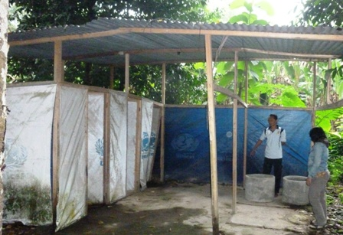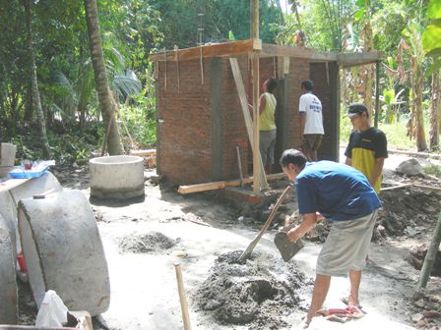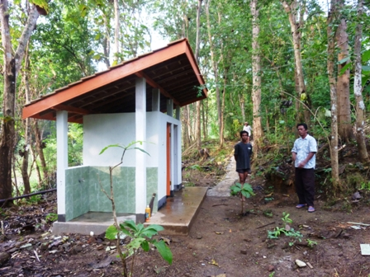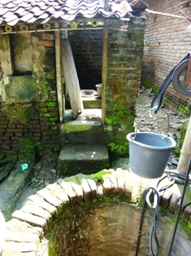

Before: Unicef emergency toilets Work in progress The result This cries for an MCK

3. YOUTUBE !!! and other media
On You Tube (www.youtube.com/user/GotongRoyongUtrecht) videos of our projects can be found:
- NEW: the Widhya Asih children’s home (thanks to Anne)
- the nursery in Yogyakarta
- Ibu Suresemi (a Parkinson patient receiving our support)
We have mentioned it before, but in case you have not read it yet: an article that was published in the Jakarta Post can still be found on our website.

4. Sponsor visits!

It was a busy tourist season on Bali. First Jan and Carel came (we met them before) and brought a whole box of glasses for the seniors. On Java, in Yogya, we visited several projects with Edward, Lucienne and their children David, Yeshe and Mirte. They also attended a seniors’ meeting. In Singaraja they stayed at the children’s home.
Successively we received Eugene and Betty, Ria and Mat and Astrid and Gerrit, who were very enthusiastic. After them 16 students of Hogeschool Holland visited us. They are taking a five months’ course at the Dhyanapura school in Denpasar. Finally board member Merel spend a useful week with us in Yogya.

5. Sponsor possibilities

If you decide to support the initiatives of Gotong Royong financially, first think if you want to help any specific project or if you want to leave the spending to us.

Possibilities:
- the scholarship programme: one scholarship is € 60 (primary school) € 95 (junior high school) or € 125 (senior high school) a year and can start any time during the year,
- sponsoring a child of the children’s home for € 12 a month (€ 36 a quarter or € 144 a year) for complete sustenance,
- the support of a senior (60 plus) for € 10 a month (especially for vitamins, minerals and medical care). This is € 30 a quarter or € 120 a year,
- the support of a child in the Roemah Kita nursery for € 10 a month.
- the support of mentally ill patients by paying their monthly medication: € 14 a month

Of course you can also send us a free gift and leave the spending to us.

6. Gifts

Gifts are more than welcome at our bank account in Holland (Fortis): 84.21.36.932 (for the attention of Stichting Gotong Royong - Utrecht). For people who want to donate and who are living outside Holland, please contact us by e-mail so we can find a proper method of transaction for your donation.

7. Tell a friend

Please would you do us a favour and send this newsletter to your family, friends and colleagues or draw their attention to our website: www.gotong-royong-utrecht.nl where this newsletter is published as well (in English and in Dutch)!

8. Email & website

If you want to let us know something, if you have feedback, do you want to ask anything? Send us an email:
info@gotong-royong-utrecht.nl

And have a look at our website, with many photos of our projects:
www.gotong-royong-utrecht.nl

