newsletter
volume 13 issue 1 31 march 2014


‘Gotong Royong Utrecht’ Foundation
postal address: oudkerkhof 15 bis, 3512 GH Utrecht, the netherlands
email: info@gotong-royong-utrecht.nl
bank account: NL74ABNA084.21.36.932
reg.number chamber of commerce H30179877

- From the board

Volume 13 of the newsletter! It is hard to believe that already twelve years ago we started this adventure. At the time, after spending a four months’ sabbatical in Indonesia, we decided that if we wanted to continue to provide support, an official form (a Foundation) was needed to ensure continuity and reliability. During the sabbatical, without a preconceived plan, we started small projects in response to (emergency) situations we encountered. Gradually and while doing it, we discovered our great challenge to keep things in balance: the balance between giving and receiving, the balance between costs and benefits, but especially the balance between the energy we put into it and the output in the form of joy. This has remained our norm since. Even though a lot has changed: the environment has changed, the resources have changed and there was inner change (development). Through all this we have kept the balance. So as long as there are situations that challenge our compassion and commitment and as long as funds permit, we will carry on with joy.

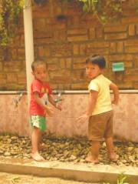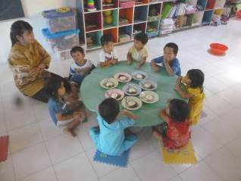

Nursery/ Pre-school Rumah Kita: washing hands before the meal

Many thanks to those of you who supported us in the past quarter. Thanks for the responses to the letter about the scholarships. In the first ten weeks of 2014, we received more than 5,000 euros from private sponsors!! It is heart-warming to find that our projects still have your attention. We thank all contributors of whom some we want to mention especially: Loes (of Intent), Jack, Erik, Theo, Bart and Herma, Ria, Pim, Cees and his wife, Pak Pok and Hub

An important announcement on our MCK project: we have suspended the building of new MCKs for a few months because of the April elections. Otherwise, chances are that the construction and delivery of MCKs in one way or another will be translated into 'mandatory voting advice' if a candidate arrogates the credits of supplying the location and the construction of the MCK.

2. Couleur locale Indonesia

There are three major issues that dominate the talk of the town. Number one is of course the weather and nature’s forces. It seems to be an El Niño year. This means deviations in the degree of drought, rainfall, wind, wave height, the amount of fish. But then again, what with global warming exceptional situations might become the new rule. What people are mainly preoccupied about are the tectonic movements of the earth and the volcanic activity. In the past two months, three volcanoes were active in Java. The eruption of Mount Kelud in Malang resulted in an ash and dust layer of a few centimetres in areas hundreds of kilometres away. Yogyakarta was one of the cities that was affected. Now, a few weeks later, at first glance all seems tidy again, but it is an illusion. The wind is still carrying silky and fine sand that crawls into every crack and hole. The second issue is the work of the Anti-Corruption Commission. They are bringing one scandal after another into the open and are arresting one mega corruptor after another. Whether they will all be convicted remains questionable though. Finally, there are the upcoming elections of the local MPs AND the president. The campaigns have been launched and are visible everywhere: a lot of ​​flags, traffic jams caused by noisy campaign parades and the subtle process of collecting votes (everything can be bought).

3. Project information

I. Yogyakarta-Java : MCKs (public bath-/washrooms)

In the last newsletter we wrote there was no stopping us, but now we have to report we have temporarily suspended the project after four or five dubious experiences with the assessment of possible sites. The upcoming elections are bringing about certain mechanisms and processes and therefore we cannot guarantee a proper course of business. People (who have nothing to do with the construction of the MCK) might arrogate the success of an MCK for political reasons. Or representatives think we have a political agenda and start to negotiate and ask, for example, to build an internet transmission tower instead of an MCK. Very practical and pragmatic – we do not blame them, but for us it is better to retreat for a while.
In February three new MCKs were officially handed over to the people, but they were already built in 2013 and had been waiting for dry weather since so that the finishing touch (paint) could be put on them. One of the MCKs that was now officially transferred is the one sponsored by Ans and Rob.

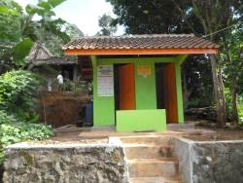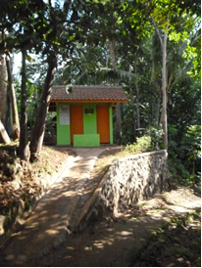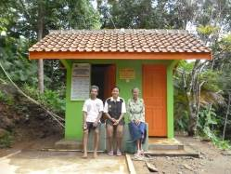

Three MCKs in Karangasam, Central Java: with paths, walls and lighting.

II Yogyakarta-Java / Singaraja-Bali Scholarships

The second semester has started and is already well advanced for the children in the final year. In a few weeks the national final exams will begin. Amaliah, our coordinator in Yogyakarta, spoke to all the children. She advised us to terminate the scholarships of three children because they and/or their parents repeatedly did not show up for appointments. We followed her advice.
In contrast, Derli, who is studying nursing, ended the semester with A scores (the highest score possible) on all courses. This fits in with her goal to graduate with an Honors Degree. Sumi, who is studying at Art School (Dance), is working on her first solo choreography. She has to organize and pay for the performance herself (dancers, location, props, costumes and catering), so we give financial support.

III Yogyakarta-Java : Seniors and Medical Support

All is quiet again in Tegal Mulyo, where we found last December that a group of less impoverished seniors from the district became pushy and wanted to share in our support. The groups were taken apart and their activities are on different days now. When we were there again in March, during the medical check, we noticed that 'our' seniors had closed ranks and, without the dominant 'better off' (less poor), were content as a group again.
Late February, we received a list of fifteen new candidates for the project. In five different groups places had become available because members had deceased. We visited all fifteen seniors at home to interview them and look at the housing situation. Often, the first sight was already sufficient. Sometimes there were dreadful situations (bedridden people in dark stuffy little rooms with no prospect of improvement). Of the fifteen seniors, we admitted twelve. In three cases we and our local volunteers were of the opinion that the relatives had sufficient capacity to take care of the seniors themselves.

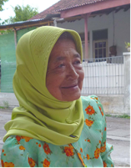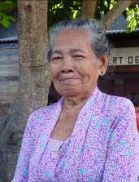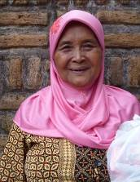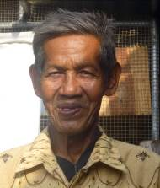

IV Yogyakarta-Java: Nursery and Pre-school (PAUD) Rumah Kita

The new classroom is now completely finished. An additional ceiling has been added to stop the heat of the tin roof and there are two fans causing a pleasant breeze. Two of the five tutors study at university part time at our costs (S1 Pedagogy and School Management) so Roemah Kita will soon meet all accreditation requirements. We asked one of them to suspend her studies one or two semesters so she can first learn to plan and carry out her work at the nursery and pre-school.

V Bali : Widhya Asih III children’s home, Singaraja

The children are doing well at school and at home. There are good reports on the SMA Santo Paulus (senior high school), where the new management (nuns) is doing a very good job. The staff of the children's home not only sees good academic results but also an improvement in attitude and behaviour of the children who go to this school.
Eka has returned from Yogya with her Nursing diploma D3 and is applying for a job in Denpasar. She was offered a job at the Paramisidi hospital in Singaraja, where she would have had to commit herself for three years at a salary of 60 euros per month. Understandably, she was not interested. Yudi graduated in Economics at university. Given his dedication, experience and commitment as a child and later as a staff member of the Widya Asih III children's home, expectations are that a job as head of a children's home awaits him.
Outside of the children’s home a few more kids receive scholarships organized by Ratna, our coordinator. Furthermore, there are four seniors who receive support. Nyanyi (student and staff member of the children's home) keeps in touch with the two seniors in Abasan and takes care of their medications and complementary food.

4. Sponsor visits

In the past months it was quiet. The visit of Dick and Joke was cancelled because of the volcanic eruption of Mount Kelud. During the next few months, there will be quite a few visits and sponsor activities.

5. YouTube: Gotong Royong Utrecht channel

http://www.youtube.com/user/GotongRoyongUtrecht
- Widhya Asih children’s home; thanks to Anne from Alkmaar!
- new walker for Ibu Tegalmulyo

6. Sponsoring possibilities

- the scholarship programme: one scholarship is € 60 (primary school), € 100 (junior high school) or
€ 165 (senior high school) a year and can start any time during the year,
- sponsoring a child of the children’s home for € 12 a month (€ 36 a quarter or € 144 a year) for complete sustenance,
- the support of a senior (60 plus) for € 10 a month (especially for vitamins, minerals and medical care). This is € 30 a quarter or € 120 a year.
Of course you can also send us a free gift and leave the spending to us.

7. Gifts

Gifts are more than welcome at our bank account in Holland: NL74ABNA084.21.36.932 (for the attention of Stichting Gotong Royong - Utrecht). For people who want to donate and who are living outside Holland, please contact us by email so we can find a proper method of transaction for your donation.

8. Email & website

If you want to let us know something, if you have feedback, if you want to ask something, please send us an email: info@gotong-royong-utrecht.nl

And have a look at our website, with many photos of our projects: www.gotong-royong-utrecht.nl

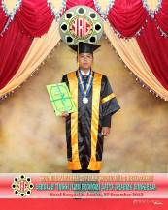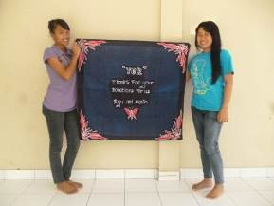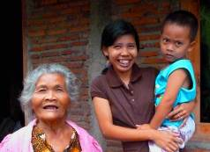
Yudi’s graduation two students with a ‘thank you batik’ three generations of curiosity

