newsletter
volume 12 issue 1 31 march 2013


‘Gotong Royong Utrecht’ Foundation
postal address: oudkerkhof 15 bis, 3512 GH Utrecht, the netherlands
email: info@gotong-royong-utrecht.nl
bank account: 84.21.36.932 (FORTIS)
reg.number chamber of commerce H30179877

- From the board

By the end of January Ibu Saptoto suddenly died at the age of 81. Until a few years ago she was the coordinator of the seniors’ programme in Yogya. It was in her house we met Mrs. Gardjito in 2001, which led to the founding of Gotong Royong in Utrecht and our partner Sejahtera Mulia Foundation in Yogya. She was a highly respected lady in her district and hundreds of people came to her house to offer their condolences.

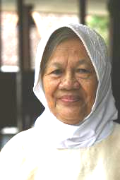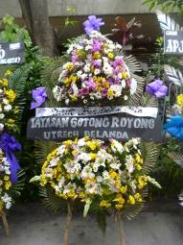
Ibu Saptoto (R.I.P.) Funeral wreath on behalf of Gotong Royong

The Foundation entered its twelfth year, which is quite an achievement! We are busy preparing the annual accounts. Looking back, we see that last year was fairly quiet. We focused on ongoing projects and spent 30% less money because the revenues were also down 30%. Yet no ongoing projects stopped for financial reasons. It is a fact that in 2012 a lot fewer MCKs (public toilets) were built, but this is not due to savings but the consequence of our critical assessment of the conditions of potential locations needed to justify the construction of an MCK. Because a seniors’ group (60 members) has stopped (on its own, after the leaders of this group decided they did not want to discriminate between people on financial grounds), we unintentionally spent less there also.

The call in the last newsletter for scholarship sponsors was reasonably successful, yet the names of sponsors who supported the successful programme for many years are often lacking. This is unfortunate and we hope they will remember us when the economy recovers. We are optimistic.

As of January 1 we stopped the seniors’ programme on Bali (Singaraja) because it proved difficult to continue the organization. We stopped a year earlier than we had anticipated. The private sponsors, who (after their first visit) financed 80% of the budget for this Balinese group for many years, would have ended their support in December 2013. But because Ratna, our local volunteer, had increasing difficulty getting the cooperation of the district representatives, we decided to stop at the start of the year. Due to the poor leadership of the district representatives, more and more seniors were represented by their children or grandchildren instead of retrieving the food parcels themselves. Because the seniors visited the meetings less frequently, medical care and social activity came under pressure and the effort of the medical team and Ratna were no longer in proportion to the response from the districts. The termination of this Balinese project also fits within our vision on the developments on this tourist island. The moment for self-sufficiency is approaching and in some parts (Ubud/Denpasar/Sanur/Candidasa) it has already arrived. It is obviously not easy for NGOs to let go and leave. However, many NGOs will need to make a critical assessment. Because sponsors are critical, a good story about the necessity and the success of a project is not enough anymore. Sponsors are less gullible and ask for more scrutiny. This is a widespread development, not specific to Bali. But given all the money that is earned on the island, obviously to the benefit of all, NGOs must be critical and local contribution to social work in Bali is getting more and more standard. However, this is not common practice yet.

2. Couleur locale

While Holland suffers too long and cold a winter and is tired of snow, Bali and Yogyakarta are soaking after lots of rain. Good for the agricultural sector; slightly annoying for the people on the road because the monsoon rains cause floods and landslides that damage the already poor roads. Extreme weather and geological conditions. Fortunately global warming is a myth, otherwise you might really think that something serious is going on. ☺

In Bali the holidays of Nyepi and Galungan have just finished and people are preparing for the election of the new governor. Mangku Pastika, the once praised current governor, turned out to be a disappointment (guess once: corruption and nepotism). Striking: the word Mangku refers to his status as a Hindu priest. The Island of the Gods is going to the dogs. The Pastika party of Megawati Sukarnoputri miraculously did not re-elect him. But there is another party that wants him as its leader. We will see if Bali is indeed the Italy of the East.
In Yogya people are preparing for the tourist season, more and more local tourists (the rising bourgeoisie) come to central Java, the beating cultural heart of Indonesia. In the streets with its backpacker losmen (lodgings) three star hotels are being built, with five or six floors.

3. Project information

I. Yogyakarta-Java : MCKs (public bath/washrooms)

(See chapter 1 also). In January an MCK was finished in Agungsari, in the Bantul region. We ‘handed over’ the building in a ceremony together with Amaliah and Mrs. Gardjito

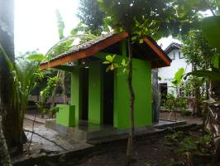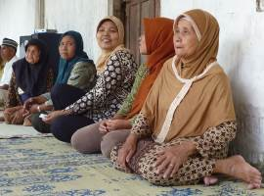
In February we visited six candidate sites and talked with many people on the spot. Four of these locations were not suitable for technical or social reasons: not centrally located, no free land, too low (which bears the risk of the septic tank flooding) and in one case the impression was that social cohesion was too low (i.e. there was a lack of the cooperation needed to limit the building costs). Two locations were suitable and we made agreements about place, time, costs and procedures. In mid-March construction started at one location.

II Yogyakarta-Java / Singaraja-Bali Scholarships

By the end of February, we met the students Eka, Derli, Sumi and Trifena in Yogya. They all brought last semester’s grades which were all very good. Derli (S1 Nursing) even received a performance bonus. Sumi (the dancer at the Art Academy) has to make a choice between choreographer/dancer or a more theoretical direction. She would like to choose the former, which is expensive because for graduation assignments students have to organize their own music, venues, dancers, food/drink and clothing.

Recently we received requests for student scholarships for next school year:
- Sumi: the choreographer who needs additional funds
- Sulastra (gardener at the children’s home): an agricultural training in Salatiga in Java
- Novia: who wants to study at university to become a Kindergarten teacher
- The male twins Adi and Ade who both want to study mathematics in Yogya
- Febi who wants to study Economics at university
The courses all start in July/August, we call on you to consider if you can support one of these dreams.
III Java : Seniors and Medical Support

This very useful and widely appreciated project with 264 participants is mainly financed from free gifts, for it is difficult to find dedicated sponsors for this project. The remarkable thing is that once someone attended a seniors’ activity himself (over the past few years there were several visitors who did) and experienced what it means and how much joy and gratitude there is, nine out of ten want to sponsor this project immediately. So we invite you cordially to come visit us in Yogya to see it with your own eyes. Travel costs can be saved by taking our word for it and in that case we invite you to donate 10% of the money you thus save to this project. ☺

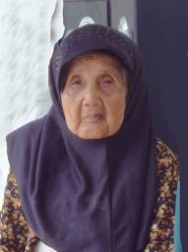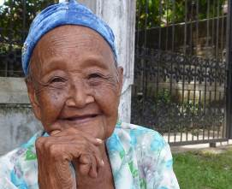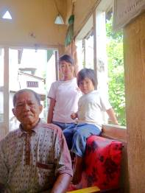

IV. Bali, Singaraja: Widhya Asih III Children’s home

All is well at the Widhya Asih III children’s home in Singaraja. The new vision is simple and unambiguous. Focus is on learning and studying and less than with Yohanes on creativity and activity. The atmosphere is good. Franky, the new head, spends less time in the office. In the team he is the "primus inter pares", towards the children he is cheerful. With pleasure we will continue to support them, starting with scholarships, the school bus and the medical costs.
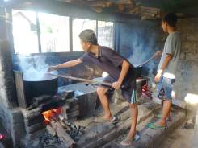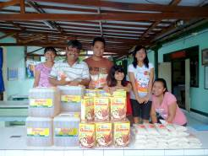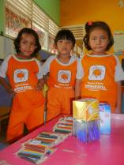
Batik production Staff and children with the presents brought by Siep and his wife

4. Sponsor visits

In February, Piet and Ine visited Yogyakarta. They were especially impressed by their meeting with the seniors.
We received the first profits of Jacqueline’s 'scarves project' ​​. Many thanks also to Jannie, René, Mr. Pok and Jack for their generous donations!

5. YouTube: Gotong Royong Utrecht channel

- Widhya Asih children’s home; with thanks to Anne from Alkmaar!
- new walker for Ibu Tegalmulyo: http://youtu.be/87X6JaeOqBg

6. Sponsoring possibilities

- the scholarship programme: one scholarship is € 60 (primary school), € 95 (junior high school) or
€ 125 (senior high school) a year and can start any time during the year,
- sponsoring a child of the children’s home for € 12 a month (€ 36 a quarter or € 144 a year) for complete sustenance,
- the support of a senior (60 plus) for € 10 a month (especially for vitamins, minerals and medical care). This is € 30 a quarter or € 120 a year.
Of course you can also send us a free gift and leave the spending to us.

7. Gifts

Gifts are more than welcome at our bank account in Holland (ABN AMRO): 84.21.36.932 (for the attention of Stichting Gotong Royong - Utrecht). For people who want to donate and who are living outside Holland, please contact us by e-mail so we can find a proper method of transaction for your donation.

8. Email & website

If you want to let us know something, if you have feedback, if you want to ask something, please send us an email: info@gotong-royong-utrecht.nl

And have a look at our website, with many photos of our projects: www.gotong-royong-utrecht.nl

