newsletter
volume 11 issue 1 31 march 2012


‘Gotong Royong Utrecht’ Foundation
postal address: oudkerkhof 15 bis, 3512 GH Utrecht, the netherlands
email: info@gotong-royong-utrecht.nl
bank account: 84.21.36.932 (FORTIS)
reg.number chamber of commerce H30179877

- From the board

We started our eleventh year in good spirits after having celebrated our tenth anniversary with a small and pleasant meeting. In the Netherlands imminent cuts on development aid cast a dark cloud, but we still see the sunny side: we feel supported by both loyal and new sponsors.

Yet we would like you to note that in Indonesia the cost of living (especially basic things like food) and costs for education are increasing rapidly. In addition, our call for scholarship sponsors and for supporting a senior, did not bring what is needed. Possibly there are sponsors who forgot to donate (and are now triggered) or possibly people are influenced by the current debate about the effectiveness of development aid. Then let us repeat that the effectiveness and the efficiency of our work is extremely high (directly on the spot, no intermediaries, minimum operating cost, 100% voluntary work), hoping those who doubt will reconsider. Some sponsors have other priorities or cannot donate regularly. But irregular support is also welcome. Because that is also ‘Gotong royong' (= helping each other)!
We welcome questions and critical comments; ask them, please do so. It keeps us sharp.

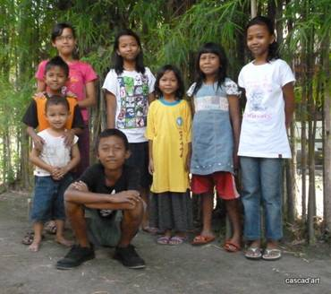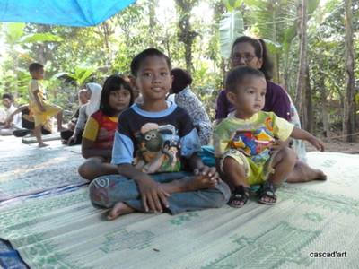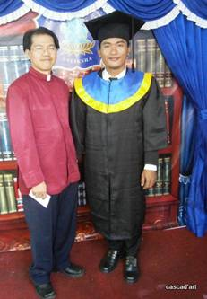
Artana graduated!

2. Couleur locale

We had a lot of rain in the past months, it's the monsoon season. Sometimes this causes a delay in building a public toilet. Meetings are cancelled because "it was raining" is a very acceptable reason for not appearing. "It will rain" is less acceptable, in any event as far as we are concerned ☺.
In January and February we met many children who receive a scholarship, both in Java and Bali, often accompanied by their parents and our coordinators. It is a great pleasure to see our policy put into practice, with tailor-made support for every child.

3. Project information

I. Yogyakarta-Java : MCKs (public bath/washrooms)

One of our most successful projects: a Golden Oldy that still has not lost its power nor its necessity and which has become a standardized concept with a firm set of procedures and an experienced construction team. And of course each site is unique and there are specific circumstances that require adjustments in implementation.
We met a real challenge in Banaran (15 kilometres from Yogyakarta) where the need to build is clear, but groundwater is 25 to 30 metres deep so the well would take a lot of time digging and would cost extra money. Furthermore it was difficult to find anyone prepared to descend to such a depth via a shaft with a 1.5 metre diameter. But we managed to find a team that dared to do it. They are now digging this well in a month (10 hours a day) on a ‘no water, no pay’ basis. In the meantime, an MCK was finished in Agrosari and we visited potential sites for MCKs in Sunggingan in Sleman. We approved the sites and construction started on April 2.

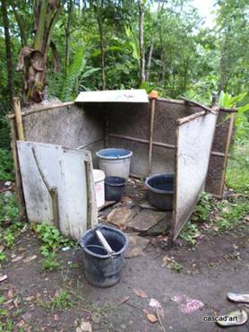
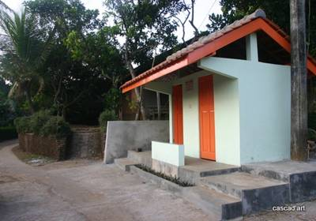
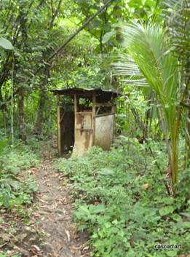

On the left and right you see the kind of ‘bathroom’
we replace by new, hygienic MCKs

II Yogyakarta-Java Scholarships

The second semester was completed. Amaliah is the coordinator and she has done a tremendous job: she involves the parents and children in the choices that have to be made. In January and February, we visited a total of three schools, three parent/child groups (outside school) and we arranged a few home visits. We also interviewed the parents of next year’s scholarship candidates. The focus of the Yogya-scholarships will shift from primary to secondary school (where possible to vocational education, SMK). For this we need more money. The cost of an SMK scholarship equals three to four primary school scholarships. In Gunung Kidul we visited a group of SMK students gathered with their parents at the home of one of the children. It was touching to see how they talked about how essential the support from our sponsors is. We clearly make a difference here and create opportunities for young people who, without vocational training, would have no prospects on the labour market.

III Yogyakarta-Java: NEW community development project

Taking into consideration our good experiences with community development in 2006-2008 in the village of Wukirsari in Bantul, we are very motivated to start a similar project in Gunung Mojo in Sleman: infra-structural and economic development. A crucial element of this project is the construction and installation of electricity. We also want to pave the paths and gutters, build two MCKs and install public lighting. And we want to instruct the people in agricultural work and change their attitude towards self-sufficiency by providing micro-credits. For this project we are seeking additional funds and private sponsors who are fascinated by this thorough approach. Are you?

IV Java - Bali : Seniors and Medical Support

One of our major projects. In February we visited the seniors of Singaraja in Bali again, after three months. Their reactions were angry: "where had we been all this time" and "how could we leave them all alone." And all of this repeated 60 times. All in a playful manner, to celebrate the joy of the reunion. The project was of course perfectly managed during our absence by Ratna and the medical team. But "Pak Will and Kornelis" were really missed. A good feeling, a pleasant reunion for all.

V. Bali : Widhya Asih III Children’s home, Singaraja

Yohanes and his staff do their job with love and passion and their motivation is as strong as ever. It is wonderful to see the children getting, and taking, opportunities to develop. “Trust, delegate, and see them grow”. Sudiyanti for instance (student of economics) who took on the management of the scholarship programme: the inventory of supplies needed per child, procurement, distribution and administration. She has grown and has become a strong young women.
In February we had a party. Artana, Art and Design student at the University of Singaraja, graduated! He successfully completed five years of study and his chances of finding a job are good.

VI. Bali : Scholarships

While Sudiyanti did her part at the orphanage, Ratna managed the scholarship programme for primary schools (Paket Agung and Santa Maria) and St Paul’s High School (SMP). We were available in the background, but it was not necessary: Ratna and Luh did the job.
We visited the SMP to consult the coordinator and to make payments (tuition, books and extra lessons e.g. computer instruction). Of course a lot of lobbying took place to continue our scholarship programme, although they do understand why our priorities shifted to Yogyakarta.

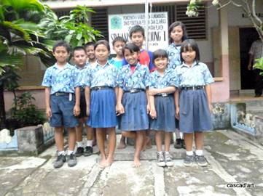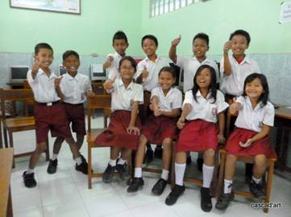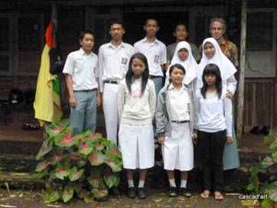

4. Sponsors!

In February Ine and Peter visited us in Yogyakarta. They supported the orphanage in Singaraja with a gift (rice,oil and sugar). The fund-raising of Lisette and Edwin (which started in December 2011) resulted in an amount sufficient for building an MCK. Fantastic! In April Dolf celebrates his 75th birthday. For the occasion he called on his family and friends to make a donation to our foundation. Cees, Anne and Michael of the Alkmaar freemason’s lodge are still busy trying to find sponsors for the orphanage in Singaraja. Our most heartfelt thanks to all!

5. Social networks

Project videos can be found at You tube: http://www.youtube.com/user/GotongRoyongUtrecht:
- Widhya Asih children’s home; with thanks to Anne from Alkmaar!
- Ibu Suresemi (a Parkinson’s patient receiving our support)
If you are a Facebook user, please link our website to your Facebook by using the ‘thumbs up’ symbol on our site. Your Facebook friends might be interested in supporting us!

6. Sponsor possibilities

- the scholarship programme: one scholarship is € 60 (primary school), € 95 (junior high school) or
€ 125 (senior high school) a year and can start any time during the year,
- sponsoring a child of the children’s home for € 12 a month (€ 36 a quarter or € 144 a year) for complete sustenance,
- the support of a senior (60 plus) for € 10 a month (especially for vitamins, minerals and medical care). This is € 30 a quarter or € 120 a year.

Of course you can also send us a free gift and leave the spending to us.

7. Gifts

Gifts are more than welcome at our bank account in Holland (Fortis): 84.21.36.932 (for the attention of Stichting Gotong Royong - Utrecht). For people who want to donate and who are living outside Holland, please contact us by e-mail so we can find a proper method of transaction for your donation.

8. Email & website

If you want to let us know something, if you have feedback, if you want to ask something, please send us an email: info@gotong-royong-utrecht.nl

And have a look at our website, with many photos of our projects:
www.gotong-royong-utrecht.nl

