newsletter
volume 10 issue 1 31 march 2011

‘Gotong Royong Utrecht’ Foundation
postal address: oudkerkhof 15 bis, 3512 GH Utrecht, the netherlands
email: info@gotong-royong-utrecht.nl
bank account: 84.21.36.932 (FORTIS)
reg.number chamber of commerce H30179877

1. Ten years!

Volume 10: incredible! Ten years ago we started small-scale projects in Indonesia. Ten years that flew by. Ten intensive years. Ten instructive, confronting, formative and very inspiring years that started with a four- month sabbatical leave on Bali and Java in 2001. After this year there was no stopping doing what we have done for ten years now: following our hearts. And we can recommend it: just make the first move and the rest will follow.
These ten years would not have been possible without you, dear readers, sponsors, old and new friends, (ex)colleagues, family, brothers and sisters, new acquaintances and all others involved. Because of you we were able to realise what the local population needed and what we considered necessary. We represented you and carried out your wish to contribute to the well-being of others. We extend our thanks to you.


The foundation is entering its tenth year. Perhaps there will be a party when we celebrate the tenth anniversary (March 2012): we would like to meet our sponsors and we would love to receive presents. But spending money on this would not be right, so we consider the options and are looking for sponsors who would like to support. Don’t hesitate to contact us on this matter.

2. Attention Facebookers!

On our website’s home page www.gotong-royong-utrecht.nl we put a thumbs up symbol you can use to point out our website to your Facebook friends. Hoping this social network will work, we ask you to use it to link our site to your Facebook.

3. More from the board

Financially 2010 was a successful year in which we managed to survive economic storms and financial troubles. We were able to stabilize our level of activity on Bali and expanded on Java (+ 20%). Once again we managed to spend over 95% of gifts received directly on the projects. Bank and office costs have risen slightly compared to 2009, because of more project activity and higher rates. (Local) traffic costs were not paid from gifts and volunteers’ lodging expenses were paid by these volunteers themselves. The annual accounts can be retrieved by e-mail.
In July 2011 Gotong Royong will take office in Yogyakarta (Java). Because of a 70% rent raise of the premises in Singaraja Bali and because we are needed more in Yogya where more projects take place, we decided to abandon the Bali office. Apart from financial and organisational reasons, there are also personal reasons for the move to Java. The Bali projects will proceed, we will travel from Java to Bali frequently to monitor the projects there.

Sharing networks in order to get financial support did not produce anything yet. In total, five local service clubs (Lions, two Rotaries, Kiwani’s and ‘Junior Kamer’) have been approached by sponsors. It did not lead to project sponsoring. There was, however, a successful action by a freemasons’ lodge in Alkmaar and presentations at several other lodges will be held. Also an artist is preparing a works of art sale, the profits of which will be donated to our projects.
We hereby thank all our sponsors for their generous gifts. Edwin and Lisette deserve our special thanks: these (world) travellers raised money and wrote very enthusiastically about their visits to our projects on their website. You will find a link to it at our website’s home page.

4. Project information

I. Bali: Widhya Asih III children’s home, Singaraja

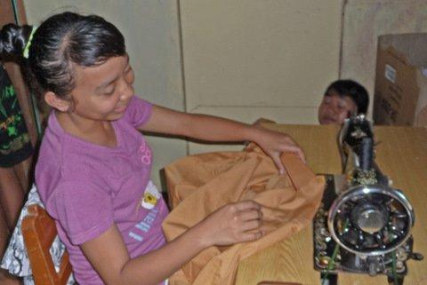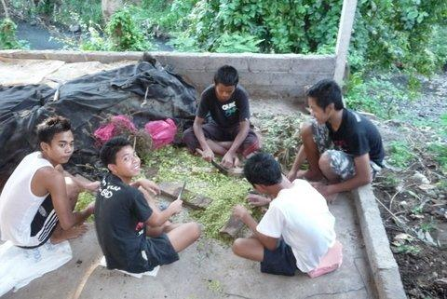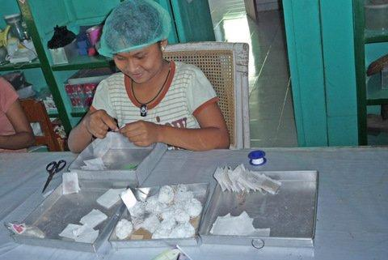

The home is prospering. We say this with pride, because it is a real achievement. An achievement of the staff and the children. All kinds of things happen that have to be dealt with: foreign visitors, a child with appendicitis, a child that meets the evil spirit of a cut down waringin tree and causes panic, children that are naughty, theatre performances and many, many other things.
An example of quick-wittedness and organisational talent was the way they handled the collecting, buying and distribution of school supplies, uniforms, bags and shoes. A young girl, Sudi, who assisted Trifena (who is now studying in Yogya) last year, took over the management of this project and did the job in three days. Armed with our wallets we followed her when she went purchasing all supplies in the shops and at the market and witnessed her thoroughness. A month later we spoke to Yohanes, the head of the home, about new candidates for continued schooling and Sudi’s name came up. She would like to study Economics and Management in the evenings and work at the children’s home during the days. That same day we told her we would look for a sponsor. She was thrilled, she almost could not believe it. And now, a month later, we received an e-mail from two Dutch travellers who visited the home, witnessed her joy and offered to pay for her studies. Instant karma!
A new project was born: an internet café for the children living in the home and those living in the neighbourhood (who will pay for using it). We will look for a sponsor but first have to agree on the execution of the plan. We will keep you informed.

II. Bali: Scholarships

The start of the second semester is the moment to collect school supplies, clothes and shoes for all children. The children’s home is managing its part, but the rest is up to us. Fortunately we, the schools and the shops, are so experienced in the process that the job was easy. Within two weeks it was done, only school fees and books will have to be paid and administration will have to be updated. Some additional specific individual requests usually follow, but those are a pleasure to deal with.

III. Bali: Seniors & Medical Support

Living close to seniors relieving their feelings every now and again means we are confronted with the temporariness of life more often than others. Not a month passes without the message that someone will not attend the next meeting because he or she passed away. Until this year in these cases a new participant has been able to join, but because of risen food prices the parcels are much more expensive now. By NOT taking in new seniors after decease we compensate for the risen costs. This also sends out the signal that this project doesn’t come natural and we also suffer from the crisis.
In March Bapak Gede Ngurah died; after a second stroke, exercise was of no more use; he was tired, weak and depressed. Ibu Setre, who cared for her one-year-old great-grandchild, also died. A new home had to be found for the child because the father is in jail and the mother has disappeared. The situation of Ibu Suresemi who suffers from Parkinson’s disease (you can see her on our You tube video) improved because of better medication; she has less pain, is able to walk better and remains optimistic.
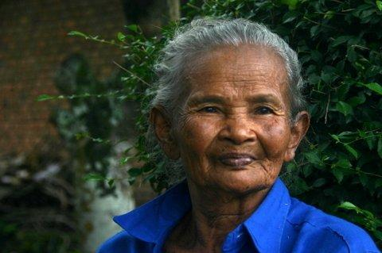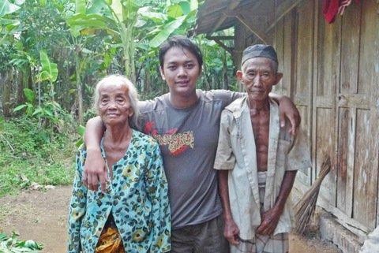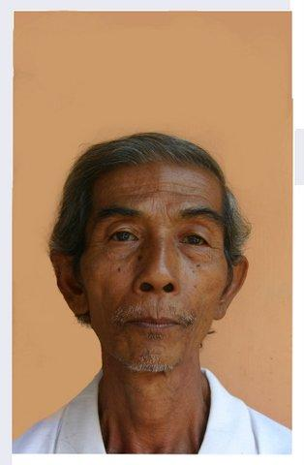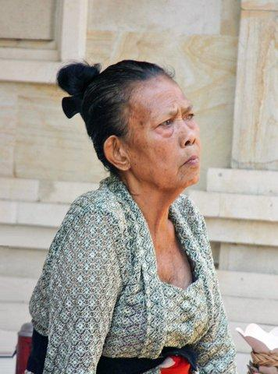

IV. Java: Yogyakarta; Seniors and medical care

This project is going well. Many volunteers (partly of the PKK district committees) assist us. The costs of our food parcels have risen with 40 euro cents per parcel, a monthly budget rise of 144 euros for 360 parcels.
Our plans with the Nur Hidayah hospital in Bantul (the Mother and Child project: preventing death at birth) are being worked out.

V. Java: the students

Eka, Derli and Trifena (all from the Bali children’s home) are successful in Yogyakarta; in their studies as well as in living in the Javanese city. Agung, who finished his nursing study six months ago and who now has a job in the Nur Hidayah hospital, would like to proceed with further studies in his field because this would offer him a better position and a higher salary.

VI. Java: Yogyakarta; Scholarships

The 150 scholarship children in Yogyakarta also received their uniforms, shoes and school supplies. A big job for the volunteers who carried it out. Amaliah (personal assistant of Ibu Murdijati, the chairwoman of our local partner foundation) is in charge.

VII. Java: MCKs (public wash/bathrooms)

Amaliah also coordinates the building of the MCKs and she does it thoroughly. We once again joined her in searching new locations, checking the work in progress and monitoring the result. In February we visited four possible locations in Sleman. Two, we immediately agreed upon, were good. One village will look for a new location at our request. They favoured a location where there already was a well, but we had the water tested and it was of bad quality. One location we rejected, without much discussion: the representatives of this district were mainly interested in what more we could do for them.
Amaliah and we actually always share the same opinion. She is critical and is able to cross the cultural mine field without the so called Dutch directness, that in Asia is often considered rude.

VIII. Java: Yogyakarta; mount Merapi

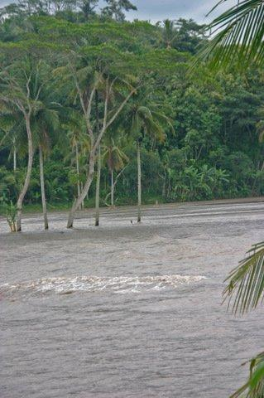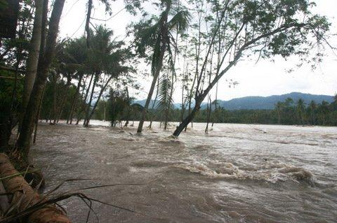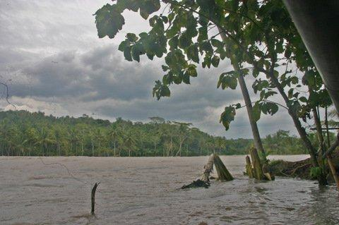

Because of all disasters and (civil) wars, the problems of Mount Merapi’s eruption disappeared from the world news. This, however, does not mean problems are solved. The meters thick layers of ash on the slopes turned liquid when the monsoon rains fell and came down taking huge rocks with them. In Sleman, north east of the city, bridges have been washed away and huge areas of sawah fields were flooded. A river overflowed and became five times as wide. Many farmers are waiting for this mud flow (which they call cold lava) to stop and give back their land to them.

5. social media (you tube and facebook)
Project videos can be found at our You tube page http://www.youtube.com/user/GotongRoyongUtrecht:
- Widhya Asih children’s home; with thanks to Anne from Alkmaar!
- the nursery in Yogyakarta
- Ibu Suresemi (a Parkinson’s patient receiving our support)
As mentioned above: link our website to your Facebook by using the ‘thumbs up’ symbol on our site.

6. Sponsor visits!

Lisette and Edwin visited the projects in Yogyakarta and the children’s home in Singaraja (click on the names to read about it on their website).
Kees and Els visited the children’s home and stayed there for a couple of days.

7. Sponsor possibilities

If you decide to support the initiatives of Gotong Royong financially, first think if you want to help any specific project or if you want to leave the spending to us.

Possibilities:
- the scholarship programme: one scholarship is € 60 (primary school) € 95 (junior high school) or
€ 125 (senior high school) a year and can start any time during the year,
- sponsoring a child of the children’s home for € 12 a month (€ 36 a quarter or € 144 a year) for complete sustenance,
- the support of a senior (60 plus) for € 10 a month (especially for vitamins, minerals and medical care). This is € 30 a quarter or € 120 a year,
- the support of a child in the Roemah Kita nursery for € 10 a month.
- the support of mentally ill patients by paying their monthly medication: € 14 a month

Of course you can also send us a free gift and leave the spending to us.

8. Gifts

Gifts are more than welcome at our bank account in Holland (Fortis): 84.21.36.932 (for the attention of Stichting Gotong Royong - Utrecht). For people who want to donate and who are living outside Holland, please contact us by e-mail so we can find a proper method of transaction for your donation.

9. Email & website

If you want to let us know something, if you have feedback, do you want to ask anything? Send us an email:
info@gotong-royong-utrecht.nl

And have a look at our website, with many photos of our projects:
www.gotong-royong-utrecht.nl

