newsletter
volume 13 issue 2 30 JUNE 2014


‘Gotong Royong Utrecht’ Foundation
postal address: oudkerkhof 15 bis, 3512 GH Utrecht, the netherlands
email: info@gotong-royong-utrecht.nl
bank account: NL74ABNA084.21.36.932
reg.number chamber of commerce H30179877

- From the board

For all children who receive our support, the school year ended with (sometimes very) good results. The new 2014-2015 school year will start in mid-July. Therefore we place a modest appeal to anyone who in the past year supported a scholarship (ie per school year, not per calendar year) to consider doing so again in the coming year, to support the study of a child (elementary school, junior high school, vocational school, or even college or university).

We received some extra nice gifts. Thanks to Rene, (Ma) Ria, Pak Lim Yann Pok and Jaap. We also pay tribute to those of you who support us through monthly direct debits.

In the last newsletter we wrote about the temporary suspension of the construction of MCKs (public bath/washrooms) in connection with the elections, since such projects are vulnerable to corruption. The parliamentary elections are now behind us and the presidential elections will take place on July 9th. Until then, we will look at this shadow play (wayang topeng) from a distance. And because Ramadan will start
just now, we do not expect to start building again before August.

Good news: Yudi and Novianti (who both lived in the orphanage in Singaraja) got a beautiful baby girl. In this picture you see mother and child.

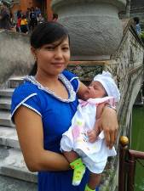

2. Couleur locale Indonesia

At this moment two things prevail: the presidential election and the world football championships. Indonesia is a football loving country and a large part of the Indonesian population supports Holland.
For the presidency there are two candidates: the popular new governor of Jakarta, Jokowi, and the man from the old Suharto camp: Prabowo, who considers his ex father-in-law (head of one of the richest and corrupted families of Indonesia) a national hero. Jokowi and his runner-up, former vice president Jusuf Kalla, are quite popular. The slandering and defamation has already begun and the media, which are not independent, play an important role. The stakes are high and individual interests clearly prevail over the regional and national ones. "Every country gets the president it deserves," is what we think.

3. Project information

I. Yogyakarta-Java : MCKs (public bath/washrooms)

Although construction work has been suspended, the search for suitable locations continues. Amaliah nominated two candidates. Regrettably, it was not possible to get a good agreement on the land: the owners did not want to sign a waiver. As a result the land cannot be made an official community property and, in theory, the family can reclaim the land with the MCK on it at any given time. This risk should be taken seriously. Children or grandchildren that live or were born elsewhere, often have weak links with the kampong and tend to ignore adat law especially when money is involved. We had to choose between settling for a verbal commitment or refraining altogether. On the advice of our local volunteers, we decided on the latter.

You can nevertheless see some new MCK developments on our You Tube channel. There is a new video about this MCK in Karangasem south of Yogyakarta.

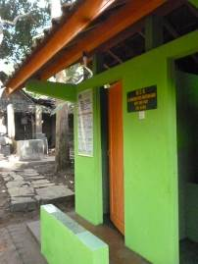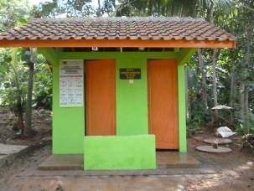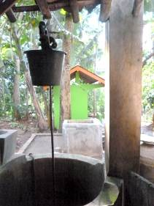

The MCK sponsored by Rob en Ans

II Yogyakarta-Java / Singaraja-Bali: Scholarships

The school year is over and the results are good: all children passed and practically all will move to the next grade. In Yogyakarta there are children again who hope they will qualify for further education. In principle, the duration of our scholarship lasts until the final exams of their current school. After that, if a child wishes to proceed his or her education, we have to decide whether or not we will support them, and thus commit ourselves to sponsoring them for another three years to come. Amaliah, whose judgement we value very much, will again advise us on this.

On Bali there are three children, outside the children’s home, who receive a scholarship. They are all grandchildren of pak Made Putra. The eldest grandson (Putu), who is studying Hotel Business at vocational school, passed his exams with honors! His sister passed her final exams at junior high school (SMP Santo Paulus). The youngest brother, who is in primary school, will move to second grade.

III Yogyakarta-Java-Bali : Seniors and Medical Support

All runs smoothly; the two new volunteers (Bu Santi and Bu Daryati) are fully trained now. The five groups (currently 230 seniors) receive proper care and attention and the group in Tegal Mulyo that was restarted is a close-knit group again. After having had some discussion about the quality of the medication, we chose for better quality and more variety in blood pressure medication.

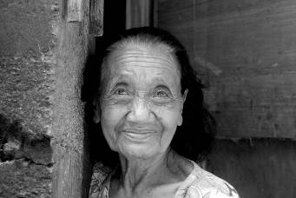
Bu Reken
On Bali one of the last three seniors who still receive our support, Bu ​​Reken, unexpectedly passed away. Everyone had expected that her weakened sister would die, but it was Bu Reken instead.
In addition to the now two remaining seniors, we support a younger widow (Penarukan) with three children. One of her children lives in the children’s home.

IV. Singaraja, Bali : Widhya Asih III Children’s home

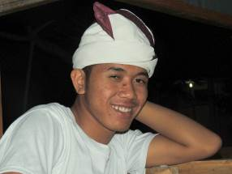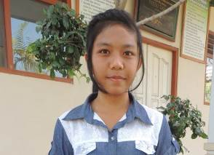
Pande Lina

From the group that finished high school in June, two candidates emerged who have the motivation and capacity to continue studying at university: Lina (Dietetics) and Pande (Economics & Management). The former at Denpasar and the latter at Singaraja. The Dietetics study (Ilmu Gizi) at the University is especially expensive, partly because Lina will have to live in Denpasar, which increases costs by 40%.
Who will support them? For more information please contact us at info@gotong-royong-utrecht.nl.

What about the students who already started?
Derli (Nursing Studies at Yogyakarta) completed the theoretical part and will soon start practice. Trifena (Theology) is halfway her internship. Sumi, who studies Dance at the Yogyakarta Academy of Arts, conducted her first choreography. Sudi started writing her thesis (Economics, Singaraja) and Suarcaya is now taking his exams (Higher Technical school at Denpasar). Nyanyi and Novia successfully finished the year (Economics) and Ayu successfully completed her first two semesters.

4. Sponsor visits

At this moment Loes, who just finished high school, is in the orphanage for a two months’ period of voluntary work. When she was there for the first time with her parents six years ago, she said, "Before I start my studies, I will be back to help!" And here she is now!

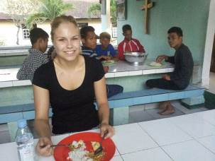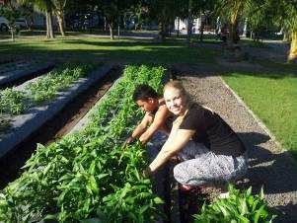

In July Sylrieke, another young student, will visit the orphanage.

In April Jaap celebrated his 70th birthday and he asked his family and friends to donate money to one of his favourite charities. We received 590 euros! Many thanks to those who gave a donation and especially to Jaap!

5. You tube: Gotong Royong Utrecht channel

http://www.youtube.com/user/GotongRoyongUtrecht
- Widhya Asih children’s home; thanks to Anne from Alkmaar!
- new walker for Ibu Tegalmulyo
- NEW: an impression of the location and the operation of a new MCK: http://www.youtube.com/watch?v=pY8CY9Yr5pc

6. Sponsoring possibilities

- the scholarship programme: one scholarship is € 60 (primary school), € 100 (junior high school) or
€ 165 (senior high school) a year and can start any time during the year,
- sponsoring a child of the children’s home for € 12 a month (€ 36 a quarter or € 144 a year) for complete sustenance,
- the support of a senior (60 plus) for € 10 a month (especially for vitamins, minerals and medical care). This is € 30 a quarter or € 120 a year.
Of course you can also send us a free gift and leave the spending to us.

7. Gifts

Gifts are more than welcome at our bank account in Holland: NL74ABNA084.21.36.932 (for the attention of Stichting Gotong Royong - Utrecht). For people who want to donate and who are living outside Holland, please contact us by email so we can find a proper method of transaction for your donation.

8. Email & website

If you want to let us know something, if you have feedback, if you want to ask something, please send us an email: info@gotong-royong-utrecht.nl

