newsletter
volume 12 issue 2 1 july 2013


‘Gotong Royong Utrecht’ Foundation
postal address: oudkerkhof 15 bis, 3512 GH Utrecht, the netherlands
email: info@gotong-royong-utrecht.nl
bank account: 84.21.36.932 (FORTIS)
reg.number chamber of commerce H30179877

- From the board

The second quarter was successful both financially and in terms of project progress. We had adjusted our expectations for this quarter because we noticed how heavily the national sense of economic crisis was felt and it seemed the worst was yet to come. However we experienced we have fantastic sponsors who, despite the crisis, continue to support us and motivate others to do the same. This encourages us to proceed our projects in Indonesia with energy and joy.

In this newsletter we thank our board member Loes for her contribution over the past nine years. Other busy work compelled her to stop working for the foundation. Thank you for your dedication, enthusiasm and scrutiny.

The 2012-2013 school year ended in the third week of June. School holidays started both in Singaraja and in Yogya . All children who did their final exam passed. Most of them will continue their education at a higher level. We call on the sponsors who give their scholarship support per academic year to keep supporting them. We will take care of the rest. On this you have been able to rely for 12 years already!

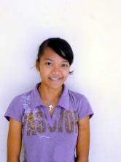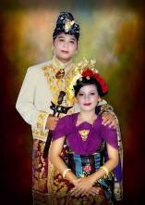
Novia, new student Ayu Mang, new student Yudi and his wife

2. Couleur locale - Holland-Indonesia

Holland: With an open mind we read Femke Halsema’s (a Dutch former politician) critical opinion on emergency aid organizations. She certainly has got a point. Large organizations tend to have an inward focus: bringing in money becomes a goal in itself. We experienced this ourselves in 2005 (Aceh tsunami), 2007 (Bantul earthquake) and 2011 (Mount Merapi eruption). Collaboration is hindered by fear of losing the organization’s own identity and thus ‘losing my job’. This lack of collaboration sometimes is quite understandable, there is a lot of well-intended amateurism next to expensive professionalism. Criticizing each other was not done. Now things appear to be changing because government support has been reduced whereas overhead costs have not. So, despite the governments urge for collaboration, rivalry arises. Apart from the religious and social differences that already existed, there are now also financial reasons to distinguish oneself. The social media play an important role, everyone seems to feel free to publish their opinion. As do we, herewith ☺

Indonesia: Not only in the Netherlands people complain about too much rain and too little sun, in Bali and Java this is also the case. It is too wet. The monsoon should have been over long ago, but the rain still keeps falling and farmers fear the rice harvest will fail.

At last: the fuel subsidies were reduced. The price of petrol will be raised 40% to about 49 eurocent per liter. This provides great savings to the government, they are now deciding on allocating those funds to other goals such as education and health care (about time!).

3. Project information

I. Yogyakarta-Java : MCKs (public bath-washrooms)

In the past months we visited many sites and some of them were very suitable. In April we built an MCK in Imogiri (Seropan) that was officially handed over in May. We also found two locations in Karangasem (Bantul) and two in Kedungprahu (Sleman). There we already finished one MCK and we started building the second one in the third week of June. We hope we will finish it before the beginning of Ramadan (July 10). In the rest of July and the first weeks of August not much work can be done due to Ramadan and Idul Fitri (Sugar Feast). We will resume work by the end of August.
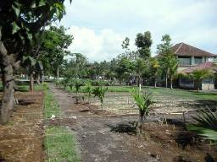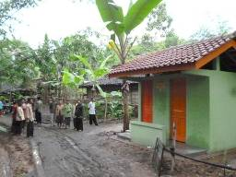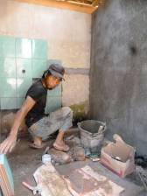
Garden Widhya Asih III children’s home MCK Seropan (May 2013) Tiling in Kedongprahu

II Yogyakarta-Java / Singaraja-Bali scholarships

In the last newsletter we called for additional scholarship contributions. We like to repeat this call, especially since we now know exactly what awaits us: which children will continue their education and how many new candidates were admitted. In June, on a neutral location, we spoke to many parents who signed up for scholarship support. After the first selection we visited the children at home to get an impression of the home environment and we performed a data check. As a result six more children fell off. The remaining children (a few more than the outflow) were admitted.

In Bali, all ten children who had to do the final exams of the SMA (senior high school) or the SMK (Vocational Training College) passed. Four of them (boys) will go to college in Denpasar (not at our expense) and two girls were admitted to the study of their choice. Novia wil study to become a kindergarten teacher and Ayu Mang starts studying Economics. We continue to support them. The others leave the orphanage looking for work. Cahyadi graduated in April. He studied Sociology and Public administration at a university in Singaraja.
The twins from Gunung Kidul in Java who wanted to study Mathematics did not pass the first entrance exam of the prestigious Gajah Mada University. They did not do it again because they were selected (5 out of 150 candidates) for a training programme at a large multinational in Jakarta. Their talent was recognized!

III Yogyakarta-Java : Seniors and Medical Support

In May and June we mapped the blood pressure and blood sugar of all 264 seniors to develop policies regarding medicine. We measure blood pressure every month, but because we do not have the same doctor doing it at each location, we saw differences in the type and amount of medication prescribed. Using the data collected in consultation with a doctor we decided on a standard policy. Someone with chronic high blood pressure is not helped by getting pills for only five or ten days. We also developed a policy on diabetes medication. And we switched to centralized procurement of drugs, which lowers the price.

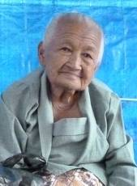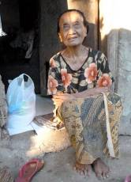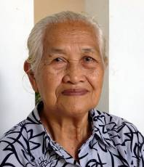

IV Yogyakarta-Java : Rumah Kita nursery

The nursery and pre-school Rumah Kita is very successful, not in the least because of the enormous commitment of Mrs Bambang Soehendro! In June they celebrated its 8th anniversary. For this occasion a children's operetta was organized by the parents and the volunteers. It looked very professional.

The Masonic Louisa Foundation was willing to co-finance the construction of a new classroom so all 55 children (in different age groups) can sit dry even during the wet monsoon season.

V Bali : Widhya Asih III children’s home, Singaraja

Former visitors to the children’s home will probably not recognize the courtyard anymore. It now serves as a vegetable garden. Sulastra, the gardener, has taken a course in Salatiga on growing vegetables and immediately started digging to prepare the courtyard for growing vegetables. His enthusiasm is contagious and the project will certainly reduce costs because less has to be purchased on the market.

Earlier this year, the first WA3-marriage occurred. You can see a picture of it on page 1. Yudi (staff member and former inhabitant of the home) married Novianti (a young woman who left the home five years ago for a training in Denpasar after completion of high school). They met again and now they are married.

School holidays! Most children went home at the end of June (to family). All children who had to do their final exams have passed, and all others went to the next grade with good results.

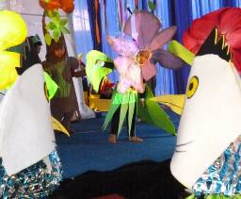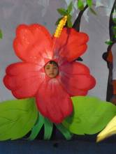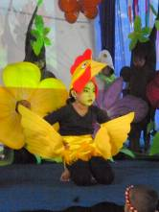
The 8 year anniversary celebration of Rumah Kita

4. Sponsor visits

There were no visitors in the past three months. But the holiday season has started and the first guests already signed up for July. We would like to thank Jenny for the generous gift to the Singaraja children’s home. The money was collected on the occasion of the funeral of her husband John, with whom she visited the home a few years ago. Also many thanks to Ton and Sas, Noor, Merel and Ria for their large gifts!

5. YouTube: Gotong Royong Utrecht channel

- Widhya Asih children’s home; thanks to Anne from Alkmaar!
- new walker for Ibu Tegalmulyo: http://youtu.be/87X6JaeOqBg

6. Sponsoring possibilities

- the scholarship programme: one scholarship is € 60 (primary school), € 95 (junior high school) or
€ 125 (senior high school) a year and can start any time during the year,
- sponsoring a child of the children’s home for € 12 a month (€ 36 a quarter or € 144 a year) for complete sustenance,
- the support of a senior (60 plus) for € 10 a month (especially for vitamins, minerals and medical care). This is € 30 a quarter or € 120 a year.
Of course you can also send us a free gift and leave the spending to us.

7. Gifts

Gifts are more than welcome at our bank account in Holland (ABN AMRO): 84.21.36.932 (for the attention of Stichting Gotong Royong - Utrecht). For people who want to donate and who are living outside Holland, please contact us by e-mail so we can find a proper method of transaction for your donation.

8. Email & website

If you want to let us know something, if you have feedback, if you want to ask something, please send us an email: info@gotong-royong-utrecht.nl

And have a look at our website, with many photos of our projects: www.gotong-royong-utrecht.nl

