newsletter
volume 11 issue 2 30 june 2012


‘Gotong Royong Utrecht’ Foundation
postal address: oudkerkhof 15 bis, 3512 GH Utrecht, the netherlands
email: info@gotong-royong-utrecht.nl
bank account: 84.21.36.932 (FORTIS)
reg.number chamber of commerce H30179877

- From the board

It’s summer in the northern hemisphere, holidays for many! For us it is the time to focus at finishing the 2011-12 school year and starting the next one. Not only is there a lot to administer and organize, but we are also looking for sponsors who are willing to support a child, or even several children, to continue its/their education. Hence the call:
Support the scholarship programme 2012-2013!
The children and their parents are hoping for your help!
A child can attend one year of junior high school for 95 euros
and one year of vocational education for 125 euros.

2. Couleur locale

There is much debate in the country about the Panca Sila, the official philosophical foundation of the Indonesian state . The principle of ‘unity in diversity’ is being challenged: pluralism is put on the agenda. Remarkable events even reach the international media: a Lady Gaga concert that was cancelled due to the pressure of a small number of hardliners; and the political struggle between Muslims and Christians on several islands. The country is changing and it may go in any direction, but as long as Indonesia is the third country on the list of growing GDP (over 6.6% growth), the influence of radicals is generally expected to remain limited. The results of the 2014 elections will show if these expectations are right.
Meanwhile we witness a growing amount of local tourists visiting Yogyakarta, Bromo and Bali. The concepts of recreation and holiday are gaining ground.

3. Project information

I. Yogyakarta-Java : MCKs (public bath/washrooms)

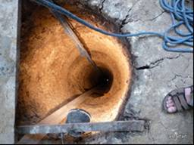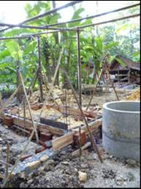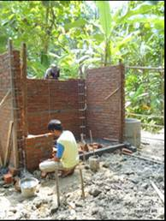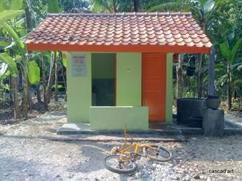
Digging for water Building Liset-Ed-family&friends’ MCK!

We found water! At 29 metres depth, after 26 days of digging and chipping. Thus the main precondition for the construction of the MCK in Banaran Lor was fulfilled allowing construction to start. And on June 9 the brand new MCK was presented to its sponsors: Edwin, Lisette, and Lisette's parents and brother. You can read their (Dutch) report at www.edenliset.waarbenjij.nu, but beware: their enthusiasm is contagious!
In the same area another MCK was built in Banaran Kidul, at a former ‘sendang’ (a well with a traditional washing place). We continue to be critical and will not build MCKs everywhere. In the last three months we rejected three proposed sites, not for technical reasons but for social reasons (like capacity, commitment and social cohesion in the neighbourhood). Besides: with Ramadan and Idul Fitri approaching no new projects will start until September.

II Yogyakarta-Java Scholarships

The 89 children in Java all passed to the next grade (which frankly does not always tell the whole story) or passed their final exam (which tells a bit more) and are trying to find affordable further education. Those who graduated vocational school reached the end of their education, they are looking for work.. and finding it! Three Playen graduates for instance already found a job in line with their training only one week after the exams. Some children would like further education, but our policy here is the same as in Bali: first they work for at least a year, so they can save some money and see if they are still motivated, and the following year we’ll be talking again.
We shift our focus from elementary school scholarships to secondary education. Vocational education is expensive and many drop out because of financial problems. Our scholarships are extremely effective: there has never been a sponsored child who dropped out too early. In June we were in Gunung Kidul, south of Yogya, where we met children (and their parents) who just received their SMP diploma (junior high school). Seven applied for a scholarship for vocational education, four of which were granted.
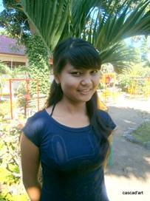 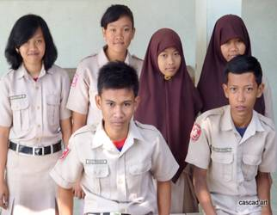 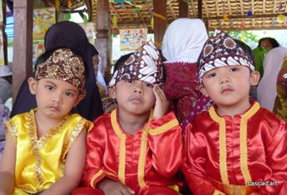 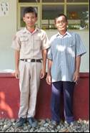 Nyanyi, student graduates SMP Playen 7th anniversary CAC Student and father

III Yogyakarta-Java: NEW community development project

In a previous newsletter we wrote about our enthusiasm for a new community development project. We have found sponsors and yet we have put the project on hold. We invested a lot of time and money in connecting the village to the electricity network and reactions were euphoric. But as electrical power came in, the energy went out of the project because the informal community leader left the village. He had found a job in Kalimantan. His successor has not yet proven to us to be an informal leader and the success of the project depends on such a person. So we decided to wait half a year and see how the social structure develops. If all goes well, we will start in October. But for now we’ll just wait and see.

IV Java - Bali : Seniors and Medical Support

“One of our main activities" we wrote a quarter ago. And so it is; with great pleasure and good results we run this project, but it is ever so hard to get (larger) sponsors interested in it. Everyone likes to help children with a future, few care for the short future of seniors. So we experience severe financial pressure. We already stopped one seniors’ group in Yogya. On Bali we reduced the food parcel budget by 25%. This is not pleasant but there is no other option (hopefully temporarily.
Medical care is not at risk, we have enough resources for this and we also get help from the Nur Hidayah hospital in Bantul who in turn received help from us: we gave them second-hand operating instruments, which Wil managed to get from a hospital in Utrecht in the Netherlands. We were also able to buy Ibu Tegalmulyo a new walker. She beamed as if she had won a prize.
Consider this: For a few euros a month you help a senior in our project.

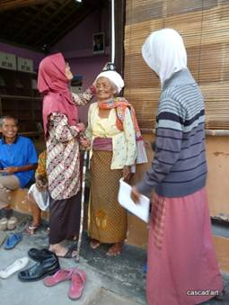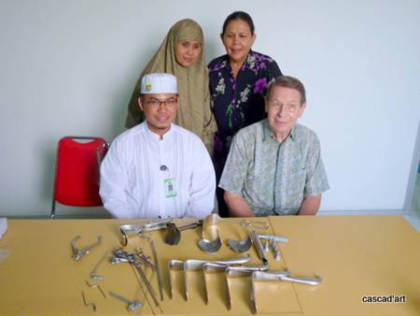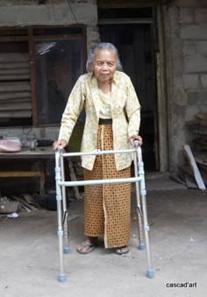
Medical check instruments for Nur Hidayah new walker

V. Bali : Widhya Asih III Children’s home, Singaraja

There is work to be done at the children’s home: the plumbing needs to be renovated and a few drying spots for clothing must be created. There are some leaks, plastic doors that need replacing (damaged because of dehydration) and floors that need to be made. All this will be done this summer during the holidays. All children who did their final exams graduated. For those who finished vocational school this is the end of their education, they will leave and find a job. The rest is hoping to be allowed further education. The Widhya Asih organization is trying its best to find sponsors since we will no longer give support. We keep a watchful eye though, without them knowing it. Our support for the home will continue in clearly defined projects instead of open-ended support. This coming semester Nyanyi will start her studies in Economics at the University. She finished high school a year ago, has been working this last year and proved to have the right motivation and attitude. A fundraising action of Golf Club Ookmeer did the rest.

VI. Bali : Scholarships

Last month we closed the official Bali scholarship programme that ran for six years and supported 180 to 220 children per year. We have asked the main sponsor to help in funding a transition period of two years for 25 children who are still in vocational school. The students of the orphanage will be supported until they finish their studies. And if sponsors are found, we will continue supporting university education for children’s home students.

4. Sponsors

In June Edwin and Lisette visited us with Lisette’s parents and brother (see 3.I.) as did Anshu and Ramadatta. Wendy, Jos and their children are interested in our work and will pay a visit in July to look at some projects. Dolf’s fundraising yielded over 1485 euros! There were also fantastic and unexpectedly large donations from Sir Pok, former colleague Ria and Freemason’s lodge ‘de Noordstar’, thanks to Cees, Anne and Michael for their unwavering commitment. Lenie organized a treasure hunt for members of golf club ‘Ookmeer’, they were hunting a golf pro. The entry fee of 350 euros was donated to us, including a gift from the Pro! Many thanks, on behalf of Nyani.

5. Social networks

Project videos can be found at You tube: http://www.youtube.com/user/GotongRoyongUtrecht:
- Widhya Asih children’s home; with thanks to Anne from Alkmaar!
- Ibu Suresemi (a Parkinson’s patient receiving our support)
- NEW: new walker for Ibu Tegalmulyo: http://youtu.be/87X6JaeOqBg
If you are a Facebook user, please link our website to your Facebook by using the ‘thumbs up’ symbol on our site. Your Facebook friends might be interested in supporting us!

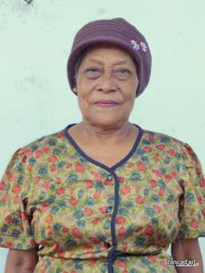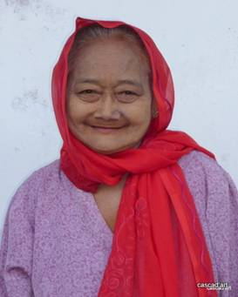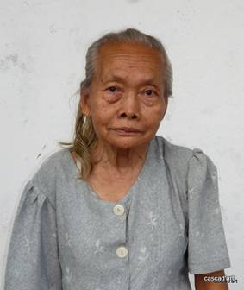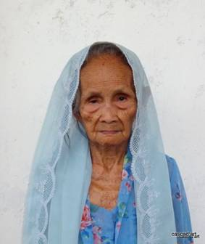

6. Sponsor possibilities

- the scholarship programme: one scholarship is € 60 (primary school), € 95 (junior high school) or
€ 125 (senior high school) a year and can start any time during the year,
- sponsoring a child of the children’s home for € 12 a month (€ 36 a quarter or € 144 a year) for complete sustenance,
- the support of a senior (60 plus) for € 10 a month (especially for vitamins, minerals and medical care). This is € 30 a quarter or € 120 a year.

Of course you can also send us a free gift and leave the spending to us.

7. Gifts

Gifts are more than welcome at our bank account in Holland (ABN AMRO): 84.21.36.932 (for the attention of Stichting Gotong Royong - Utrecht). For people who want to donate and who are living outside Holland, please contact us by e-mail so we can find a proper method of transaction for your donation.

8. Email & website

If you want to let us know something, if you have feedback, if you want to ask something, please send us an email: info@gotong-royong-utrecht.nl

And have a look at our website, with many photos of our projects: www.gotong-royong-utrecht.nl

