newsletter
volume 10 issue 2 5 july 2011

‘Gotong Royong Utrecht’ Foundation
postal address: oudkerkhof 15 bis, 3512 GH Utrecht, the netherlands
email: info@gotong-royong-utrecht.nl
bank account: 84.21.36.932 (FORTIS)
reg.number chamber of commerce H30179877

1. From the board

In the Netherlands summer started last week. The summer holidays are approaching. For many people the time to relax and travel. Here in Indonesia an increasing number of people spend the holidays travelling in their own country: Yogyakarta and Bali are flooded with tourists and the accompanying traffic. It is the law of the large numbers: a 1% increase of the travelling population means 50,000 more buses x 12 metres = 600 kilometres x 2 for the return journey = 1200 kilometres of traffic. Luckily they do not all travel at the same time.
Here on the southern hemisphere it is winter. The nights are cool, temperatures can drop to 23 degrees Celsius. We look back at a wet season with unpleasant consequences for the farmers whose rice, coffee, cocoa or clove harvests failed.
We closed the Bali office at the end of June, the Yogya office is in full swing now. The Bali projects continue as usual; Ratna is in charge and is doing a great job, frequently contacting us. We will visit on a regular basis. Our presence on Java is very useful and people are pleased with it. We hope to expand our activities here, doing more of the things we are good at: scholarships, senior citizen’s support and MCKs.

2. Sharing success!

As most of you will have read, we launched a campaign on Facebook and e-mail to find sponsors for Sumiasih from the Singaraja children’s home to pay for her four-year studies as a dancer at the Yogyakarta art school. We raised 3155 euros, sufficient to pay the school fees. The children’s home headquarters already agreed to pay for her travel expenses and lodging in Yogya (max. 45 euros per month). A great success! The money was raised by ten people responding to Facebook, stimulated by Wouter’s offer to double the amount, and seven people responding to the e-mail. Four sponsors together raised 2640 euros. A successful experiment with a new social medium. We will start a similar campaign for Gede Wira soon.

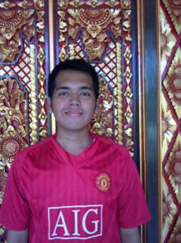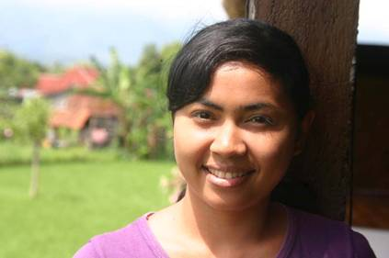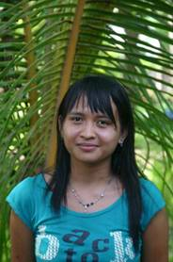
Gede Wira Sumiasih Sudiantini

3. Project information

I. Bali: Widhya Asih III children’s home, Singaraja

These days it is quiet at the home. Many children visit their families. The Hindu festivals take place in the school holidays this year, so a home visit is unavoidable. Often it is only for a week and then they return. Although it is nice to see familiar faces and meet the grandparents, they are better off at the home and with each other.
Yohanes, the manager, was very pleased with the good school results, partly thanks to the tutoring the children receive from each other and the staff. We are still waiting for the university results. This takes a long time, sometimes even months after the closing of the semester. We do receive positive signals from the students: Trifena (theology) passed her first year, Artana (last year of art school) is finishing his thesis, Cahyadi (government management) is doing an internship, Eka is very happy in nursing school and Derli is doing an internship at a hospital in Klaten. Luh Deyantini finished her computer studies and found a job at a bank and Muliani is starting her last semester of Indonesian language studies. Yudi and Sumi work at the children’s home and take evening classes in economics and management, their grades our good. We are very happy our sponsors enable so many children to study.

A few months ago a waste paper project started: the older boys make art objects that are sold at markets and exhibitions. It is not the objective to be completely self-supporting; child labour should be avoided at all times. But proceeds from the paper objects, batik, tea and vegetable growth help to reduce the home’s dependency on funding.
The laptops we received from Maurits several years ago need replacing. We are looking for money to buy desktop PCs that are better suited to the fingers of dozens of children (a keyboard can easily be replaced).

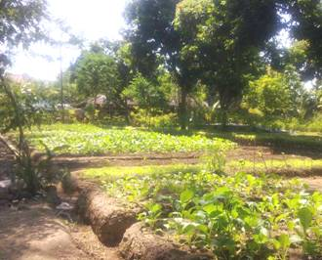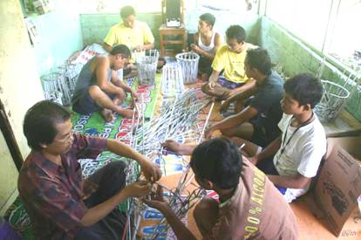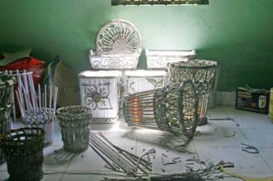
vegetable garden waste paper project waste paper products

II. Bali : Scholarships

We finished another school year successfully. Apart from the 110 children from the children’s home, we helped another 50 children in two small primary schools (Paket Agung and Santa Maria) and also 50 children from poor families who are in high school (SMP Santo Paulus). Besides, like every year, there were special cases we helped: a boy in the third year of senior high school who had to leave school because there was no money (he passed his final exams!), a child that had to go to the Paket Agung kindergarten in order to gain access to the Paket Agung primary school, by far the best school in that district. A Catch 22 situation. Kindergartens are mostly private and therefore much more expensive than government education

III. Bali-Java: Seniors & Medical Support

This project is still going strong, in Singaraja Bali (60 seniors) as well as in Yogya (360 seniors). We had to make a few adjustments to make ends meet, especially because the price of food has risen significantly and because it is hard to find institutional sponsors for this project. Grandchildren are more popular than grandparents… So, after consulting the local organisation, we gave up the outings and the gymnastics and gave priority to food and medical care.
After two years we stopped supporting Hidup Bahagia (mental care). Not because we doubt the necessity, but because of bad collaboration: we were mere money lenders, which was not what we agreed to be. Reports were absent or late and we did not receive information on other financial means. We expect Ibu Prof. Suryani’s charisma to be big enough to find other sponsors.
Our cooperation with the Nur Hidayah hospital in Bantul will continue. Wil Goosen found the Diakonessen hospital in Utrecht (Holland) willing to donate used medical instruments. In June these were handed over. The mother and child project is focusing on Caesarian sections, operations that in Indonesia are performed indiscriminately because they are regarded as profitable.

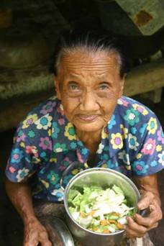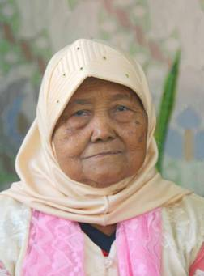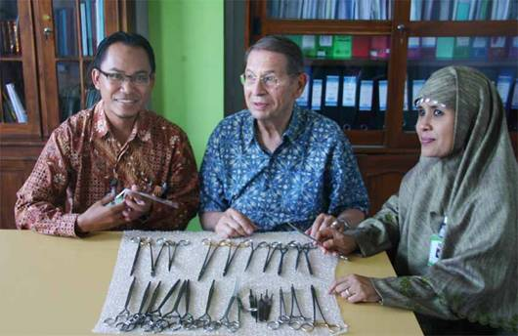
Two members of our senior citizen’s group and the handover of medical instruments

IV. Java: MCKs

This is our core business and really very successful: a cheap solution (900 to 1000 euros) to create a laundry, bathing and sanitary facility for an average of fifteen families. Often we also improve access by installing stairs, pavement and lighting. In the past three months we finished four new MCKs in the Sleman area! And we will proceed as long as sponsors are interested. You might want to consider sponsoring an MCK together with your friends or colleagues or ask one for your birthday!

V. Java: Yogyakarta; Scholarships

As on Bali we are very motivated to continue providing scholarships. We wish to support more children in junior (SMP) and senior high school (specifically SMK, craft school). This type of education is becoming more expensive and an increasing number of parents can no longer afford it. We now continue supporting the children that move from primary school to high school and gradually stop adding new primary school children. Amalia, the coordinator, advises us in this.

VI. Java: Community Activity Centre Rumah Kita; nursery

An important moment is approaching for Rumah Kita: in the new school year it will be self-supporting. We will keep an eye on it and continue to pay for specific non-operational costs. It is doing a very good job, has a clear perspective and excellent quality control. At the start we paid for the building costs and the yoglo, after this we subsidised 75% of the operational costs for years. The last three years this allowance dropped to 25%. And now there is enough financial strength (fees, local donations and savings) to be able to step back.

4. Sponsor visits

In May and June Wouter, Milou and their two children and René (member of the board) and Jaap visited us in Yogya. We visited several projects: the nursery, MCKs under construction or recently finished, and seniors’ meetings. Thanks to Ibu Murdijati and Ibu Bambang Suhendro, who put a lot of effort in hosting them.

5. Social networks

Project videos can be found at You tube: http://www.youtube.com/user/GotongRoyongUtrecht:
- Widhya Asih children’s home; with thanks to Anne from Alkmaar!
- the nursery in Yogyakarta
- Ibu Suresemi (a Parkinson’s patient receiving our support)
If you are a facebooker, please link our website to your Facebook by using the ‘thumbs up’ symbol on our site. Your Facebook friends might be interested in supporting us!

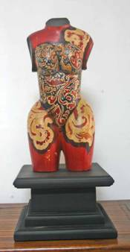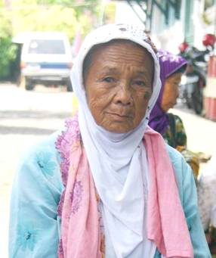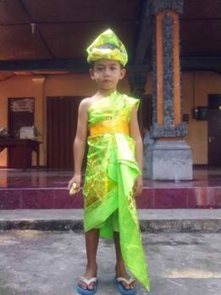
Art-ana’s work member of the senior’s group Putu the Balinese dancer Art-ana’s work

6. Sponsor possibilities

- the scholarship programme: one scholarship is € 60 (primary school), € 95 (junior high school) or
€ 125 (senior high school) a year and can start any time during the year,
- sponsoring a child of the children’s home for € 12 a month (€ 36 a quarter or € 144 a year) for complete sustenance,
- the support of a senior (60 plus) for € 10 a month (especially for vitamins, minerals and medical care). This is € 30 a quarter or € 120 a year,
Of course you can also send us a free gift and leave the spending to us.

7. Gifts

Gifts are more than welcome at our bank account in Holland (Fortis): 84.21.36.932 (for the attention of Stichting Gotong Royong - Utrecht). For people who want to donate and who are living outside Holland, please contact us by e-mail so we can find a proper method of transaction for your donation.

8. Email & website

If you want to let us know something, if you have feedback, do you want to ask anything? Send us an email: info@gotong-royong-utrecht.nl

And have a look at our website, with many photos of our projects:
www.gotong-royong-utrecht.nl

