newsletter
volume 14 issue 2 5 july 2015


‘Gotong Royong Utrecht’ Foundation
postal address: oudkerkhof 15 bis, 3512 GH Utrecht, the netherlands
email: info@gotong-royong-utrecht.nl
bank account: NL74ABNA084.21.36.932
reg.number chamber of commerce H30179877

- From the board

Summer 2015. While in Utrecht the temperature and humidity reach Indonesian standards and the Tour de France starts in a tropical atmosphere, we think of those who practise Ramadan both in Indonesia and in the Netherlands with its long days and short nights. If tropical heat is already hard with food and drink, how hard must it then be without eating and drinking during the day? Whatever you may think of it, in any case it calls forth respect. And so do the cyclists in the heat, although they mainly serve the goddess of commerce.

The past three months were quiet for Gotong Royong; all is going according to plan and the support of our sponsors is reasonably in line with previous years. The economic crisis in the Netherlands seems to have been averted, there is some economic growth again. Let's hope that in the not too distant future this will also reflect on our revenues.
Speaking of money: thanks to everyone who made a scholarship donation for the 2015-2016 school year even without us asking for it. Great! If you have similar plans, we would very much appreciate it if you take to heart this reminder.
We also received a few large private donations again for which we are very grateful. Thanks in particular to the Pok family and Ria.

In the last Newsletter we wrote about the MCK renovation project. We received permission from one of the MCK sponsors to use funds which were meant for building new MCKs for renovation instead. We are very grateful to Impulsis (and, indirectly, the City of Utrecht) for this.



2. Couleur locale Indonesia

Most people now focus mainly on fasting and preparing for Eid, the feast of celebrating the end of fasting, which starts on July 17. Possibly because of this things are fairly quiet, apart from intimidating actions of a few fanatics which are being magnified by Western media. President Jokowi is receiving a good press. His goal is to achieve self-suffiency in rice production in three years’ time, so Indonesia will no longer have to import rice from Thailand and Vietnam. The programme designed for this purpose (more government support for fertilizer, including assistance in distribution, more technical assistance and better irrigation) is successful. Rice production increased significantly in the first half year.

3. Project information

I Yogyakarta-Java: MCKs (public bath/washrooms)

The fact that a substantial part of the funding for the renovation project is secured, does not mean the project had a quick start. For three reasons everything is going a bit slowly. The first and most obvious reason of course is Ramadan. A second and more substantial reason is that renovations are carried out by volunteers (the users of the MCK themselves) in their spare time, which means mostly only on Sunday mornings. So the process takes a longer period of time. A third reason is the fact that recently the commemoration of the May 27, 2006 earthquake took place in this area and there were several official occasions with dignitaries from the province and the national government. This took a lot of painting, sweeping and cleaning; all had to be neat and tidy. Nevertheless, progress has been made: renovations of five MCKs in the Wukirsari area near Imogiri have now been completed.

II Yogyakarta-Java/Singaraja-Bali: Scholarships

The school year 2014-2015 is finished. The results are good, as usual: all children with a Gotong Royong scholarship were promoted to the next grade and those who took their final exams all passed, some with a high ranking (in the top 3 of their school or even their region). In Yogyakarta 21 children passed the final exams for primary or secondary school. 10 of them proceed with further education and 19 new scholarship children were admitted to the programme.
From the students we also receive good messages, often directly by email, SMS or whatsapp (yes, they too!). They are all doing excellently.

The three students in Yogyakarta are in the final phase. Derli took an internship in the Philippines. She was very excited about her first international experience in nursing. During the transit in luxurious Singapore she felt like Alice in Wonderland. She now works as an intern in a hospital in the Big Durian: in Jakarta. After this she will take one more internship, in a psychiatric institution on Java. These are all very instructive experiences. Novia (Economics) left her native island of Bali for the first time to visit various companies and factories on Java. She was in Jakarta for the first time in her life. You will understand these are all massive impressions.

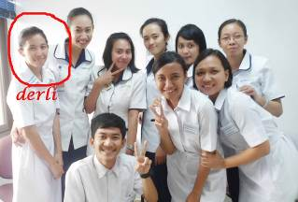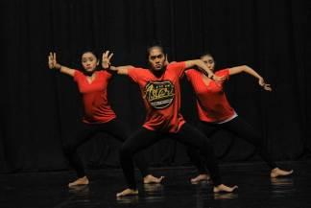
Derli with other nursing students Rehearsal of Sumi’s masterpiece

Sumi (who studies Dance at the Academy of Arts) has started creating her "masterpiece" choreography. She has to manage the entire project: clothing, music, location, scenery, selection of the dancers, rehearsals and catering. We hope we will be able to show you the results on our You-Tube channel. The performance of her previous choreography can still be seen: https://www.youtube.com/watch?v=124hkOhCJWo

Sudi started her Marketing studies. She is very excited and grateful for getting this opportunity. With the study, a full-time job and volunteering on Sunday (teaching English to a group of girls) she admits that she has perhaps quite a busy schedule.

For the next academic year we received three more requests through the staff of the Widhya Asih children’s home in Singaraja. One we have adopted: Kadek Rediasih, a girl who wants to study Economics in Singaraja. She will continue to live at the home and in return will help the staff. If you are interested in sponsoring (part of) her studies we would be very pleased to hear from you.

III Yogyakarta-Java-Bali: Seniors and Medical Support

For many visitors from the Netherlands this is the most appealing project. It is a very direct and pragmatic form of aid: taking care of seniors by issuing supplementary food, performing medical check-ups and dispensing medication. With the instant side-effect during the meetings: heartwarming friendliness. The group consists of 230 seniors spread across five locations in the city. A group of 15 volunteers, led by two coordinators, do somevery good and rewarding work.

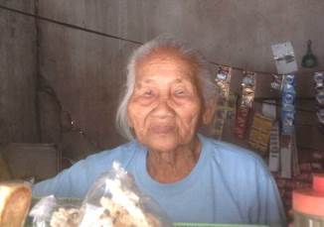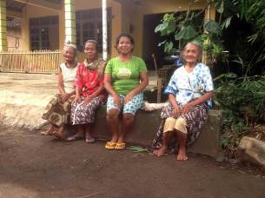

IV Bali: Widhya Asih III and Widhya Asih VII children’s homes

Business as usual, we could say: a good and caring staff who ensure a clear and structured day programme for the children. Acquiring sufficient financial resources remains a problem. We helped them to make an overdue payment to two secondary schools in May. And we temporarily pay the food, so they can save for school fees for the next semester.

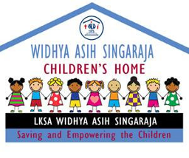  Redi, the new student

Above you see the new logo of the children's home; a funny drawing with bright colours carrying the name "children's home" and not "orphanage". The term orphanage is generally and deliberately misused. There are no more orphans on Bali than there are in the rest of the world. There has not been an epidemic, nor a war, earthquake nor tsunami. So there is no reason to believe (or presume) that on Bali there are more orphans than elsewhere. The children who live in one of the (too) many children's homes on Bali come from less desirable social/economic situations (broken families, poor families) or from areas where school attendance is impossible because of large distances.

In our previous newsletter we informed you that Yudi, who grew up in the children’s home and until recently was a staff member, had been asked to become the head of a small children’s home in Amlapura: Widhya Asih VII. Recently he has started in his new position and as a gift we donated a big rice cooker to the home so that all children now get their plate of rice at the same time and no longer have to wait until the next pot of rice is cooked.
Two friends of us visited Yudi in Amlapura and gave us a report. It is not our intention to start funding this home in a structural way. Yudi first has to recruit a few other big sponsors. The home receives a basic amount for operating expenses from its headquarters, the rest they need to see to by themselves.
We will support the purchase of school supplies and clothing at the start of the new school year.

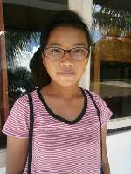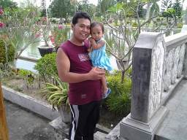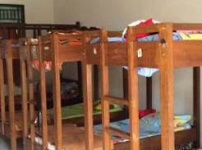
Glasses for Wayan Deni (WA7) Yudi and his daughter Girls’ dormitory (WA7)

4. Sponsor visits

In June Patty and Ellen visited the Widhya Asih VII children’s home in Amlapura. They met Yudi who was very grateful to receive his first foreign visitors.

5. You tube Gotong Royong Utrecht channel

On our You tube channel http://www.youtube.com/user/GotongRoyongUtrecht you can see several videos:
- Widhya Asih children’s home; thanks to Anne from Alkmaar
- An impression of the location and the operation of a new MCK
- NEW: Sumi’s dance performance
- NEW: an impression of a gamelan lesson at the children’s home and a general overview of the premises

6. Sponsoring possibilities

- the scholarship programme: one scholarship is € 60 (primary school), € 100 (junior high school) or
€ 165 (senior high school) a year and can start any time during the year,
- sponsoring a child of the children’s home for € 12 a month (€ 36 a quarter or € 144 a year) for complete sustenance,
- the support of a senior (60 plus) for € 10 a month (especially for vitamins, minerals and medical care). This is € 30 a quarter or € 120 a year.
Of course you can also send us a free gift and leave the spending to us.

7. Gifts

Gifts are more than welcome at our bank account in Holland: NL74ABNA084.21.36.932 (for the attention of Stichting Gotong Royong - Utrecht). For people who want to donate and who are living outside Holland, please contact us by email so we can find a proper method of transaction for your donation.

