newsletter
volume 13 issue 4 2 january 2015


‘Gotong Royong Utrecht’ Foundation
postal address: oudkerkhof 15 bis, 3512 GH Utrecht, the netherlands
email: info@gotong-royong-utrecht.nl
bank account: NL74ABNA084.21.36.932
reg.number chamber of commerce H30179877

- From the board


Wishing you a happy new year,
in good health and with a heart full of love.

A whole new year lies ahead. A wonderfully blank diary, with days ready to be filled with activities or to be left empty to relax and enjoy. On one of the last days of 2014 we met with the board to look back to the past year and to look forward to 2015. The past year has been a stable year, with few ups and downs. A year of rest, routine and rhythm. All projects rest on a solid foundation. There is a stable and experienced volunteer team which helps carry out the work, led by Ibu Gardjito and Amaliah. We have good insight (thanks to the volunteers) into what is happening socially in Indonesia, so we know what developments to expect. For 2015 our motto is: "keep doing the things we are good at, always remain alert, and never stop amazing ourselves."
There is a good financial basis to continue the projects. In recent months we received a few very large donations, from both individual sponsors (Loes, Frank, Pak Pok) as well as three foundations which we applied for support. The regular donations from our loyal sponsors continued. So we look back with gratitude and we look forward with confidence and enthusiasm.
We are merely intermediaries between your intentions and the hopes and wishes of the people who benefit from the projects. Without you there would be no foundation and no happy faces. Thank you all for your unwavering commitment!!

2. Couleur locale Indonesia

Not all news is positive. At Christmas a plane full of mainly Indonesian passengers crashed into the sea. It doesn’t take much effort to imagine what this must mean for their family and friends. Very sad.
Near Dieng in central Java there was a large landslide and dozens of people were buried under the mud. Impotence, or "pasrah", as the Indonesians say, which does not express resignation, but active surrender to a fact.
The newly inaugurated president Jokowi and his Vice President Yusuf Kalla lost no time. They took a difficult but necessary decision: they lowered the subsidy on petrol. As a result the petrol price rose from 43 cents per liter to 56 cents per liter, which is an over 30% increase. The fuel subsidy budget was larger than the entire national budget for education and medical expenses put together. Jokowi and Kalla promised the funds made by lowering the subsidy will go directly into the budgets of Education and Health. Within three weeks they presented three programmes; Scholarships, Medical expenses and Seniors.
Over the next year we will investigate whether we will become redundant as a result. Let's hope so!! But the realists among us (no, not the cynics) know the proof of the pudding is in the eating. We keep hoping and remain alert. And we will keep you informed.

3. Project information

I. Yogyakarta-Java : MCKs (public bath/washrooms)

In the September newsletter we informed you there seems to be noticeably less need for public toilet/wash-rooms because of a regional subsidy for building private toilets.
In October we finished an MCK in Nogosari RT 6, which was officially transferred to the village in December. The renovation of the roof of an MCK in Butuhan in Sleman was completed. Also two MCKs in Nogosari RT 5 were renovated. The deepening of two wells which had fallen dry in Butuhan has been postponed until the start of the dry season (mid-2015).
There is still one application for a new MCK. The location will be inspected in January.

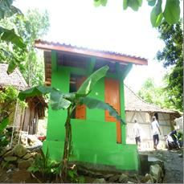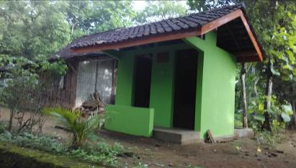
MCK Nogosari RT 5 MCK Nogosari RT 6

II Yogyakarta-Java / Singaraja-Bali Scholarships

All university students on Bali are doing very well. We hear and see nothing but good results and super happy faces. Pande, Lina, Novia and Ayu are steadily continuing. The studies of Nyanyi (Economics) have been extended because a national minimum number of credits was determined which her programme did not meet. Hence, she will be doing a fifth year, which is quite common for a university study. Derli (Nursing) started her final year in Yogyakarta in October. Trifena (Theology) wisely chose a new subject for her thesis. Sumi (remember: our first and only student who successfully organized a Facebook crowdfunding campaign and thus was able to start her dance course at the Yogyakarta Art Academy) is working very hard on her final exam in choreography which will be performed in January. And then there is the phenomenal Sudi (also called Green). In October she got her Bachelor’s degree in Economics in Singaraja. Thanks to Edwin and Lisette who paid for a substantial part of her studies.
A few years ago she already told us she wanted to proceed her studies to get a Master’s degree in Financial Management. She not only has a mission in life, but also a very strong drive. Her professor offered to put her on his staff. This way she could do her Master studies ‘for free’. However, after getting her Master’s degree she would be obliged to work for a substantial number of years for a minimal salary (more like a tip). We advised her not to do it. We offered to search for sponsors for her Master studies provided she found a job with a wage adequate to support herself.
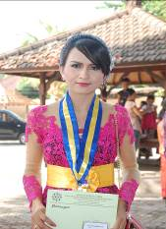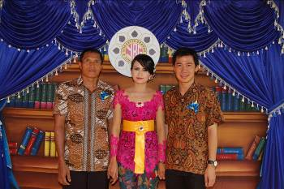
Sudi-Green her blind father, Sudi and her boyfriend

It is two months later now. She moved to Denpasar, she found a job with a reasonable starting salary (100 euros a month) and with free lodging. With her salary she also supports her blind father, her grandmother and her brother who are very poor and living in the north of Bali. So, you understand: we kept our word. We decided to fund a Master's programme for this young woman and immediately found a sponsor who made available 2000 euros for the first year. Fantastic!

III Yogyakarta-Java-Bali : Seniors and Medical Support

In October we received a request from Ibu Gardjito, the chairwoman of our local partner foundation Sejahtera Mulia, to provide money for an outing for the seniors who participate in our seniors’ programme. The question came from the seniors themselves, who had good memories of previous trips. We agreed to sponsor it and on December 23 seven buses filled with seniors and attendants drove to the beach south of Yogyakarta, to enjoy the scenery, sing, eat, do gymnastics and hike. We also rented an open pavilion where they could sit. During the day Ibu Gardjito sent us a text message saying it was a success and the 'oldies' were delighted. We forwarded this message to Lisette and Edwin who responded immediately, saying they would transfer the money they gathered with family and friends that same day. And so they did. Many thanks on behalf of 240 people!

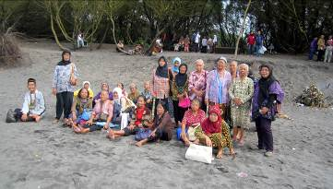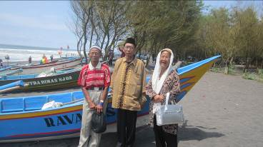

A survey was conducted in the neighbourhoods where our seniors’ groups live. The data and the physical locations of proposed candidates who hope to be admitted to the existing groups were checked. In addition there was the desire to start a new group in the area between the Kraton and the market, in the centre of Yogyakarta. After having verified the need, we decided to do so.

IV. Bali : Widhya Asih III children’s home

All is well with the children and staff in Singaraja. The home no longer depends on us for operational costs. However, we continue to sponsor a small number of children (6) and in addition we support medical expenses.

4. Sponsor visits

In the past three months there have been no sponsor visits. However, in the Netherlands Regina and her daughter Kesuma put up a nice campaign. They wanted to contribute to our projects in Yogyakarta, a city they feel connected to. They sold homemade lanterns at the Christmas Fair in their neighbourhood and handed out flyers. With this they collected enough money to sponsor several primary school scholarships. Many thanks for your initiative!

5. You tube: Gotong Royong Utrecht channel

http://www.youtube.com/user/GotongRoyongUtrecht
- Widhya Asih children’s home; thanks to Anne from Alkmaar!
- new walker for Ibu Tegalmulyo
- NEW: an impression of the location and the operation of a new MCK: http://www.youtube.com/watch?v=pY8CY9Yr5pc

6. Sponsoring possibilities

- the scholarship programme: one scholarship is € 60 (primary school), € 100 (junior high school) or
€ 165 (senior high school) a year and can start any time during the year,
- sponsoring a child of the children’s home for € 12 a month (€ 36 a quarter or € 144 a year) for complete sustenance,
- the support of a senior (60 plus) for € 10 a month (especially for vitamins, minerals and medical care). This is € 30 a quarter or € 120 a year.
Of course you can also send us a free gift and leave the spending to us.

7. Gifts

Gifts are more than welcome at our bank account in Holland: NL74ABNA084.21.36.932 (for the attention of Stichting Gotong Royong - Utrecht). For people who want to donate and who are living outside Holland, please contact us by email so we can find a proper method of transaction for your donation.

8. Email & website

If you want to let us know something, if you have feedback, if you want to ask something, please send us an email: info@gotong-royong-utrecht.nl

