newsletter
volume 12 issue 4 1 january 2014


‘Gotong Royong Utrecht’ Foundation
postal address: oudkerkhof 15 bis, 3512 GH Utrecht, the netherlands
email: info@gotong-royong-utrecht.nl
bank account: NL74ABNA084.21.36.932
reg.number chamber of commerce H30179877

- From the board

A very inspired, stress-free and loving 2014 to you and all your loved ones! We hope you may experience prosperity and well-being and that all your wishes may be fulfilled. We also express our hope that the people who receive your support will continue to benefit from your generosity!

We look back on an eventful year, in which we sharpened our focus. It was not an easy year, yet it was a positive one in which we made choices and concentrated our activities in order to keep doing the things we are good at. 2013 ended positive with a very large donation from a fund that has been supporting us for a long time, thanks to Boris, that enabled us to continue scholarships and seniors’ support.
We sent a report on the new classroom for the Rumah Kita nursery in Yogyakarta to the Masonic Louisa Foundation who sponsored it, and we received an enthusiastic response in which they stated that they would like to support our work in the future.

We have already written about last year’s inflation in Indonesia (almost 10%). Prices have gone up, in general and in particular for food and education. The families we help through scholarships are under increasing pressure and we decided we needed to make more money available (see also 6. Sponsoring possibilities).

2. Couleur locale Indonesia

Mrs. Murdijati Gardjito, who has long been our mainstay and who is the President of our local organization in Yogyakarta, received an important national award from the Indonesian President SBY in November for her work as a professor at the Gajah Mada University. She was honoured as the protector of the national heritage in the field of nutrition (recipe) and as an innovator in the production of traditional products.

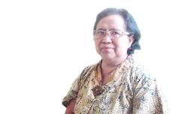

You can read more about her in this Jakarta Post article published in July:
http://www.thejakartapost.com/news/2013/07/16/murdijati-gardjito-local-food-produce-and-wisdom.html

3. Project information

I Yogyakarta-Java : MCKs (public bath-washrooms)

There is no stopping us: again we built two new MCKs. Both in the village of Karangasem (numbers 3 and 4). In September and November we visited three other places in this district (consisting of scattered settlements) where people asked for public toilets. We saw the sites and spoke to the local representatives. Unfortunately for them, we had to reject all three sites because they did not meet the criteria. At two sites we had the impression that it was initiative rather than money that was lacking, at the third the group that would benefit was too small (only two families in a neighbourhood where other people have private toilets).
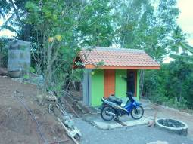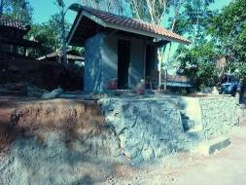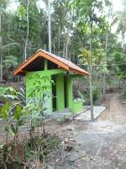
Karangasem mck 3 karangasem mck 4 karangasam mck 2
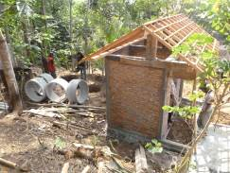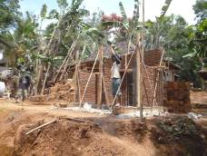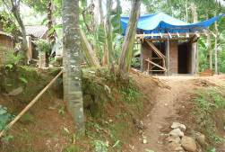
Karangasam mck 3 karangasam mck 4 karangasam mck 5

II Yogyakarta-Java / Singaraja-Bali: Scholarships

The first semester is finished, but as usual the results are not yet in. During these last months we celebrated the graduation of three students. First Komang Ariasa graduated at the Polytechnic School in Denpasar (D3 Civil Engineering), then Dewi Neliani at the University of Singaraja (Indonesian language and literature, S1) and recently Eka Setiyani (D3 Nursing).

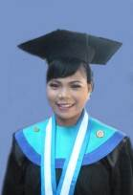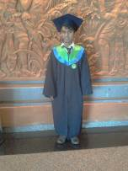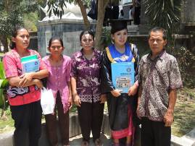
Eka Komang Dewi
III Yogyakarta-Java: Senior citizens and Medical support

Our increased contribution (+25%) for the food packets we wrote about in the previous newsletter, was obviously received very enthusiastically by the seniors. We adequately compensated the huge increase in food prices. In one of the neighbourhoods where we help a group of seniors who are poor, we found that the support was shared with other people. For organizational reasons, two groups of seniors assembled at the same place at the same time: our group and a group of seniors who gathered for a gymnastics class organized by the district office. That the second group also wanted to make use of our medical care we felt was okay, but the fact that they wanted to share in the food packets as well we did not approve of. Yet it happened out of sight, because the seniors from the neighbourhood who are better off, were jealous of the members of our group getting something from us that they didn’t get. Fortunately a volunteer brought this to our attention so we could set things straight. Now the two groups assemble at separate times.
In October we visited eight candidates who were eligible for 'special care'. All are women who cannot take care of themselves because they are blind, demented or bedridden. They are totally dependent on family or neighbours who are also poor. We selected five who will receive a weekly package of complementary food and care.

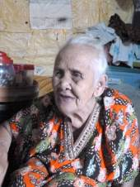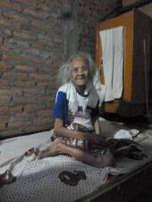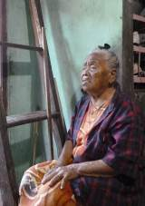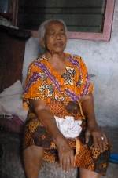
Bu Ginem: blind, osteoporosis Bu Jumimem: paralyzed Bu Kanti: blind Bu Sutrisno: blind

IV Yogyakarta-Java: Rumah Kita nursery

The new classroom, co-financed by the Masonic Louisa Foundation, was put into use:

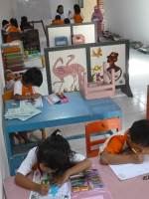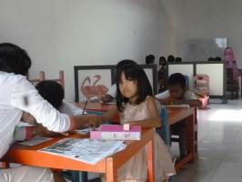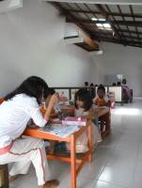

V Bali : Widhya Asih III children’s home, Singaraja

It is going well at the orphanage, new bathrooms and toilets for boys and girls have been built (not funded by us) and the children are doing well at school. Quite often foreign visitors leave a donation. We still pay for a small group of senior high school students and six Singaraja college students (Yudi, Sudi, Nyanyi, Ayu, Novia and Suarcaya), in addition to the three students (formerly living at the home) who are studying in Yogyakarta (Derli, Sumi and Trifena).

4. Sponsor visits

The holiday season is over and fewer Dutch people visited Indonesia this time of the year, so we did not have sponsors visiting us on site. However, there were sponsorship activities in the Netherlands. René successfully stimulated his friends and family to sponsor and Theo asked his family and friends to donate to us, instead of buying presents for his birthday. Many thanks to the generous donors!

5. YouTube: Gotong Royong Utrecht channel

http://www.youtube.com/user/GotongRoyongUtrecht
- Widhya Asih children’s home; thanks to Anne from Alkmaar!
- new walker for Ibu Tegalmulyo

6. Sponsoring possibilities

- the scholarship programme: one scholarship is € 60 (primary school), € 100 (junior high school) or
€ 165 (senior high school) a year and can start any time during the year,
- sponsoring a child of the children’s home for € 12 a month (€ 36 a quarter or € 144 a year) for complete sustenance,
- the support of a senior (60 plus) for € 10 a month (especially for vitamins, minerals and medical care). This is € 30 a quarter or € 120 a year.
Of course you can also send us a free gift and leave the spending to us.

7. Gifts

Gifts are more than welcome at our bank account in Holland: NL74ABNA084.21.36.932 (for the attention of Stichting Gotong Royong - Utrecht). For people who want to donate and who are living outside Holland, please contact us by e-mail so we can find a proper method of transaction for your donation.

8. Email & website

If you want to let us know something, if you have feedback, if you want to ask something, please send us an email: info@gotong-royong-utrecht.nl

And have a look at our website, with many photos of our projects: www.gotong-royong-utrecht.nl

