newsletter
volume 11 issue 4 31 december 2012


‘Gotong Royong Utrecht’ Foundation
postal address: oudkerkhof 15 bis, 3512 GH Utrecht, the netherlands
email: info@gotong-royong-utrecht.nl
bank account: 84.21.36.932 (FORTIS)
reg.number chamber of commerce H30179877

- From the board

First of all, we wish you a very happy and prosperous new year!
We like to send you this Christmas card made by the orphanage’s staff:

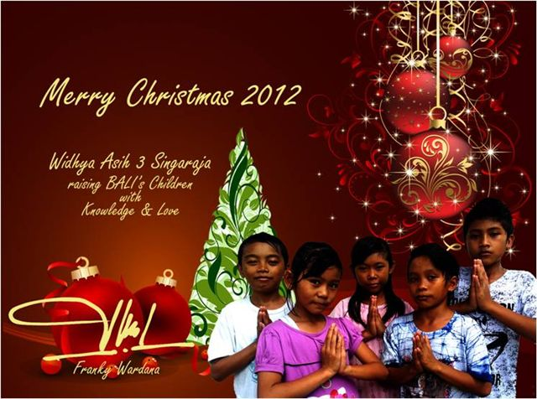

For Gotong Royong the new year will be an exciting one, both financially and from an organizational point of view. A year in which we will continue the planned transfer of projects to the local volunteers, a year in which our role will change: less operational and initiating, more coaching and controlling. Our main challenge will be fundraising.

Hence the following call to those who support the scholarship programme per calendar year (instead of per school year, which is from July until June):
The first semester is finished and in January 2013 the second semester will begin. In July we made agreements to support several hundred children, in any case in the year 2012-2013. Partly we could make this commitment because of sponsors’ promises, and partly because we trusted that those who give support each calendar year, will do so again in 2013. May we hereby invite you to consider doing so? The children will be very grateful for your support.

2. Couleur locale

For reports on Indonesia we in the Netherlands are quite dependent on the opinion of one Jakarta correspondent who frequently confirms his audience’s expectations of corruption, nepotism and rising fundamentalism. Now these are easy to find in Indonesia, but there are also positive developments that, once you notice them, give you a more optimistic view. The new governor of Jakarta for instance, condemned quite explicitly (which is usually not done in Indonesian culture) the tendering procedures used by developers of infrastructural projects. And the purchasing power of a large part of the population has grown a little. Surely bank loans create huge debts, but who are we to point out the risks, considering our own credit bubble of the past decades? Moreover: rising prosperity is an antidote to religious fundamentalism.
The economy also benefits from the significant increase in tourism profits this year. If only all this prosperity would be equally divided over the entire population, then foundations like ours would be made redundant.

3. Project information

I Yogyakarta-Java: MCKs (public bath/washrooms)

After the Ramadan and Idul Fitri recess we completed another MCK in October. This time in Ngaglik Sumbersari in Sleman. We expect to build another one in that region. But first we went back to Bantul to investigate a location in Agung Sari. The village, where the earthquake’s devastation is still remarkably visible, very much needed an MCK. The location with an already existing well was suitable, but a goat stable had to be moved because it was too close to the well and would negatively affect the quality of the (ground) water. As a matter of fact, the quality of the water is always tested in advance. The start of building this MCK was in November and it was finished in early December, but because of the humidity caused by heavy monsoon rains, people are still waiting for the paint to dry.

II Yogyakarta-Java / Singaraja-Bali: Scholarships

(Please note the call in section 1.).
The students are doing well. Derli graduated from nursing school in September in Yogya. Because of her very good results and the study advice she received, we granted her wish to fund further studies in Nursing at university. Muliani (language), Yudi (economy) and Cahyadi (administration) are working on their theses. Eka (nursing) and Ariasa (Technical School) are also in their final year.

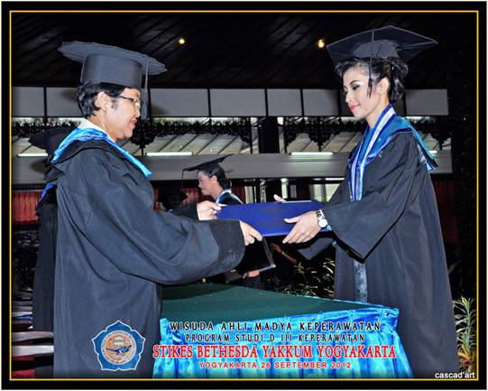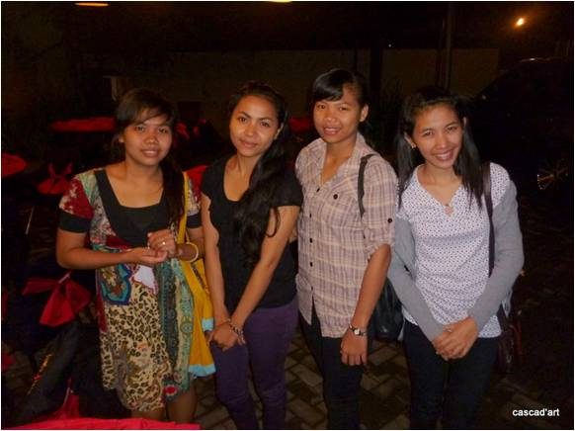
Derli graduating Trifena, Sumi, Eka and Derli (the Jogya Four)

III Java - Bali : Senior citizens and Medical support

In Yogya we performed the annual scan of the seniors’ data. We took a critical look at the participants and especially at the economic situation of their children if the seniors live with them. The purpose of this was to find out if we could downsize the groups as we are chronically short of money for this project. We either had to make smaller (and thus cheaper) parcels or smaller groups. The staff preferred the second option. The scan resulted in 25 fewer seniors in need of help. 264 seniors still remain in the project, divided into 5 groups. Thanks to the support of the We Do It Foundation we were able to organize an outing for them in November (we paid for buses, food and assistance). By doubling the budget all could attend. They went to Gembira Loka, a zoo and recreation resort in the city. With the help of 20 volunteers it was a great success; there were many smiling faces and many thanks.

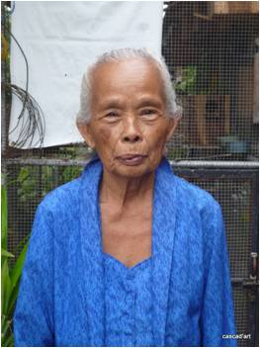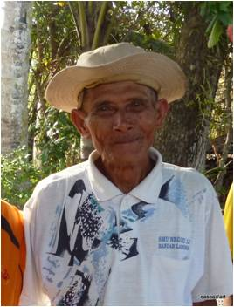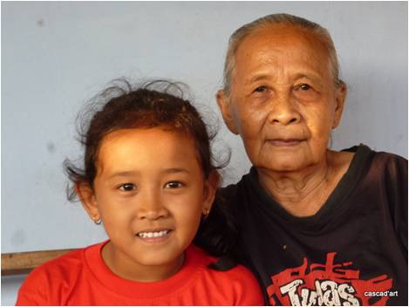

Unfortunately, we have to inform you that in Singaraja (Bali) Mrs Suresemi died. You may remember her from our YouTube video. She suffered from Parkinson's disease and we provided her with ​​medicines and other support. She suffered a lot of pain, and yet she brought much joy to her children and grandchildren. In September she stopped taking medication and food and shortly afterwards she died.

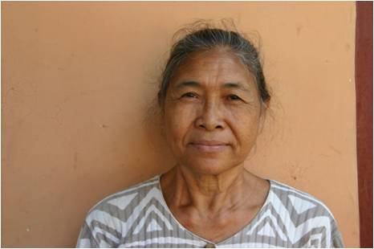
Bu Suresemi (R.I.P.)

IV Bali : Widhya Asih III Children’s home, Singaraja

In the previous newsletter we informed you that a new manager, Franky, had been appointed at the children’s home and that Yohanes had been transferred. Last November we spoke with both of them, separately. Yohanes found it very difficult to notice that Franky had other plans and a different approach. He felt that his legacy was lost and was confirmed in this by complaining children. We advised him to let go of his old work and mission, and to understand that Franky in his own way does the same as Yohanes used to do: trying his best to implement his vision. Franky puts more emphasis on learning, studying and school results and less on vocational training and art (theater, batik, music). And he is more personally involved with the children. Franky on the other hand was quite stressed by the thought that he was observed critically. He felt he had to prove to us that he is trustworthy. He was visibly relieved when he found out that we look forward, not backwards.

4. Sponsors

We want to congratulate Jaap on his 90th birthday and NOT thank him (because in his opinion it is not necessary) for the generous gift he gathered with family and friends in honor of this occasion!

5. YouTube: Gotong Royong Utrecht channel

- Widhya Asih children’s home; with thanks to Anne from Alkmaar!
- NEW: new walker for Ibu Tegalmulyo: http://youtu.be/87X6JaeOqBg

6. Sponsor possibilities

- the scholarship programme: one scholarship is € 60 (primary school), € 95 (junior high school) or
€ 125 (senior high school) a year and can start any time during the year,
- sponsoring a child of the children’s home for € 12 a month (€ 36 a quarter or € 144 a year) for complete sustenance,
- the support of a senior (60 plus) for € 10 a month (especially for vitamins, minerals and medical care). This is € 30 a quarter or € 120 a year.
Of course you can also send us a free gift and leave the spending to us.

7. Gifts

Gifts are more than welcome at our bank account in Holland (ABN AMRO): 84.21.36.932 (for the attention of Stichting Gotong Royong - Utrecht). For people who want to donate and who are living outside Holland, please contact us by e-mail so we can find a proper method of transaction for your donation.

8. Email & website

If you want to let us know something, if you have feedback, if you want to ask something, please send us an email: info@gotong-royong-utrecht.nl

And have a look at our website, with many photos of our projects: www.gotong-royong-utrecht.nl

