newsletter
volume 14 issue 1 2 april 2015


‘Gotong Royong Utrecht’ Foundation
postal address: oudkerkhof 15 bis, 3512 GH Utrecht, the netherlands
email: info@gotong-royong-utrecht.nl
bank account: NL74ABNA084.21.36.932
reg.number chamber of commerce H30179877

- From the board

Volume 14! Once again we realize perception of time is very personal. When you are enjoying yourself, time flies and you wish you could freeze it. But when you feel bad, time crawls and you wish you could push it forward. Given the speed in which these 14 years have flown by, we have been in a continuous positive flow. And all these years loyal sponsors and supporters have stimulated us and kept us focussed. The engine of our work is our intention and goal, but we need fuel to go forward and this is what you, our sponsors, provide. Sometimes we have to take calculated risks. Fortunately over the years funding has proven to be reliable and we dared to engage in projects with a duration of a year each. When promising to support a follow-up study we take more risk, because it takes four or five years. But so far our sponsors have not let us down and we have never had to disappoint any students.

In March we made a tour to inspect all our ongoing projects. In this newsletter we will tell you about the findings.

Once again we would like to thank all our sponsors. Even without sending a reminder at the start of the new school semester, most of you knew it was time for the (semi-)annual much needed support to the scholarship programme. Special thanks to some remarkable sponsors: Jack, Ton and Saskia, Frans, Kees and Pak Pok.

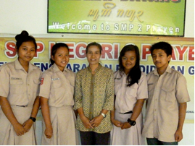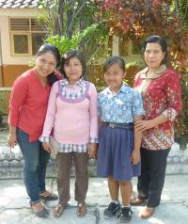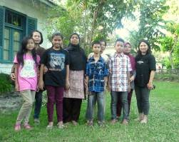
Four students + teacher at SPM school Amaliah, mother, daughter Amaliah and students of SD Pingit
and teacher

2. Couleur locale Indonesia

People see what they want to see: your focus determines what enters your mind and how you interpret it. And when you explicitly state you do not want to see a pink elephant, they appear all around you. The same thing happens when we view reality in Indonesia. Suddenly new white cars seem to appear everywhere, more burqas are visible in the streets, people wear fewer batik clothes and everyone has a smartphone. Probably this is all nonsense, if you pay closer attention you will see things differently. Earlier on, we reported that the price of petrol had gone up significantly and food prices had risen in its slipstream. The fact that fuel prices went down again, was not brought to our attention nor was it noticeable in food prices, which did not drop. As a result inflation is still substantial and the cost of living has risen considerably.

The new president Jokowi is regarded as a true warrior who governs without fear. He withstood the Head of his party, Miss Megawati (Sukarno’s daughter) by refusing to appoint the people she commanded. His programmes for senior citizens and health care are already being deployed. He also chooses to be clear about the fate of criminals who are sentenced. The death penalty (unfortunately) has a legal basis, just as in economically respected countries like China and the USA. This does not keep Australia from threatening Indonesia with tourist boycotts now that two criminals from this country await execution. As if anyone would skip his or her surfing holiday in Bali for this reason. Australia kept silent when the Indonesian government executed a Dutch drugs criminal a month ago. A typical case of nationalism and double standards.

Very good news comes from the Golkar party: Bakrie, the country's biggest kleptomaniac, is likely to be dismissed as one of the most powerful party officials, thus paving the way for the party to support the minority government of President Jokowi.

3. Project information

I. Yogyakarta-Java : MCKs (public bath/washrooms)

In March, we visited 40 MCKs to inspect the condition and to see if there were reasons to make repairs or renovations. It was quite an experience. Our expectations were put to the test and we had to adjust our beliefs about proper maintenance and use of MCKs. We apparently had no realistic idea of ​​how powerful the effect of direct sunlight, heat, water and urine is on floors, walls and especially on wood.
A notable and positive development is that extensive use is made of the government subsidy programme to promote the construction of private toilets. In some villages MCKs were now only used by a small group of people. The smaller the group, the less responsibility they felt for cleaning and the more often maintenance was overdue. Typically, the toilets are clean but a light is missing, or the door is broken, or a tile (or more). In a few cases the septic tanks were full and the toilet was not used any more because there was no money to empty the tank. Partly thanks to the scrutiny of Amaliah, our local coordinator, we selected several locations where we will help with renovations and repairs under certain conditions (e.g. the users executing the work themselves).

We visited one location (Bulus Kulon, RT 6) which was nominated for a new MCK. Its location was not central to the user area and it was close to a stable complex, which brings a very high risk of groundwater being contaminated by manure. The request was therefore rejected.

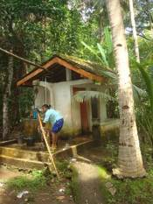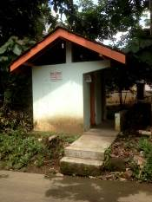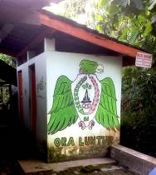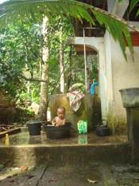

MCKs which have been in use for years now, whether or not decorated and maintained, but always clean.

II Yogyakarta-Java / Singaraja-Bali Scholarships

Recently we met all students in Bali: Pande (economics), Lina (dietetics), Novia (economics) and Ayu (kindergarten teacher) are successful and like their studies. Nyanyi (part-time programme in economics) gets particularly high scores and likes working as the accountant of the orphanage.

For the Yogyakarta students the autumn of 2015 will be a special moment. All three then hope to graduate. Derli (nursing) has been chosen by the Bethesda hospital, based on her study results, to go on a largely sponsored study/practice trip to the Philippines in April. This will be her first time abroad and will give her the opportunity to gain working experience. A great opportunity and we will gladly contribute. Trifena (theology) struggled with the disappointment of her thesis being rejected. Only recently she picked up again. Sumi (dance at the Art Academy in Yogyakarta) completed her second last assignment: a choreography and performance on stage. The attractive registration is on our You Tube channel: https://youtu.be/124hkOhCJWo We are very proud of her.

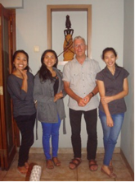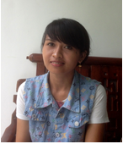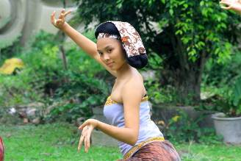
René and students in Yogyakarta Miss Green One of Sumi’s dancers (general rehearsal)
In the previous newsletter we wrote about Sudi (also called Green). In May she will start a master MM study (“Magister Manajemen”, specifically Marketing) thanks to Frank. In the meantime she is working as a service manager at a timber company with projects in major hotels and expats who build houses in Bali. During a project visit to the Mercure hotel she had a meeting with the technical supervisor Ariasa, who is also a child from the children’s home whose study was sponsored by Gotong Royong. Two success stories!
In Yogyakarta Amaliah took care of all scholarships by herself. In January and February she met all of the children and she made sure they all got what they needed: uniforms, shoes, school supplies and books.

III Yogyakarta-Java-Bali: Seniors and Medical Support

In March we were able to visit most seniors’ groups and each time was a festive occasion. We are very pleased with Bu Daryati, the coordinator of all the groups. She has a good overview and is very involved without being too predominant. Together with her we visited eleven seniors who were nominated by the local staff. We often found very distressing situations, in which our support would be very helpful. The preselection was apparently well done because all candidates but one were admitted to the programme. We also visited our old friends: Bu Rus and Bu Jati, who now gets more (paid) attention and care, as a result of which her place is also a lot cleaner. The start of the proposed new seniors’ group has been delayed because the local staff in the district is not ready yet.
In Bali we help four seniors (55+): Bu Luh, Suit Made, Kino and Bu Bu Kereja. The staff of the children’s home support us in the execution.

IV. Bali: Widhya Asih III Children’s home
All is well at the children’s home, is our impression: the atmosphere is very good and there appears to be a good balance between work and relaxation. Financially it is still difficult to make ends meet. Finding new 'big' sponsors especially for the costs of primary and secondary school is a major challenge. For now, we refrain from paying these costs, but we do help with medical expenses and other operational matters (school bus maintenance and nutritional supplements).
Good News for Yudi: he was asked to become the new head of the small orphanage in Amlapura which up until now was led part time by a vicar. Now a full time Head will be appointed, so more attention can be paid to the children. Yudi grew up in the Widya Asih III children’s home in Singaraja and has been working there as a staff member for several years now. In April, he will go to Amplura to be the first in charge. It is a good choice.

4. Sponsor visits

In March sponsor and board member René visited Yogyakarta. He assisted in evaluating projects, both on site as well as in meetings with the local staff.

5. You tube Gotong Royong Utrecht channel

On our You tube channel http://www.youtube.com/user/GotongRoyongUtrecht you can see several videos:
- Widhya Asih children’s home; thanks to Anne from Alkmaar
- An impression of the location and the operation of a new MCK
- NEW: Sumi’s dance performance
- NEW: an impression of a gamelan lesson at the children’s home and a general overview of the premises

6. Sponsoring possibilities

- the scholarship programme: one scholarship is € 60 (primary school), € 100 (junior high school) or
€ 165 (senior high school) a year and can start any time during the year,
- sponsoring a child of the children’s home for € 12 a month (€ 36 a quarter or € 144 a year) for complete sustenance,
- the support of a senior (60 plus) for € 10 a month (especially for vitamins, minerals and medical care). This is € 30 a quarter or € 120 a year.
Of course you can also send us a free gift and leave the spending to us.

7. Gifts

Gifts are more than welcome at our bank account in Holland: NL74ABNA084.21.36.932 (for the attention of Stichting Gotong Royong - Utrecht). For people who want to donate and who are living outside Holland, please contact us by email so we can find a proper method of transaction for your donation.

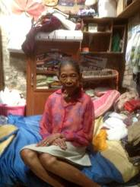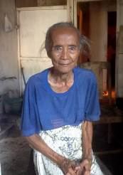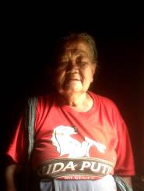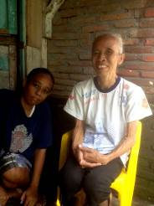

Four ladies from Yogyakarta who were recently admitted to the seniors’ programme

